Course syllabus

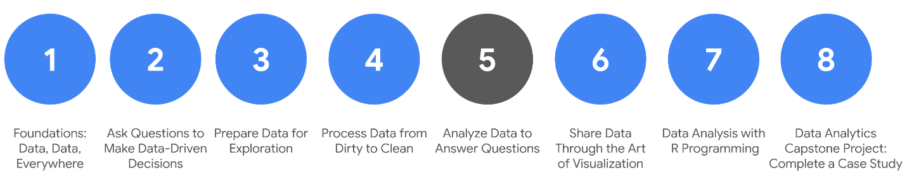

1. [Foundations: Data, Data, Everywhere](https://www.coursera.org/learn/foundations-data/home/welcome)
2. [Ask Questions to Make Data-Driven Decisions](https://www.coursera.org/learn/ask-questions-make-decisions/home/welcome)
3. [Prepare Data for Exploration](https://www.coursera.org/learn/data-preparation/home/welcome)
4. [Process Data from Dirty to Clean](https://www.coursera.org/learn/process-data/home/welcome)
5. **Analyze Data to Answer Questions** *(this course)*
6. [Share Data Through the Art of Visualization](https://www.coursera.org/learn/visualize-data/home/welcome)
7. [Data Analysis with R Programming](https://coursera.org/learn/data-analysis-r/home/welcome)
8. [Google D​ata Analytics Capstone: Complete a Case Study](https://coursera.org/learn/google-data-analytics-capstone/home/welcome)

Welcome to the fifth course in the series for the Google Data Analytics Certificate! The goal of data analysis is to make sense out of the data you collect and receive. Up until now, your focus has been on the preparations a data analyst goes through before entering the analysis phase. Specifically, in the last course, you learned about checking data for completeness and cleaning it for accuracy and reliability.

If you feel like a hiker who has climbed a great distance to get to higher ground, we are excited to tell you that you have arrived! You have reached a stage where you are ready to work directly with data. You will organize and format data. This will help you think about data in different ways. Similar to how the view from a hiker’s lookout is amazing, your view of data from this point on will be spectacular.

You will have hands-on practice organizing, sorting, filtering, formatting, converting, and combining data in spreadsheets. These are tasks you would complete in a real data analysis project. You will also learn how to sort and filter your data using SQL queries. You will be using functions and writing queries frequently as you continue your learning.

**C​ourse content**

C​ourse 5 – Analyze Data to Answer Questions

1. **O​rganizing data to begin analysis.** Organizing data makes the data easier to use in an analysis. In this part of the course, you will learn the importance of organizing your data with sorting and filtering. You will explore organizing data in both spreadsheets and with SQL queries and temporary tables.
2. **F​ormatting and adjusting your data.** As you move closer to analyzing your data, you will want to have the data formatted and ready to go. In this part of the course, you will learn all about converting and formatting data, including how to use SQL queries to combine data. You will also discover the value of feedback and support from your colleagues and how it can lead to new insights that you can apply to your work.
3. **A​ggregating data for analysis.** During an analysis, you might need to combine data to gain insights and complete business objectives. In this part of the course, you will explore the functions, procedures, and syntax to combine, or aggregate data. You will learn how to combine data within multiple cells in spreadsheets, and within multiple database tables using SQL queries.
4. **Performing d​ata calculations.** Calculations are one of the more common tasks that data analysts perform during an analysis. In this part of the course, you will explore formulas, functions, and pivot tables in spreadsheets and SQL queries. All of these are used in data calculations. You will also learn about the benefits of using SQL to manage temporary database tables.
5. **Completing the C​ourse Challenge.** At the end of this course, you will be able to put everything you have learned into perspective with the Course Challenge. The Course Challenge will ask you questions about the main concepts and then give you an opportunity to apply what you have learned in three scenarios.

**W​hat to expect**

You can expect to finish this course in about five weeks when you have completed all of the prescribed activities, which include:

* **V​ideos** of instructors teaching new concepts and demonstrating the use of tools
* **In-video questions** that pop up during or at the end of a video to check your learning
* **Readings** to introduce new ideas and build on the concepts from the videos
* [**Discussion forums**](https://www.coursera.org/learn/analyze-data/discussions) to discuss, explore, and reinforce new ideas for better learning
* **D​iscussion prompts** to promote thinking and engagement in the discussion forums
* **Hands-on activities** to introduce real-world, on-the-job situations, and the tools and tasks to complete assignments
* **Practice quizzes** to prepare you for graded quizzes
* **Hands-on activities** toreinforce learned skills for the graded quizzes
* **Graded quizzes** to measure your progress and give you valuable feedback

Hands-on activities promote additional opportunities to build your skills. Try to get as much out of them as possible. Assessments are based on the approach taken by the course to offer a wide variety of learning materials and activities that reinforce important skills. Graded and ungraded quizzes will help the content sink in. Ungraded practice quizzes are a chance for you to prepare for the graded quizzes. Both types of quizzes can be taken multiple times.

As a quick reminder, this course is designed for all types of learners, with no degree or prior experience required. Everyone learns differently, so the Google Data Analytics Certificate has been designed with that in mind. Personalized deadlines are just a guide, so feel free to work at your own pace. There is no penalty for late assignments. If you prefer, you can extend your deadlines by returning to **Overview** in the navigation pane and clicking **Switch Sessions**. If you already missed previous deadlines, click **Reset my deadlines** instead.

If you would like to review previous content or get a sneak peek of upcoming content, you can use the navigation links at the top of this page to go to another course in the program. When you pass all required assignments, you will be on track to earn your certificate.

**Tips**

* Try to complete all items in order. All new information builds on previous lessons.
* Treat every task as if it is real-world experience. Have a mindset that you are working at a company or in an organization as a data analyst. This will help you apply what you learn to the real world.
* Repeat demonstrated tasks on your own for extra practice and speed.
* Even though they aren’t graded, it is important to complete all practice items. They will help you build a strong foundation as a data analyst and prepare you for the graded assessments.
* Take advantage of all additional resources provided, including discussion forums and links to external articles for more information.
* W​hen you encounter useful links in the course, remember to bookmark them so you can refer to the information later for study or review.
* Additional resources are free, but some sites place limits on how many articles you can access for free each month. Sometimes you can register on the site for full access, but you can always bookmark a resource and come back to view it later.
* Use a notebook or electronic journal to keep track of new formulas, functions, and syntax that you learn. That way, you will be able to refer back to any notes as needed.

Data analysts use spreadsheets and SQL queries a lot. If you perform all of the assigned activities in the application environments that are recommended, you will get a good idea of what you could be doing on the job as a data analyst.

# Learning Log: Process and organize your data



## Overview



So far, you’ve learned about the steps required to prepare for data analysis. Now, you are learning about the steps required to actually analyze data. First on that list of steps is organizing and formatting data. You’ll complete an entry in your learning log to explore your thoughts on organization and how that might apply to data analysis. You will also reflect on what you think the organization process will be like and what you would like to learn more about in this course. By the time you complete this entry, you will be prepared to start learning more about the organization process.

## Reflect on organization



Organizing your data is one of the most important steps for analysis! Once you get organized, you can perform calculations to find clear and objective answers to any data question. Before you start your learning log entry, take a moment to consider what comes to mind when you think about organizing data; you’ll reflect on these thoughts in the learning log template linked below.

At the end of this course, review your responses and see how your understanding of organizing data has changed. Is it more important than you thought? Less important? Is it more or less difficult? Understanding how your ideas have changed throughout this course will be a great way to check-in with your growth and progress as a data analyst.



### Access your learning log

To use the template for this course item, click the link below and select “Use Template.”

Link to learning log template: [Process and organize your data](https://docs.google.com/document/d/1sDlibIpX411rAg58zDshRrtKmLI_iyOYjFFdNzW7Uhc/template/preview?resourcekey=0-SisbhZ9xPBCLd-YAMeTB1Q)

OR

If you don’t have a Google account, you can download the template directly from the attachment below.

**Learning Log Template\_ Process and organize your data**DOCX File

[Download file](https://d3c33hcgiwev3.cloudfront.net/pZT1t-RPQB2U9bfkT5Ad-g_677484d8da1c466ea8b1bc1b97c7bd8c_Learning-Log-Template_-Process-and-organize-your-data.docx?Expires=1648080000&Signature=BriHwaIg0ZojtWPSg31rq6f2vs~5vqh-PnmHXBDj~kDiMotFipv77PNUFT1JZ~NU-2O9vnaVWgTeOT~PU3Y40axbASWejkPoWYe6BGGUnNAfXl8hYcdkquNyeqTw0dJ8kyRlD8EMaIsXCeAhQf0wtRmt30bWe4Ca1UH-ptlUcdE_&Key-Pair-Id=APKAJLTNE6QMUY6HBC5A" \t "_blank)



## Reflection



Based on what you know, write 3-5 sentences (60-100 words) to answer the following questions:

* What’s one organizational system you already use in real life? How can you apply that logic to data organization?
* What do you think is involved in the process of organizing data?
* What do you want to better understand about organizing data?

When you’ve finished your entry in the learning log template, make sure to save the document so your response is somewhere accessible. This will help you continue applying data analysis to your everyday life. You will also be able to track your progress and growth as a data analyst.

Keeping data organized with sorting and filters

You have learned about four phases of analysis:

* Organize data
* Format and adjust data
* Get input from others
* Transform data

The organization of datasets is really important for data analysts. Most of the datasets you will use will be organized as tables. Tables are helpful because they let you manipulate your data and categorize it. Having distinct categories and classifications lets you focus on, and differentiate between, your data quickly and easily.

Data analysts also need to format and adjust data when performing an analysis. **Sorting** and **filtering** are two ways you can keep things organized when you format and adjust data to work with it. For example, a filter can help you find errors or outliers so you can fix or flag them before your analysis. **Outliers** are data points that are very different from similarly collected data and might not be reliable values. The benefit of filtering the data is that after you fix errors or identify outliers, you can remove the filter and return the data to its original organization.

In this reading, you will learn the difference between sorting and filtering. You will also be introduced to how a particular form of sorting is done in a pivot table.

**Sorting versus filtering**

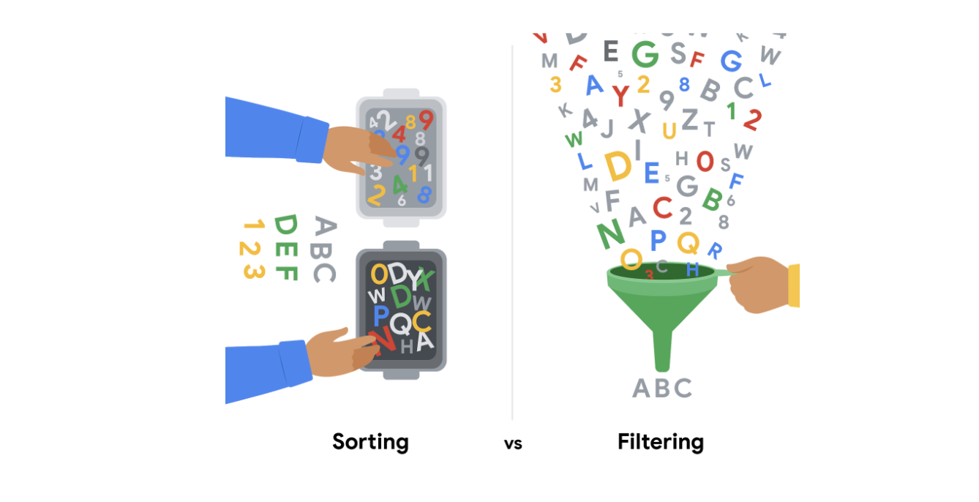

**Sorting** is when you arrange data into a meaningful order to make it easier to understand, analyze, and visualize. It ranks your data based on a specific metric you choose. You can sort data in spreadsheets, SQL databases (when your dataset is too large for spreadsheets), and tables in documents.

For example, if you need to rank things or create chronological lists, you can sort by ascending or descending order. If you are interested in figuring out a group’s favorite movies, you might sort by movie title to figure it out. Sorting will arrange the data in a meaningful way and give you immediate insights. Sorting also helps you to group similar data together by a classification. For movies, you could sort by genre -- like action, drama, sci-fi, or romance.

**Filtering** is used when you are only interested in seeing data that meets a specific criteria, and hiding the rest. Filtering is really useful when you have lots of data. You can save time by zeroing in on the data that is really important or the data that has bugs or errors. Most spreadsheets and SQL databases allow you to filter your data in a variety of ways. Filtering gives you the ability to find what you are looking for without too much effort.

For example, if you are only interested in finding out who watched movies in October, you could use a filter on the dates so only the records for movies watched in October are displayed. Then, you could check out the names of the people to figure out who watched movies in October.

To recap, the easiest way to remember the difference between sorting and filtering is that you can use sort to quickly order the data, and filter to display *only* the data that meets the criteria that you have chosen. Use filtering when you need to reduce the amount of data that is displayed.

It is important to point out that, after you filter data, you can **sort the filtered data**, too. If you revisit the example of finding out who watched movies in October, after you have filtered for the movies seen in October, you can then sort the names of the people who watched those movies in alphabetical order.

**Sorting in a pivot table**

Items in the row and column areas of a pivot table are sorted in ascending order by any custom list first. For example, if your list contains days of the week, the pivot table allows weekday and month names to sort like this: Monday, Tuesday, Wednesday, etc. rather than alphabetically like this: Friday, Monday, Saturday, etc.

If the items aren’t in a custom list, they will be sorted in ascending order by default. But, if you sort in descending order, you are setting up a rule that controls how the field is sorted even after new data fields are added.

Optional: Upload the movie dataset to BigQuery

The next video demonstrates how to use SQL to filter data in a large dataset in BigQuery.

If you would like to follow along with the instructor, you will need to log in to your BigQuery account and upload the movie dataset provided as a CSV file. If you have hopped around courses, [Using BigQuery](https://www.coursera.org/learn/data-preparation/supplement/DYOQK/using-bigquery) in the **Prepare Data for Exploration** course covers how to set up a BigQuery account.

**Prepare for the next video**

* First, download the CSV file from the attachment below:

**Movie Data**CSV File

[Download file](https://d3c33hcgiwev3.cloudfront.net/KNFbyUKxRKiRW8lCsQSo8A_8adeac50825b4df68daaf6055c404ef1_Movie-Data.csv?Expires=1648080000&Signature=j8JPj9EJv~NFE7oYSBgTabWMJKg3j3mZAHaem1mqnMB8gUGIwQn9ZanJXVH~Va8AAI9To0u60tI3frQrKxCPY5rPqjqXXY-PAnn0V3rRHdEP8NyFHKpHlTqxZVc1p3teDL2IfpJgVpUGcJtbR8YPs5d6KnpYot4j0qYU9Ou709Y_&Key-Pair-Id=APKAJLTNE6QMUY6HBC5A" \t "_blank)

* Next, complete the following steps in your BigQuery console to upload the movie dataset.

**Step 1:** Open your BigQuery console and click on the project you want to upload the data to.

**Step 2:** In the Explorer on the left, click the Actions icon (three vertical dots) next to your project name and select **Create dataset**.

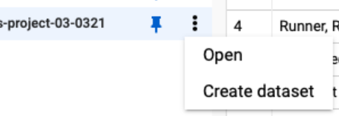

**Step 3:** In the upcoming video, the name "movie\_data" will be used for the dataset. If you plan to follow along with the video, enter **movie\_data** for the Dataset ID.

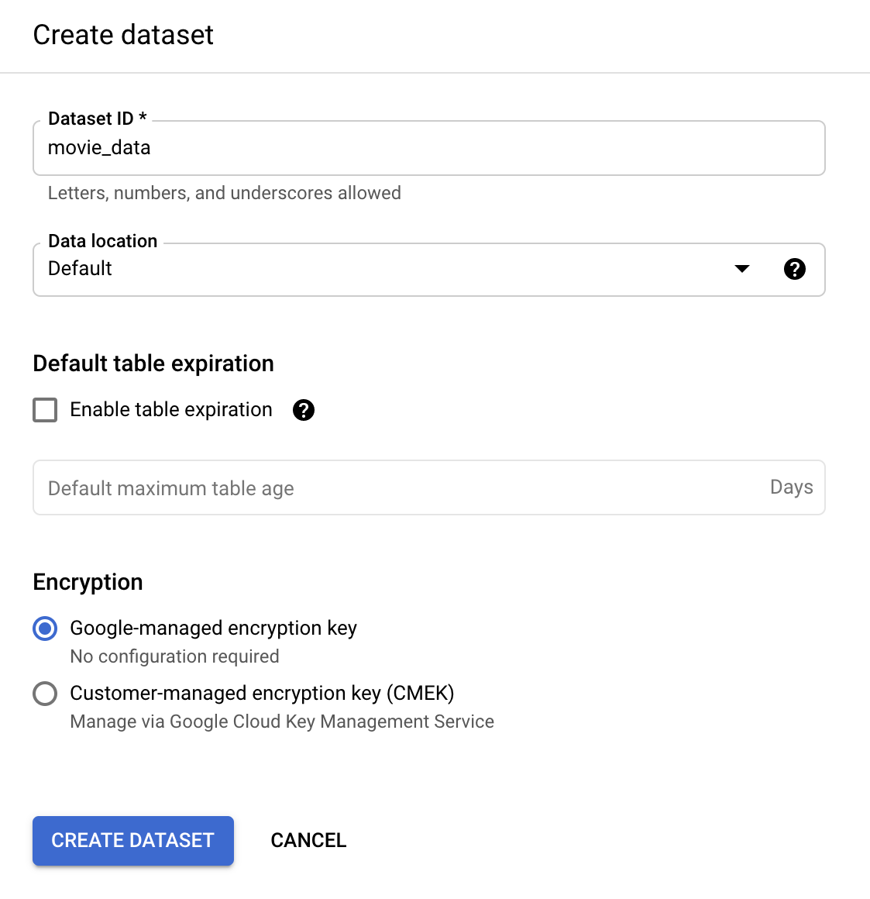

**Step 4:** Click **CREATE DATASET** (blue button) to add the dataset to your project.

**Step 5:** In the Explorer on the left, click to expand your project and then click the **movie\_data** dataset you just created.

**Step 6:** Click the Actions icon (three vertical dots) next to movie\_data and select **Open**.

**Step 7:** Click the blue + icon at the top right to open the Create table window.

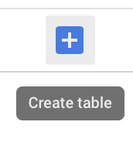

**Step 8:** Under Source, for the Create table from selection, choose where the data will be coming from.

* Select **Upload**.
* Click **Browse** to select the Movie Data CSV file you downloaded.
* Choose **CSV** from the file format drop-down.

**Step 9:** Under Destination, for Table name enter **movies** to match the table in the video.

**Step 10:** For Schema, click the Auto detect check box.

**Step 11**: Click **Create table** (blue button). You will now see the **movies** table under your **movie\_data** dataset in your project.

**Step 12:** Click **movies** and then select the **Preview** tab. Confirm that you see the data shown below.

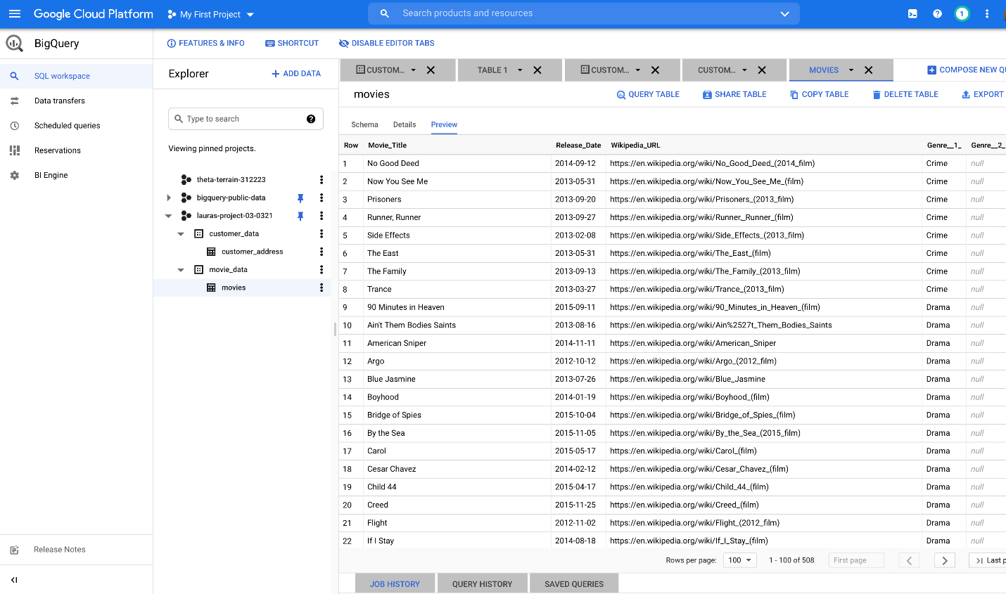

Congratulations, you are now ready to follow along with the next video.

Sorting and filtering in Sheets and Excel

In this reading, we will describe the sorting and filtering options in Google Sheets and Microsoft Excel. Both offer basic sorting and filtering from set menu options. But, if you need more advanced sorting and filtering capabilities, you can use their respective **SORT** and **FILTER** functions.



**Sorting and filtering in Sheets**

Sorting in Google Sheets helps you quickly spot trends in numbers. One trend might be gross revenue by sales region. In this case, you could sort the gross revenue column in **descending** (Z to A) order to spot the top performing regions at the top, or sort the gross revenue column in **ascending** (A-Z) order to spot the lowest performing regions at the top. Although an alphabetical order is implied, these sorting options do sort numbers, as our gross revenue example highlighted.

If you want to learn more about the set menu options for sorting and filtering, start with these resources:

* [Sort and filter data](https://support.google.com/docs/answer/3540681) (Google Help Center): instructions to sort data in alphabetical or numerical order and create filter views
* [Sort data by selecting a range of data in a column](https://www.youtube.com/watch?v=VcRBHXBMKBU): video of steps to achieve the task
* [Sort a range of data using sort criteria for multiple columns](https://www.youtube.com/watch?v=2dO4SDHKoPE): technical tip video to sort data across multiple columns

In addition to the standard menu options, there is a SORT function for more advanced sorting. Use this function to create a custom sort. You can sort the rows of a given range of data by the values in one or more columns. And you get to set the sort criteria per column. Refer to the [SORT function](https://support.google.com/docs/answer/3093150?hl=en) page for the syntax.

And like the SORT function, you can use the [FILTER function](https://support.google.com/docs/answer/3093197?hl=en) to filter by any matching criteria you like. This creates a custom filter.

You might recall that you can filter data and then sort the filtered results. Using the FILTER and SORT functions together in a range of cells can programmatically and automatically achieve these results for you.

**Sorting and filtering in Excel**

You can also sort in ascending (A-Z) and descending (Z-A) order in Microsoft Excel. Excel offers **Smallest to Largest** and **Largest to Smallest** sorting when you are working with numbers.

Similar to the SORT function in Google Sheets, Excel includes custom sort capabilities that are available from the menu. After you select the data range, click the **Sort & Filter** button to select the criteria for sorting. You can even sort by the data in rows instead of by the data in columns if you select **Sort left to right** under Options. (**Sort top to bottom** is the default setting to sort the data in columns.)

If you want to learn more about sorting and filtering in Excel, start with these resources:

* [Sort data in a range or table](https://support.microsoft.com/en-us/office/sort-data-in-a-range-or-table-62d0b95d-2a90-4610-a6ae-2e545c4a4654) (Microsoft Support): instructions and video to perform sorting in 11 different use cases
* [Excel training: sort and filter data](https://support.microsoft.com/en-us/office/video-sort-data-in-a-range-or-table-ffb9fcb0-b9cb-48bf-a15c-8bec9fd3a472#ID0EAABAAA=Transcript) (Microsoft Support): sorting and filtering videos with transcripts
* [Excel: sorting data](https://www.youtube.com/watch?v=Ep5q1cUhQas): video of how to use the Sort & Filter and Data menu options for sorting

Excel also has [SORT](https://support.microsoft.com/en-us/office/sort-function-22f63bd0-ccc8-492f-953d-c20e8e44b86c), [SORTBY](https://support.microsoft.com/en-us/office/sortby-function-cd2d7a62-1b93-435c-b561-d6a35134f28f), and [FILTER](https://support.microsoft.com/en-us/office/filter-function-f4f7cb66-82eb-4767-8f7c-4877ad80c759) functions. Explore how you can use these functions to automatically sort and filter your data in spreadsheets without having to select any menu options at all.

## Hands-On Activity: SQL sorting queries

**Total points**2

### 1.

**Question 1**



## Activity overview



So far, you’ve learned about SQL and used SQL queries to interact with databases. In this activity, you’ll practice sorting data by using SQL queries with ORDER BY and WHERE clauses.

By the time you complete this activity, you will be able to write queries that sort data depending on your needs. This will enable you to organize and use data more efficiently in your career as a data analyst.

## Sorting with SQL



To practice sorting data with SQL, you’ll query the CDC Births Data Summary public dataset. The queries you write will help you obtain some answers about which counties in the United States have the most and least births in the years 2016-2018.

### **Load the dataset**



1. Log in to [BigQuery Sandbox](https://cloud.google.com/bigquery/docs/sandbox). If you have a free trial version of BigQuery, you can use that instead. On the BigQuery page, click the **Go to BigQuery** button.

* **Note:** BigQuery Sandbox frequently updates its user interface. The latest changes may not be reflected in the screenshots presented in this activity, but the principles remain the same. Adapting to changes in software updates is an essential skill for data analysts, and it’s helpful for you to practice troubleshooting. You can also reach out to your community of learners on the discussion forum for help.

2. If you have never created a BigQuery project before, click **CREATE PROJECT** on the right side of the screen. If you have created a project before, you can use an existing one or create a new one by clicking the project dropdown in the blue header bar and selecting **NEW PROJECT**.

3. Name your project something that will help you identify it later. You can give it a unique project ID or use an auto-generated one. Don’t worry about selecting an organization if you don’t know what to put.

4. Now, you’ll see the **Editor** interface. In the middle of the screen is a window where you can type code, and to the left is the **Explorer** menu where you can search for datasets.

5. Click **+ ADD DATA** at the top of the Explorer menu**,** then **Explore public datasets** from the resulting dropdown.

6. In the **Search Marketplace** bar, type **sdoh\_cdc\_wonder\_natality**.

7. Click the **CDC Births Data Summary**.

8. Click **View Dataset**. This will bring you back to the BigQuery Sandbox interface in a new tab.

* **Note:** This may pin the **bigquery-public-data** dropdown to the **Explorer** menu. You can use this to browse datasets and tables.

9. Click back to the **Editor** tab. This is where you’ll use SQL during this activity.

10. Copy, paste, and run the following query to display the first 1,000 rows of the **county\_natality** table:

1

2

3

4

5

6

SELECT

  \*

FROM

  `bigquery-public-data.sdoh\_cdc\_wonder\_natality.county\_natality`

LIMIT

  1000





After the query has run, your results should appear like this:

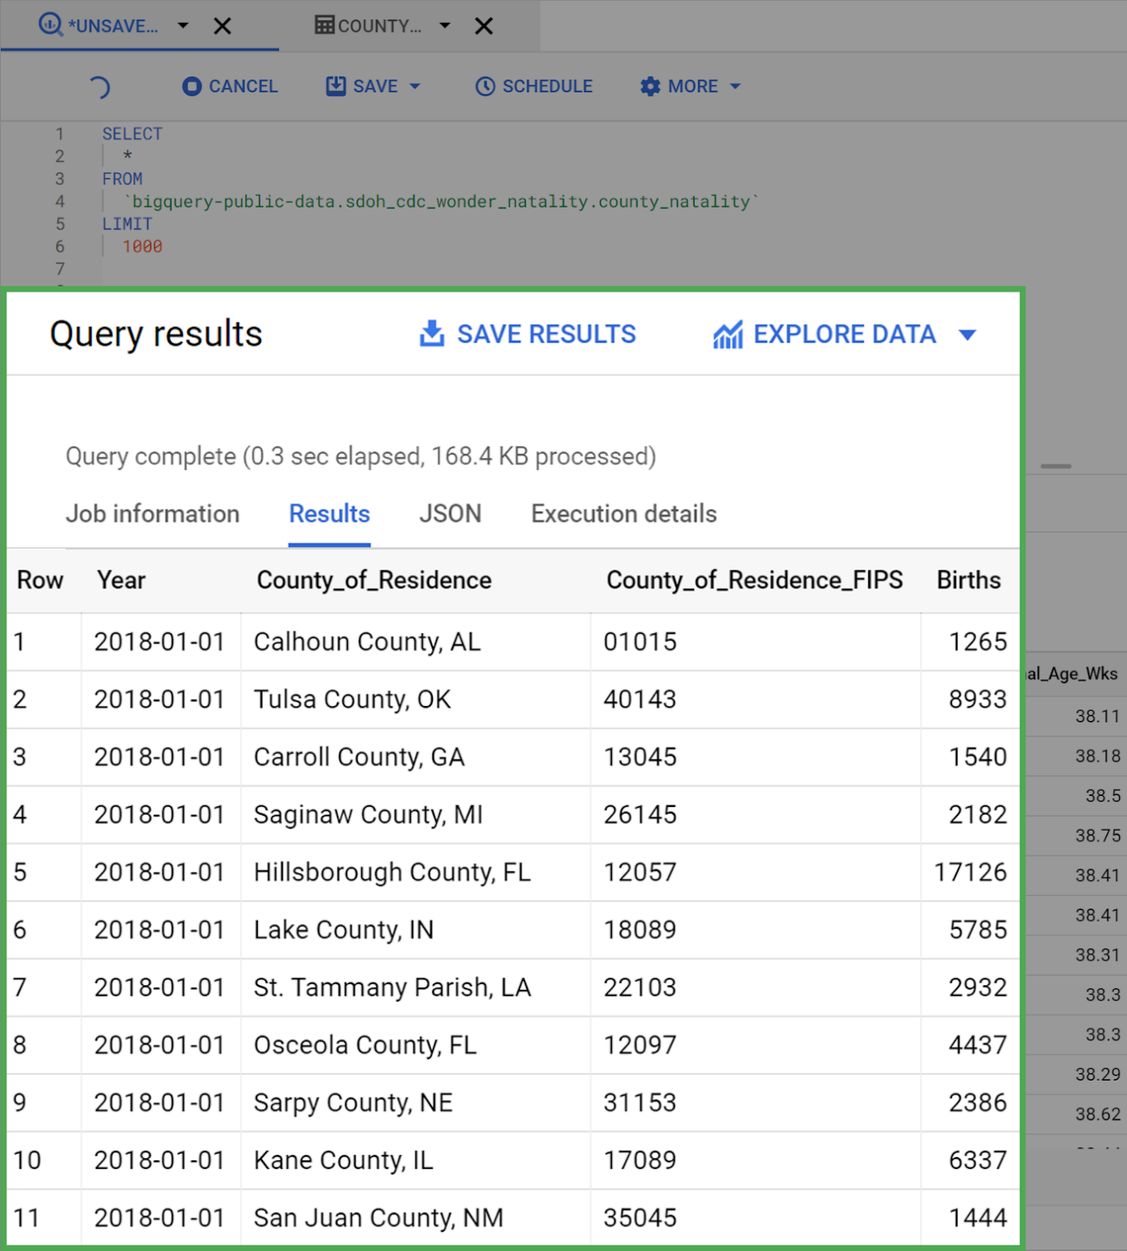

### **Use the ORDER BY clause**



Examine the dataset you just loaded. Take a moment to familiarize yourself with the columns and get a feel for what each can tell you.

Now, imagine you were asked by your manager to figure out which 10 counties had the lowest birth count for 2016-2018. You could accomplish this by modifying your query to use the ORDER BY clause.

Copy, paste, and run the following query:

1

2

3

4

5

6

7

8

SELECT

  \*

FROM

  `bigquery-public-data.sdoh\_cdc\_wonder\_natality.county\_natality`

ORDER BY

  Births

LIMIT

  10





The results of your query should appear like this:

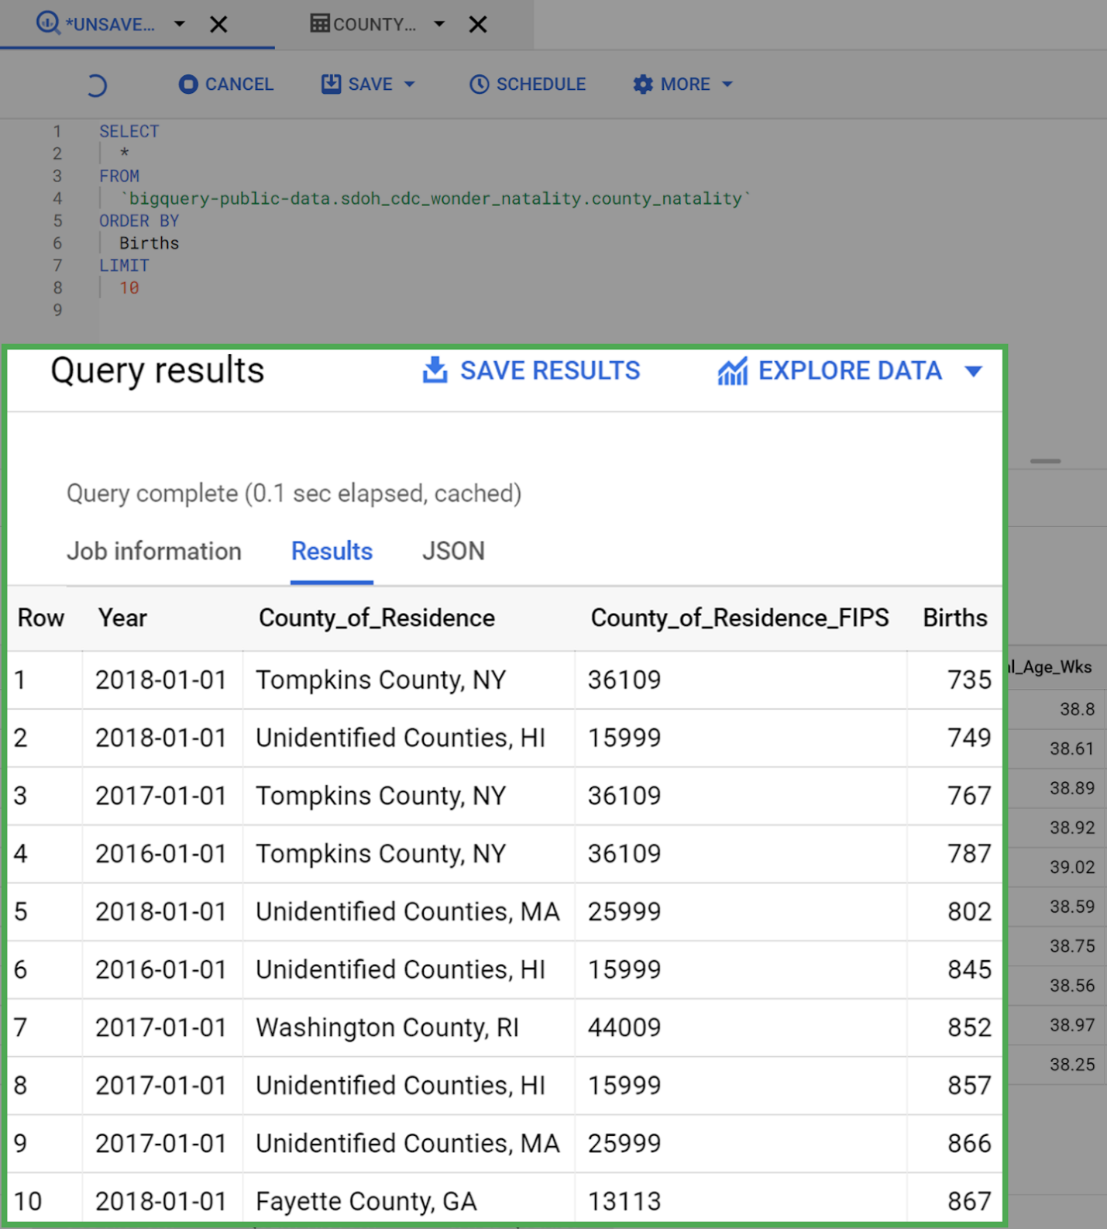

You may have noticed that the query did not specify whether it should be sorted **ASC** (ascending) or **DESC** (descending). When this is not specified, SQL defaults to sorting by ascending order. You can run another query to confirm this.

Copy, paste, and run the following query that includes ASC:

1

2

3

4

5

6

7

8

9

SELECT

  \*

FROM

  `bigquery-public-data.sdoh\_cdc\_wonder\_natality.county\_natality`

ORDER BY

  Births

ASC

LIMIT

  10





You’ll find that the results did not change. Notice that Tompkins County, NY, had just 735 births in 2018—the lowest birth count of any county in the US between 2016-2018.



### **Use DESC to reverse sorting order**



Now, modify the query to sort in the other direction, returning the top 10 counties with the highest yearly birth counts between 2016-2018.

Copy, paste, and run the following query:

1

2

3

4

5

6

7

8

9

SELECT

  \*

FROM

  `bigquery-public-data.sdoh\_cdc\_wonder\_natality.county\_natality`

ORDER BY

  Births

DESC

LIMIT

  10





Your results should appear like this:

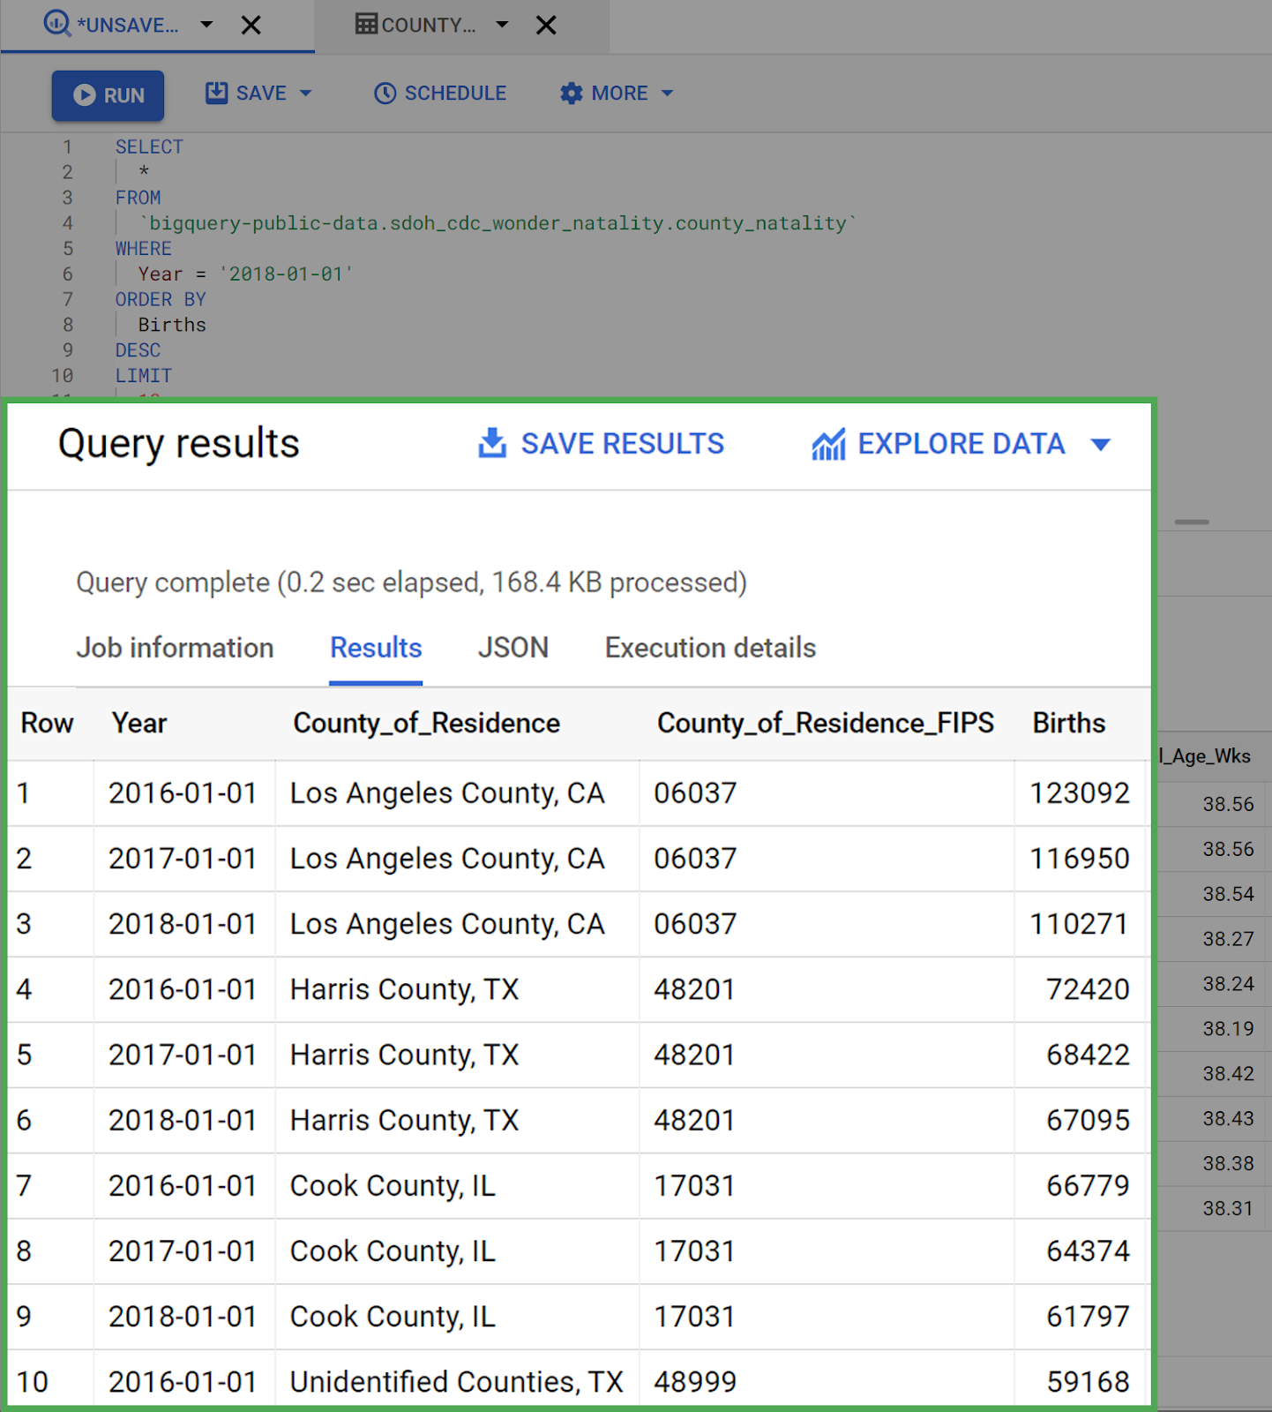

Now, the query returns the 10 rows with the largest values in the Birth column. Los Angeles County takes up the top three spots.

### **Combine ORDER BY with WHERE clauses**



Next, modify the query so that it returns the top 10 counties with the highest birth counts for 2018 only. To do this, add a WHERE clause to the query that specifies only rows that have a Year value equal to 2018-01-01. Note how the ORDER BY clause comes after the WHERE clause. Copy, paste, and run the following query:

1

2

3

4

5

6

7

8

9

10

11

SELECT

  \*

FROM

  `bigquery-public-data.sdoh\_cdc\_wonder\_natality.county\_natality`

WHERE

  Year = '2018-01-01'

ORDER BY

  Births

DESC

LIMIT

  10





Your results should appear something like this:

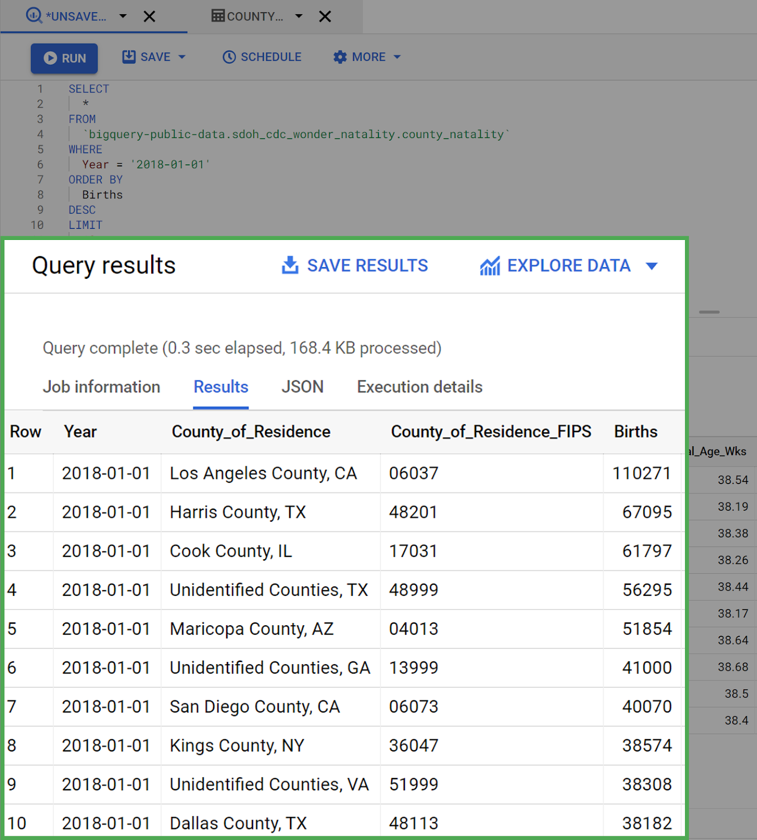

The query worked! You successfully used both ORDER BY and WHERE clauses in the same query.

## Hands-On Activity: Analyze weather data in BigQuery

**Total points**2

### 1.

**Question 1**



## Activity overview



Previously, you learned how to use BigQuery to clean data and prepare it for analysis. Now you will query a dataset and save the results into a new table. This is a useful skill when the original data source changes continuously and you need to preserve a specific dataset for continued analysis. It’s also valuable when you are dealing with a large dataset and know you’ll be doing more than one analysis using the same subset of data.

In this scenario, you’re a data analyst at a local news station. You have been tasked with answering questions for meteorologists about the weather. You will work with public data from the National Oceanic and Atmospheric Administration (NOAA), which has data for the entire United States. This is why you will need to save a subset of the data in a separate table.

By the time you complete this activity, you will be able to use SQL queries to create new tables when dealing with complex datasets. This will greatly simplify your analysis in the future.

## Access the public dataset



For this activity you will need the NOAA weather data from BigQuery’s public datasets.

1. Click on the **+ ADD DATA** button in the **Explorer menu** **pane** and select **Explore public datasets.** This will open a new menu where you can search public datasets that are already available through Google Cloud. If you have already loaded the BigQuery public datasets into your console, you can just search noaa\_gsod in your Explorer menu and skip these steps.

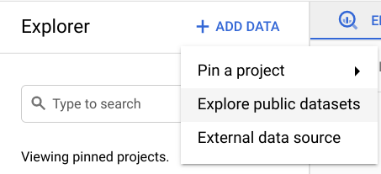

2. Type **noaa\_gsod** into the search bar. You’ll find the GSOD of Global Surface Summary of the Day Weather Data.

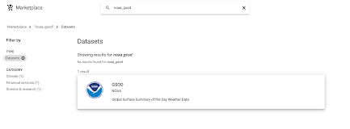

3. Click the GSOD dataset to open it. This will provide you with more detailed information about the dataset if you’re interested. **Click VIEW DATASET** to open this dataset in your console.

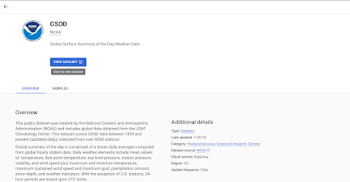

4. Search **noaa\_gsod** in your **Explorer menu pane** to find the dataset. **Click the dropdown menu** to explore the tables in this dataset. Scroll down to **gsod2020** and **open the table menu by clicking the three vertical dots.**

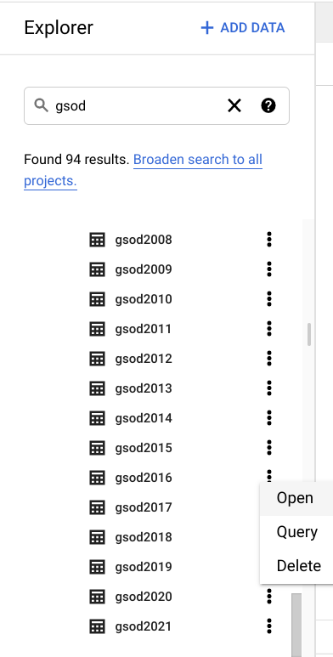

5. **Check the table’s schema and preview it** to get familiar with the data. Once you’re ready, you can **click COMPOSE NEW QUERY** to start querying the dataset.

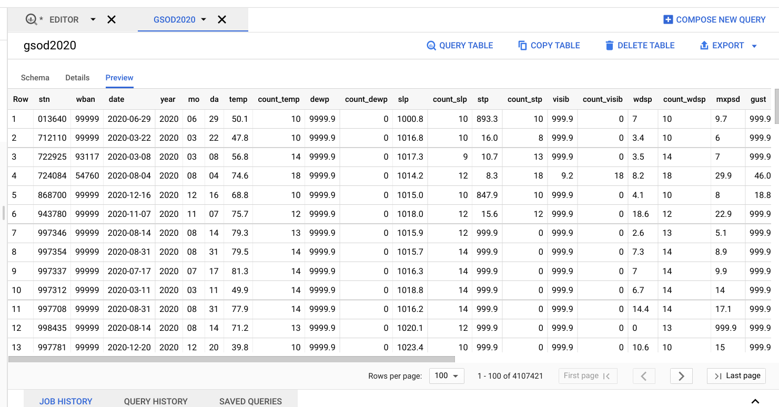

## Querying the data



The meteorologists who you’re working with have asked you to get the temperature, wind speed, and precipitation for stations La Guardia and JFK, for every day in 2020, in descending order by date, and ascending order by Station ID. Use the following query to request this information:

**SELECT   stn,**

**date,   -- Use the IF function to replace 9999.9 values, which the dataset description explains is the default value when temperature is missing, with NULLs instead.       IF(**

**temp=9999.9,         NULL,         temp) AS temperature,**

**-- Use the IF function to replace 999.9 values, which the dataset description explains is the default value when wind speed is missing, with NULLs instead.       IF(**

**wdsp="999.9",         NULL,         CAST(wdsp AS Float64)) AS wind\_speed,**

**-- Use the IF function to replace 99.99 values, which the dataset description explains is the default value when precipitation is missing, with NULLs instead.     IF(**

**prcp=99.99,       0,       prcp) AS precipitation FROM   `bigquery-public-data.noaa\_gsod.gsod2020` WHERE   stn="725030" -- La Guardia**

**OR stn="744860" -- JFK ORDER BY   date DESC,   stn ASC**

The meteorologists also asked you a couple questions while they were preparing for the nightly news: They want the average temperature in June 2020 and the average wind\_speed in December 2020.

Instead of rewriting similar, but slightly different, queries over and over again, there is an easier approach: Save the results from the original query as a table for future queries.

## Save a new table



In order to make this subset of data easier to query from, you can save the table from the weather data into a new dataset.

1. From your **Explorer** pane, **click the three vertical dots** next to your project and **select Create dataset.** You can name this dataset demos and leave the rest of the default options. **Click CREATE DATASET.**

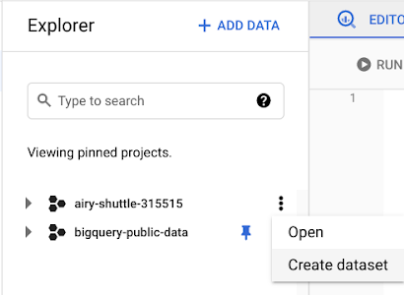

2. Open your new dataset and select **COMPOSE NEW QUERY**. Input the following query to get the average temperature, wind speed, visibility, wind gust, precipitation, and snow depth La Guardia and JFK stations for every day in 2020, in descending order by date, and ascending order by Station ID:

SELECT   stn,

  date,   -- Use the IF function to replace 9999.9 values, which the dataset description explains is the default value when temperature is missing, with NULLs instead.       IF(

        temp=9999.9,         NULL,         temp) AS temperature,

  -- Use the IF function to replace 999.9 values, which the dataset description explains is the default value when wind speed is missing, with NULLs instead. **IF(**

**wdsp="999.9",         NULL,         CAST(wdsp AS Float64)) AS wind\_speed,**

**-- Use the IF function to replace 99.99 values, which the dataset description explains is the default value when precipitation is missing, with NULLs instead.     IF(**

**prcp=99.99,       0,       prcp) AS precipitation FROM   `bigquery-public-data.noaa\_gsod.gsod2020` WHERE   stn="725030" -- La Guardia**

**OR stn="744860" -- JFK ORDER BY   date DESC,   stn ASC**

3. Before you run the query, s**elect the MORE menu** from the Query Editor and **open the Query Settings menu**. In the Query Settings menu, select **Set a destination table for query results**. Set the dataset option to **demos** and name the table **nyc\_weather**.

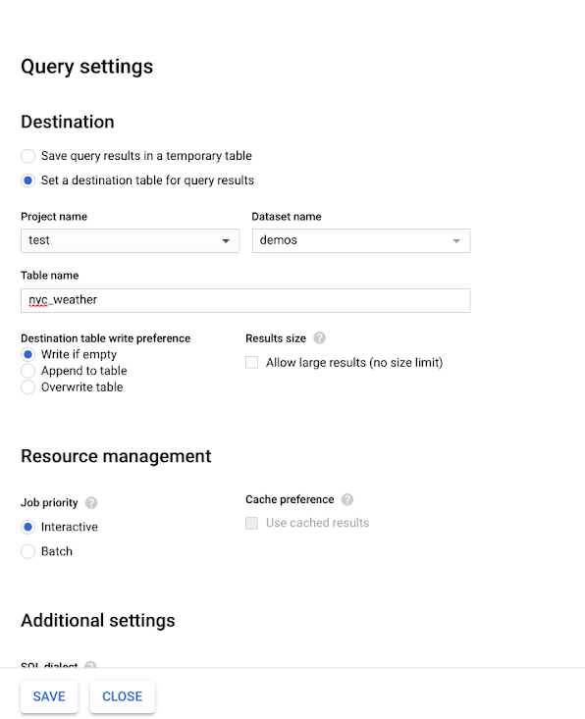

4. Run the query from earlier; now it will save as a new table in your demos dataset.

5. Return to the **Query settings menu** by using the **MORE dropdown menu**. Reset the settings to **Save query results in a temporary table**. This will prevent you from accidentally adding every query as a table to your new dataset.

## Query your new table



Now that you have the subset of this data saved in a new table, you can query it more easily. Use the following query to find the average temperature from the meteorologists first question:

**SELECT**

**AVG(temperature)**

**FROM**

**`airy-shuttle-315515.demos.nyc\_weather` --remember to change the project name to your project before running this query**

**WHERE**

**date BETWEEN '2020-06-01' AND '2020-06-30'**

You can also use this syntax to find the average wind\_speed or any other information from this subset of data you’re interested in. Try constructing a few more queries to answer the meteorologists’ questions!

The ability to save your results into a new table is a helpful trick when you know you're only interested in a subset of a larger complex dataset that you plan on querying multiple times, such as the weather data for just La Guardia and JFK. This also helps minimize errors during your analysis.

Converting data in spreadsheets

In this reading, you will learn about converting data from one format to another. One of the ways to help ensure that you have an accurate analysis of your data is by putting all of it in the correct format. This is true even if you have already cleaned and processed your data. As a part of getting your data ready for analysis, you will need to convert and format your data early on in the process.

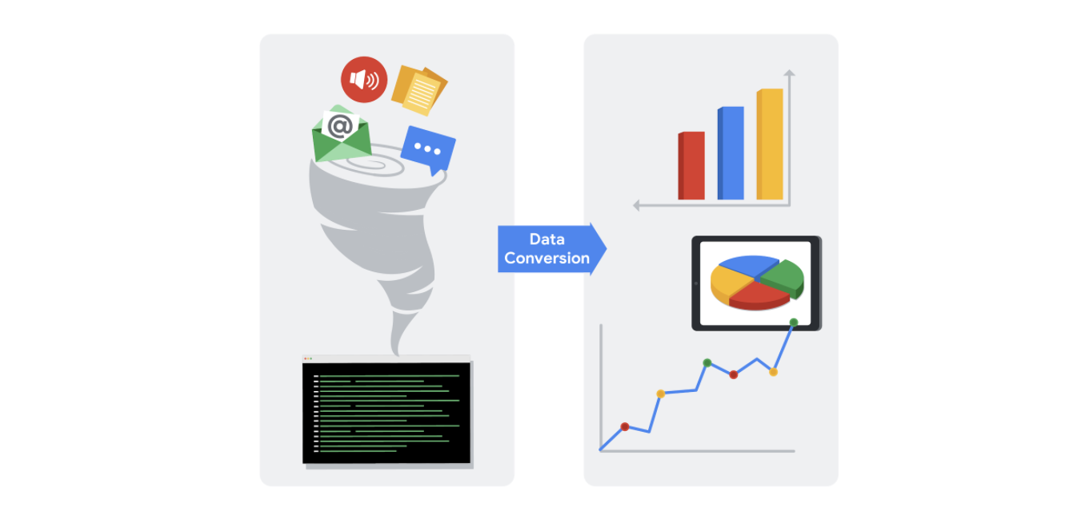

As a data analyst, there are lots of scenarios when you might need to convert data in a spreadsheet:

**String to date**

* [**How to convert text to date in Excel**](https://www.ablebits.com/office-addins-blog/2015/03/26/excel-convert-text-date/#:~:text=Excel%20DATEVALUE%20function%20%2D%20change%20text,Excel%20recognizes%20as%20a%20date.&text=So%2C%20the%20formula%20to%20convert,stored%20as%20a%20text%20string.): Transforming a series of numbers into dates is a common scenario you will encounter. This resource will help you learn how to use Excel functions to convert text and numbers to dates, and how to turn text strings into dates without a formula.
* [**Google Sheets: Change date format:**](https://www.ablebits.com/office-addins-blog/2019/08/13/google-sheets-change-date-format/) If you are working with Google Sheets, this resource will demonstrate how to convert your text strings to dates and how to apply the different date formats available in Google Sheets.

**String to numbers**

* [**How to convert text to number in Excel:**](https://www.ablebits.com/office-addins-blog/2018/07/18/excel-convert-text-to-number/) Even though you will have values in your spreadsheet that resemble numbers, they may not actually be numbers. This conversion is important because it will allow your numbers to add up and be used in formulas without errors in Excel.
* [**How to convert text to numbers in Google Sheets:**](https://productivityspot.com/convert-text-to-numbers-google-sheets/) This resource is useful if you are working in Google Sheets; it will demonstrate how to convert text strings to numbers in Google Sheets. It also includes multiple formulas you can apply to your own sheets, so you can find the method that works best for you.

**Combining columns**

* [**Convert text from two or more cells:**](https://support.microsoft.com/en-us/office/combine-text-from-two-or-more-cells-into-one-cell-81ba0946-ce78-42ed-b3c3-21340eb164a6) Sometimes you may need to merge text from two or more cells. This Microsoft Support page guides you through two distinct ways you can accomplish this task without losing or altering your data. It also includes a step-by-step video tutorial to help guide you through the process.
* [**How to split or combine cells in Google Sheets:**](https://www.techrepublic.com/article/how-to-split-or-combine-text-cells-with-google-sheets/) This guide will demonstrate how to to split or combine cells using Google Sheets specifically. If you are using Google Sheets, this is a useful resource to reference if you need to combine cells. It includes an example using real data.

**Number to percentage**

* [**Format numbers as percentages:**](https://support.microsoft.com/en-us/office/format-numbers-as-percentages-de49167b-d603-4450-bcaa-31fba6c7b6b4) Formatting numbers as percentages is a useful skill to have on any project. This Microsoft Support page will provide several techniques and tips for how to display your numbers as percentages.
* [**TO\_PERCENT:**](https://support.google.com/docs/answer/3094284?hl=en) This Google Sheets support page demonstrates how to use the TO\_PERCENT formula to convert numbers to percentages. It also includes links to other formulas that can help you convert strings.

**Pro tip:** Keep in mind that you may have lots of columns of data that require different formats. Consistency is key, and best practice is to make sure an entire column has the same format.

**Additional resources**

If you find yourself needing to convert other types of data, you can find resources on [**Microsoft Support**](https://support.microsoft.com/) for Excel or [**Google Docs Editor Help**](https://support.google.com/docs/?hl=en#topic=1382883) for Google Sheets.

Converting data is quick and easy, and the same functions can be used again and again. You can also keep these links bookmarked for future use, so you will always have them ready in case any of these issues arise. Now that you know how to convert data, you are on your way to becoming a successful data analyst.

**Hands-On Activity: Combine multiple pieces of data**

**Total points**2

**1.**

**Question 1**



Activity overview



In previous activities, you gained experience using spreadsheet functions for manipulating and cleaning data. In this activity, you’ll use the CONCAT and CONCATENATE functions to help you quickly and efficiently combine multiple pieces of raw data into new data.

By the time you complete this activity, you will be able to use these functions to combine data. This will enable you to simplify and condense data, which is important for processing and cleaning data in your career as a data analyst.



What you will need

To get started, you will need the CONCAT function exercise spreadsheet.

To use the template for the spreadsheet, click the link below and select “Use Template.”

Link to template: [CONCAT Function Exercise Spreadsheet](https://docs.google.com/spreadsheets/d/1Na9M4xb-3CA746BHECX75n3B9V04pxLo0xNs9i8jMNo/template/preview)

OR

If you don’t have a Google account, you can download the spreadsheet directly from the attachment below.

**Dataset for Project\_ CONCAT function**XLSX File

[Download file](https://d3c33hcgiwev3.cloudfront.net/s7PLxn9URlSzy8Z_VDZUqQ_90e1fe6271aa400cb7a05c5ba5c40a56_Dataset-for-Project_-CONCAT-function.xlsx?Expires=1648080000&Signature=CZkUg6s4xnqQVgvIPb8McCa2Pxl6nRLsN672RWEW6No6i-3YiQVaLq9-aU0nR5I8Df8nKJwsPum-ulre4gIsiTcW1iD3O3e4obP1xsBYCZxbdnC01IK~jhygHUH6o2QRWBETc3IzuDUamtmZ3NA9zc1GEieD0SOGVN0HZF-RA9U_&Key-Pair-Id=APKAJLTNE6QMUY6HBC5A" \t "_blank)



Using the CONCAT and CONCATENATE functions



Occasionally, you will encounter a dataset with data values in separate cells that you want to combine as a single value in a single cell. This is common when dealing with names and dates. The dataset may have separate columns for first names and last names, but you may want a column with the full names.

City/state and month/year combinations are also often desirable to have together, as they are likely to be recorded together.

The **CONCAT** function in spreadsheets can combine these kinds of data.

Combining data from two cells



First, using the spreadsheet you downloaded, you’ll combine the two sets of names in columns **First Name** and **Last Name** in a new column called **Full Name**.

To do this, follow these steps:

1. Click on cell **F2**. This is where you start the data for the new column. After you click on the cell, type **=CONCAT(A2,B2)** into the function bar and hit **Enter (Windows)** or **Return (Mac)**.

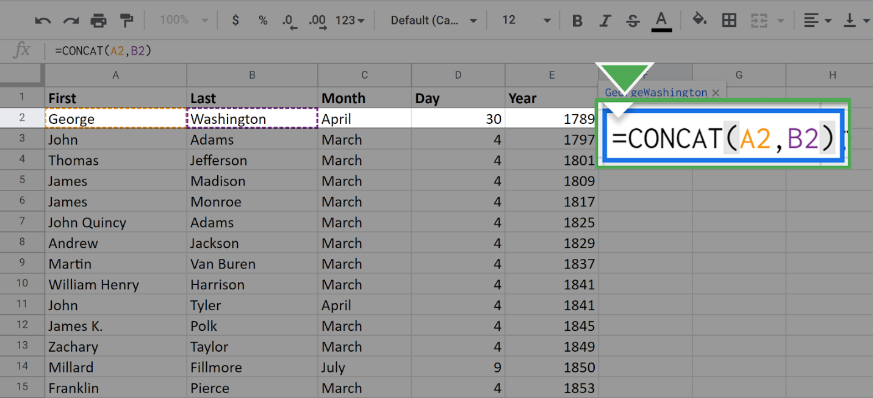

Once you press enter, the following data should appear in the cell:

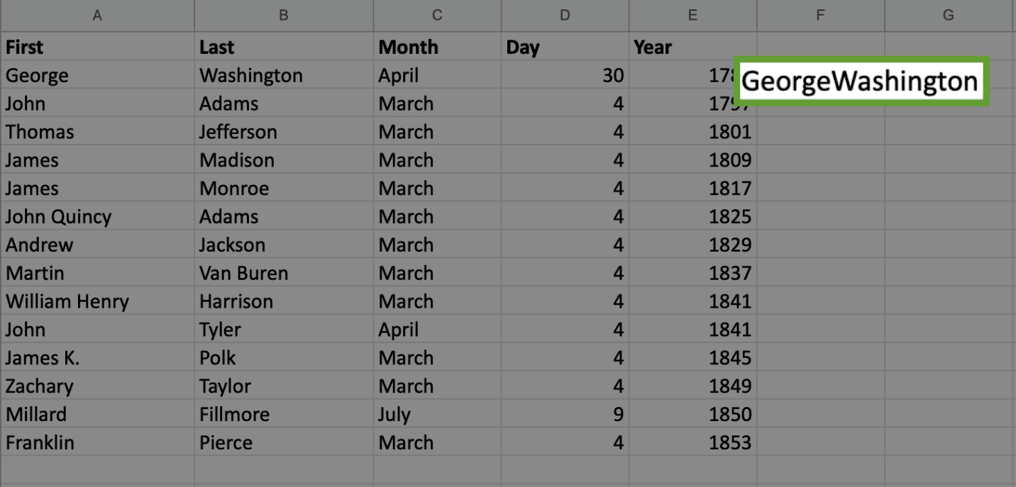

You have merged or, technically, **concatenated** the two data values from cells **A2** and **B2**. Because you listed A2 first in the CONCAT function argument, it comes first in the final result.

Notice that the two names were combined without a space between them.

If you want to put the space in between, you need to use the full **CONCATENATE** function, which allows you to combine multiple strings.

2. Click again on the cell **F2**. In the function call, place a space in quotes between **A2** and **B2** separated by commas.

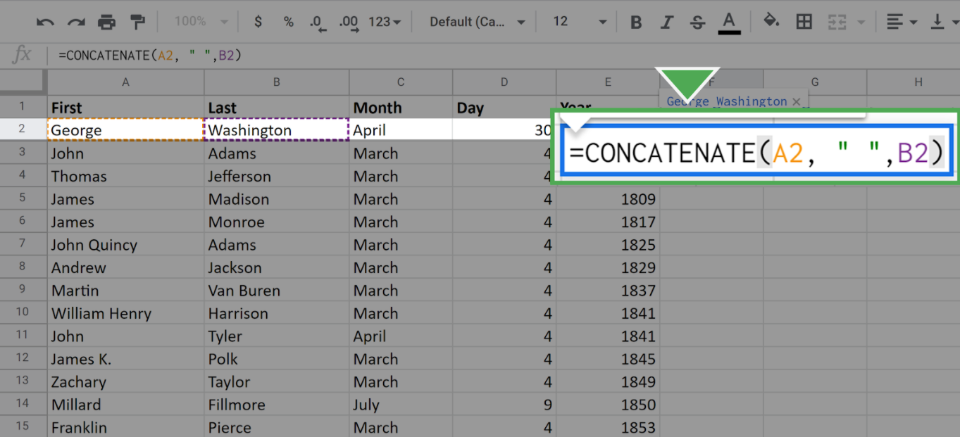

Once you press enter or return, your screen should appear like this:

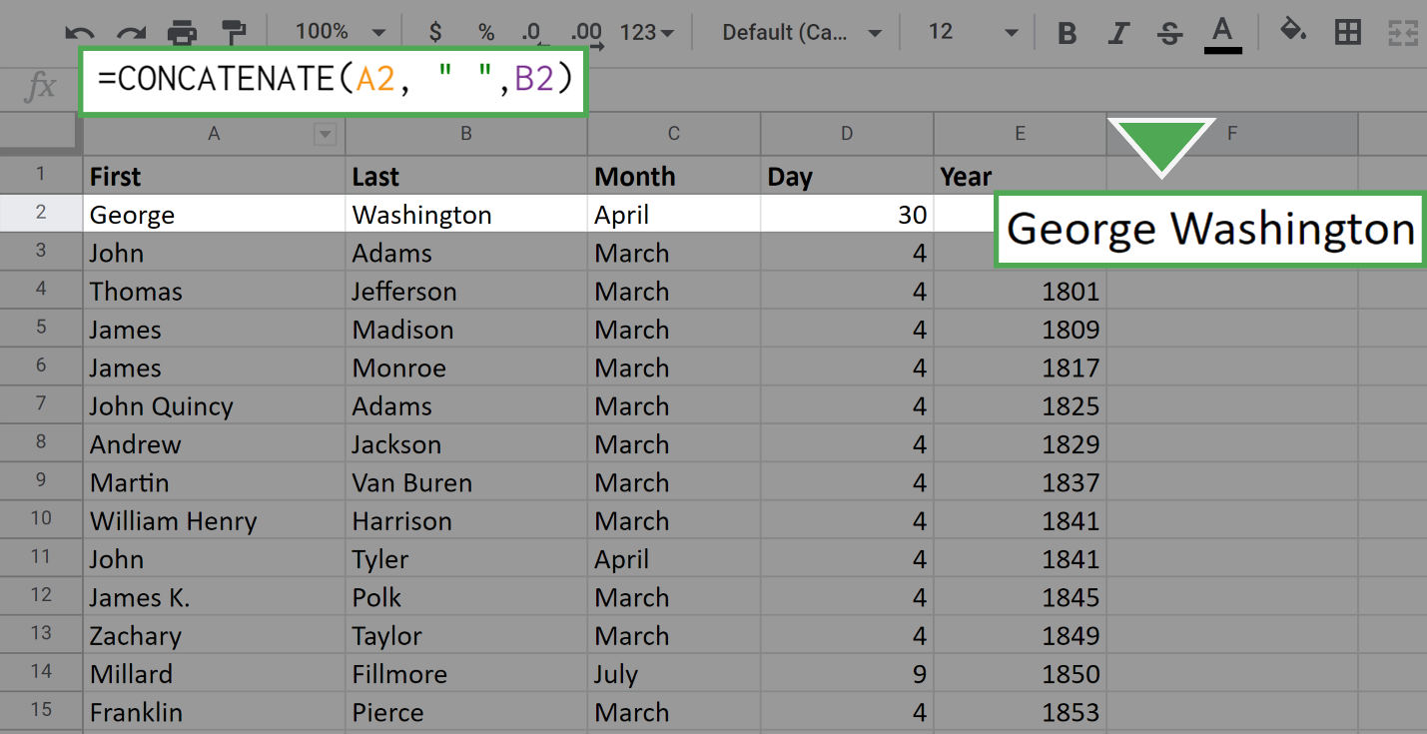

Now there is a space between the first name and the last name.

Next, repeat this process for all the remaining cells in **Column F**. Of course, you don't want to do this manually for each cell. (Especially if the dataset were larger, it would be laborious to do this cell-by-cell.) Luckily, you can fill out the data in the column by using your mouse.

1. Click on the cell **F2**. Locate the small square in the lower-right corner of the highlighted boundary of the cell.

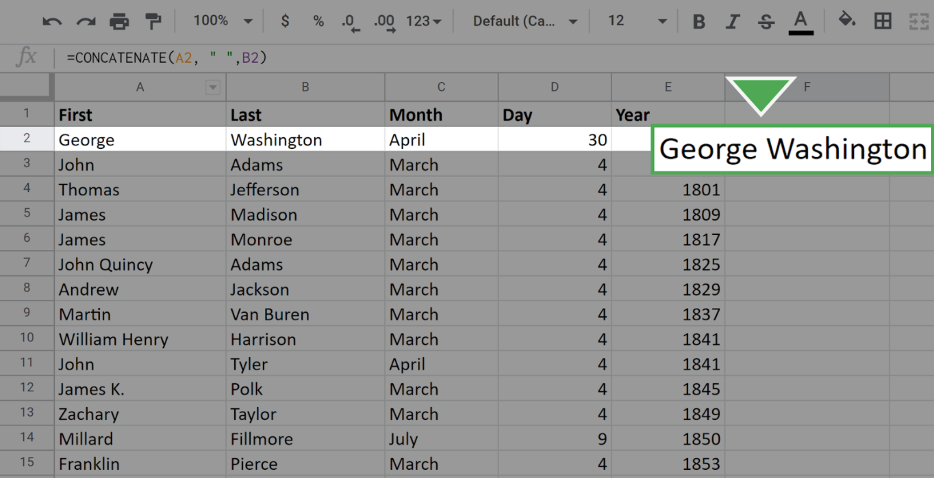

2. Click on this square, drag your mouse to the bottom of the column, and release. All the cells in the column should populate with the full name of the appropriate president.

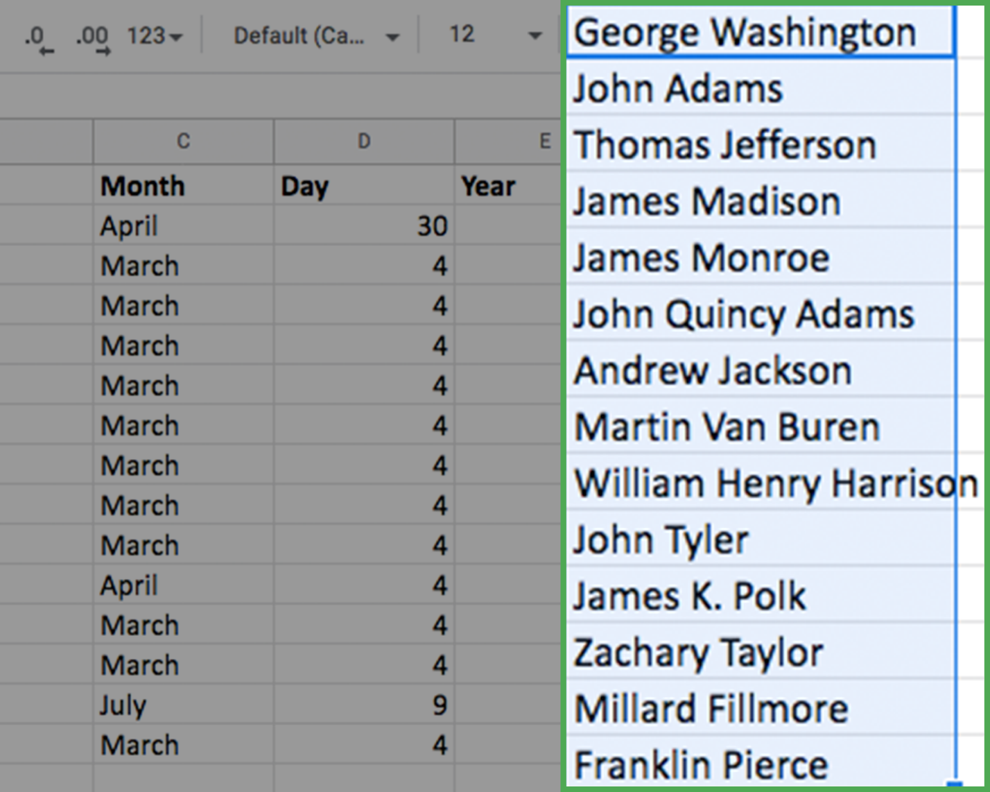

* Note: While it does not happen in this dataset, you may have extra spaces in your result after you CONCAT. If you notice you have extra spaces, you can use the TRIM function to remove them.

Combining data from three cells



The procedure for combining three pieces of data from different cells is almost identical to what you just did. The only difference is that you include a third cell in the full CONCATENATE argument.

Now, combine the month, day, and year into a single data value: **Date**. This will occupy column **G**.

1. Click on the cell where you would like the new data to start. Here, this is cell **G2**. 2. Enter the **CONCAT** command as **=CONCATENATE(C2," ",D2,", ",E2)**

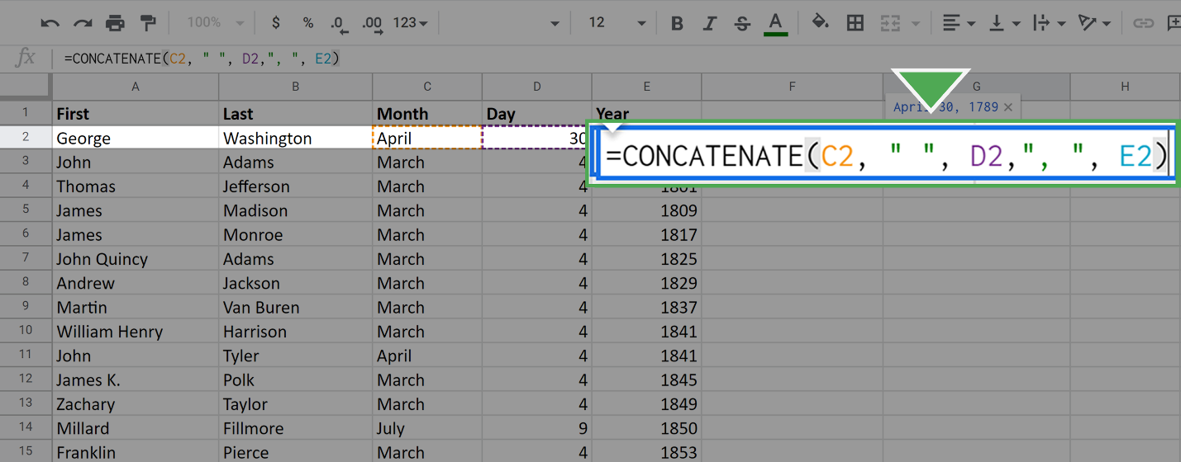

Pay particular attention to the extra strings you added between the month and the day, and between the day and the year. This is how you get the spaces and comma in your final result.

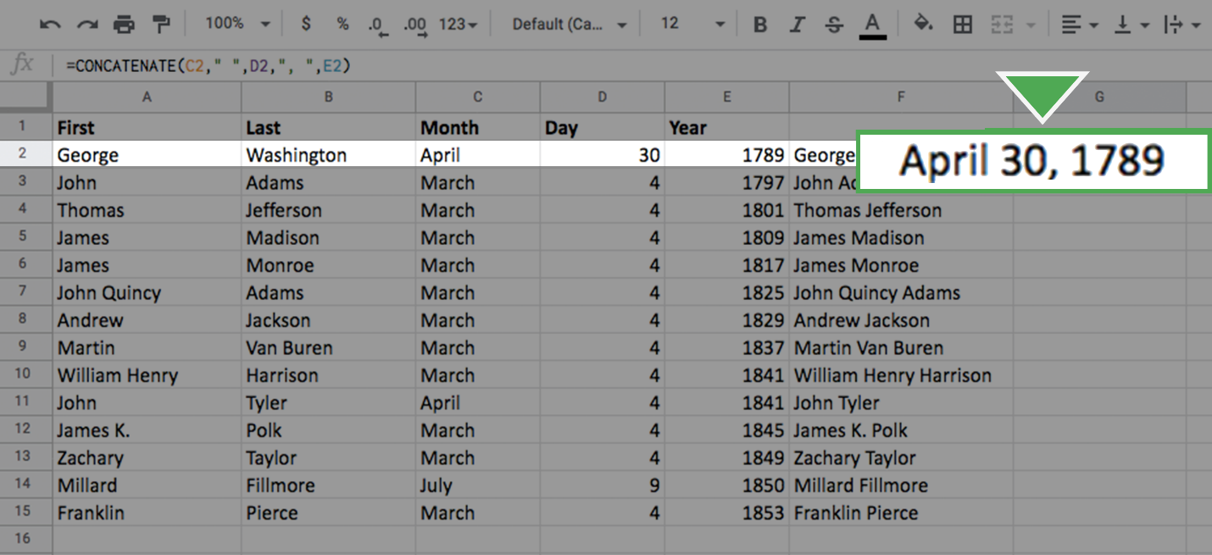

3. Fill out the rest of the column using the same click-and-drag technique as before. Your screen should appear like this:

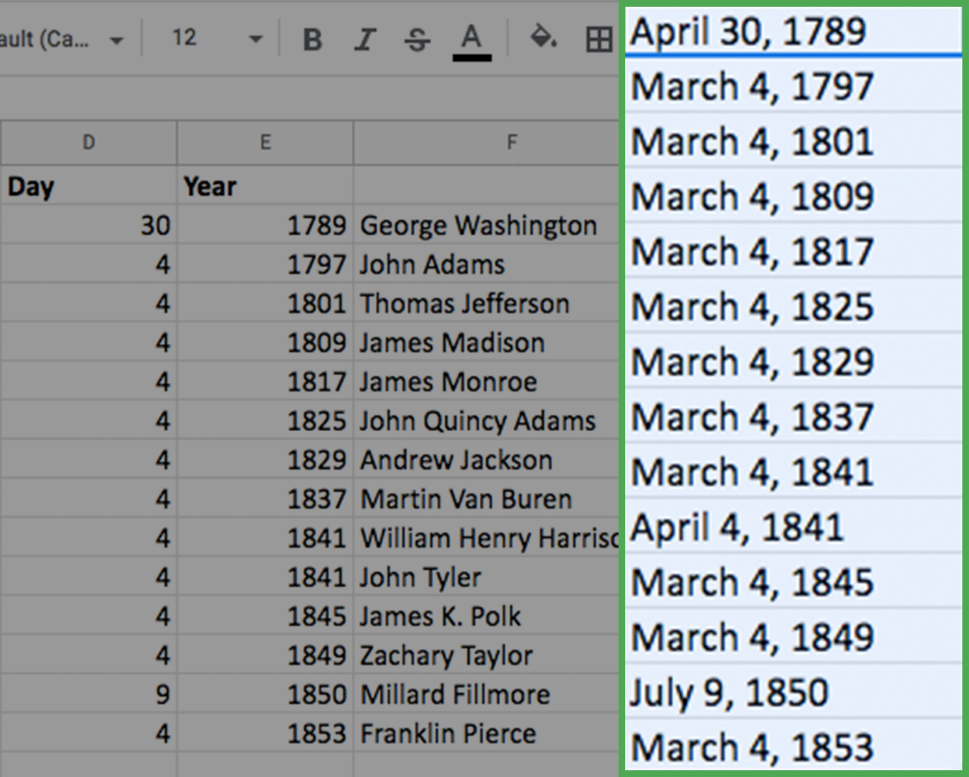

Congratulations! You’ve combined data in spreadsheets using the CONCAT and CONCATENATE functions.

Transforming data in SQL

Data analysts usually need to convert data from one format to another to complete an analysis. But what if you are using SQL rather than a spreadsheet? Just like spreadsheets, SQL uses standard rules to convert one type of data to another. If you are wondering why data transformation is an important skill to have as a data analyst, think of it like being a driver who is able to change a flat tire. Being able to convert data to the right format speeds you along in your analysis. You don’t have to wait for someone else to convert the data for you.



In this reading, you will go over the conversions that can be done using the **CAST** function. There are also more specialized functions like **COERCION** to work with big numbers, and **UNIX\_DATE** to work with dates. **UNIX\_DATE** returns the number of days that have passed since January 1, 1970 and is used to compare and work with dates across multiple time zones. You will likely use **CAST** most often.

**Common conversions**

The following table summarizes some of the more common conversions made with the **CAST** function. Refer to [Conversion Rules in Standard SQL](https://cloud.google.com/bigquery/docs/reference/standard-sql/conversion_rules) for a full list of functions and associated rules.

| **Starting with** | **CAST function can convert to:** |
| --- | --- |
| Numeric (number) | - Integer - Numeric (number) - Big number - Floating integer - String |
| String | - Boolean - Integer - Numeric (number) - Big number - Floating integer - String - Bytes - Date - Date time - Time - Timestamp |
| Date | - String - Date - Date time - Timestamp |

**The CAST function (syntax and examples)**

**CAST** is an American National Standards Institute (ANSI) function used in lots of programming languages, including BigQuery. This section provides the BigQuery syntax and examples of converting the data types in the first column of the previous table. The syntax for the CAST function is as follows:

CAST (expression AS typename)

Where **expression** is the data to be converted and **typename** is the data type to be returned.

**Converting a number to a string**

The following **CAST** statement returns a string from a numeric identified by the variable MyCount in the table called MyTable.

SELECT CAST (MyCount AS STRING) FROM MyTable

In the above SQL statement, the following occurs:

* **SELECT** indicates that you will be selecting data from a table
* **CAST** indicates that you will be converting the data you select to a different data type
* **AS** comes before and identifies the data type which you are casting to
* **STRING** indicates that you are converting the data to a string
* **FROM** indicates which table you are selecting the data from

**Converting a string to a number**

The following **CAST** statement returns an integer from a string identified by the variable MyVarcharCol in the table called MyTable. (An integer is any whole number.)

SELECT CAST(MyVarcharCol AS INT) FROM MyTable

In the above SQL statement, the following occurs:

* **SELECT** indicates that you will be selecting data from a table
* **CAST** indicates that you will be converting the data you select to a different data type
* **AS** comes before and identifies the data type which you are casting to
* **INT** indicates that you are converting the data to an integer
* **FROM** indicates which table you are selecting the data from

**Converting a date to a string**

The following **CAST** statement returns a string from a date identified by the variable MyDate in the table called MyTable.



In the above SQL statement, the following occurs:

* **SELECT** indicates that you will be selecting data from a table
* **CAST** indicates that you will be converting the data you select to a different data type
* **AS** comes before and identifies the data type which you are casting to
* **STRING** indicates that you are converting the data to a string
* **FROM** indicates which table you are selecting the data from

**Converting a date to a datetime**

Datetime values have the format of YYYY-MM-DD hh: mm: ss format, so date and time are retained together. The following **CAST** statement returns a datetime value from a date.



In the above SQL statement, the following occurs:

* **SELECT** indicates that you will be selecting data from a table
* **CAST** indicates that you will be converting the data you select to a different data type
* **AS** comes before and identifies the data type which you are casting to
* **DATETIME** indicates that you are converting the data to a datetime value
* **FROM** indicates which table you are selecting the data from

**The SAFE\_CAST function**

Using the **CAST** function in a query that fails returns an error in BigQuery. To avoid errors in the event of a failed query, use the **SAFE\_CAST** function instead. The **SAFE\_CAST** function returns a value of Null instead of an error when a query fails.

The syntax for **SAFE\_CAST** is the same as for **CAST**. Simply substitute the function directly in your queries. The following **SAFE\_CAST** statement returns a string from a date.

SELECT SAFE\_CAST (MyDate AS STRING) FROM MyTable

**More information**

Browse these resources for more information about data conversion using other SQL dialects (instead of BigQuery):

* [CAST and CONVERT](https://docs.microsoft.com/en-us/sql/t-sql/functions/cast-and-convert-transact-sql?view=sql-server-ver15): SQL Server reference documentation
* [MySQL CAST Functions and Operators](https://dev.mysql.com/doc/refman/8.0/en/cast-functions.html): MySQL reference documentation
* [How to: SQL Type Casting](https://www.blendo.co/blog/how-to-sql-type-casting/): Blog about type casting that has links to other SQL short guides

# Optional: Prepare to use the bike sharing dataset in BigQuery

The next video demonstrates how to use CONCAT in a SQL query to return data from two columns in a single column.

If you would like to follow along with the instructor, you will need to log in to your BigQuery account to use the open (public) dataset called **new\_york\_citibike**. If you need a refresher, the reading [Using BigQuery](https://www.coursera.org/learn/data-preparation/supplement/DYOQK/using-bigquery) in the **Prepare Data for Exploration** course explains how to set up a BigQuery account.

## Prepare for the next video

**Step 1:** In the BigQuery Explorer, enter **citibike** in the search bar to locate the **new\_york\_citibike** dataset under **bigquery-public-data**.

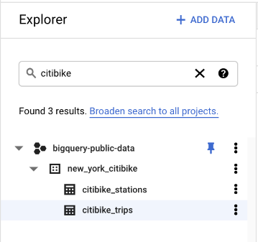

**Step 2:** Click the **citibike\_trips** table, then click the **Preview** tab to view the data in the table.

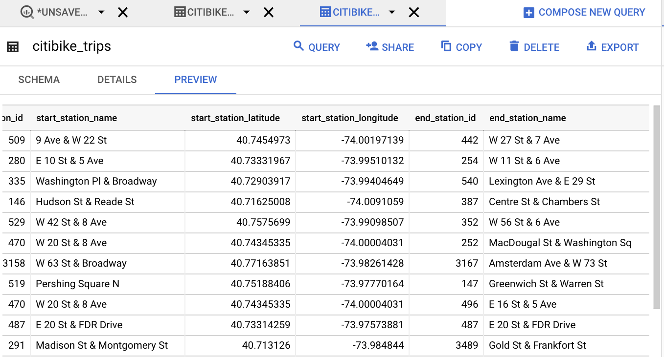

## What to expect from the query

You will be using CONCAT to combine the data in the **start\_station\_name** column with the data in the **end\_station\_name** column to create the route information in another column; for example, the route from Station 509 to Station 442 in the first row of the table above would be **9 Ave & W 22 St to W 27 St & 7 Ave**,a combination of the start and end station names.

Manipulating strings in SQL

Knowing how to convert and manipulate your data for an accurate analysis is an important part of a data analyst’s job. In this reading, you will learn about different SQL functions and their usage, especially regarding string combinations.

A **string** is a set of characters that helps to declare the texts in programming languages such as SQL. SQL string functions are used to obtain various information about the characters, or in this case, manipulate them. One such function, **CONCAT**, is commonly used. Review the table below to learn more about the CONCAT function and its variations.

| **Function** | **Usage** | **Example** |
| --- | --- | --- |
| CONCAT | A function that adds strings together to create new text strings that can be used as unique keys | CONCAT (‘Google’, ‘.com’); |
| CONCAT\_WS | A function that adds two or more strings together with a separator | CONCAT\_WS (‘ . ’, ‘www’, ‘google’, ‘com’) \*The separator (being the period) gets input before and after Google when you run the SQL function |
| CONCAT with + | Adds two or more strings together using the + operator | ‘Google’ + ‘.com’ |

**CONCAT at work**

When adding two strings together such as ‘Data’ and ‘analysis’, it will be input like this:

* SELECT CONCAT (‘Data’, ‘analysis’);

The result will be:

* Dataanalysis

Sometimes, depending on the strings, you will need to add a space character, so your function should actually be:

* SELECT CONCAT (‘Data’, ‘  ‘, ‘analysis’);

And the result will be:

* Data analysis

The same rule applies when combining three strings together. For example,

* SELECT CONCAT (‘Data’,’ ‘, ‘analysis’, ‘ ‘, ‘is’, ‘ ‘, ‘awesome!’);

And the result will be

* Data analysis is awesome!

**Practice makes perfect**

W3 Schools is an excellent resource for interactive SQL learning, and the following links will guide you through transforming your data using SQL:

* [SQL functions](https://www.w3schools.com/sql/sql_ref_sqlserver.asp): This is a comprehensive list of functions to get you started. Click on each function, where you will learn about the definition, usage, examples, and even be able to create and run your own query for practice. Try it out for yourself!
* [SQL Keywords](https://www.w3schools.com/sql/sql_ref_keywords.asp): This is a helpful SQL keywords reference to bookmark as you increase your knowledge of SQL. This list of keywords are reserved words that you will use as your need to perform different operations in the database grows.
* While this reading went through the basics of each of these functions, there is still more to learn, and you can even combine your own strings.

1. Practice using [CONCAT](https://www.w3schools.com/sql/func_sqlserver_concat.asp)
2. Practice using [CONCAT WS](https://www.w3schools.com/sql/func_sqlserver_concat_ws.asp)
3. Practice using [CONCAT with +](https://www.w3schools.com/sql/func_sqlserver_concat_with_plus.asp)

**Pro tip**: The functions presented in the resources above may be applied in slightly different ways depending on the database that you are using (e.g. mySQL versus SQL Server). But, the general description provided for each function will prepare you to customize how you use these functions as needed.

Learning Log: A data analysis checklist



**Overview**



By now, you’ve already learned a lot about the steps involved in analyzing data. As you begin your career as a data analyst, you’ll need to analyze a lot of it! In this learning log entry, you’ll start developing a data analysis checklist. This will help you stay organized during your analysis, even when you have a lot of data to deal with in the future.

**Create your checklist**



In the learning log template linked below, start a checklist of tasks you need to complete during analysis using the steps you have already learned: **Ask, Prepare, Process, Analyze, Share** and **Act**. This way, you can always remember what you need to do and in what order. As your projects get more complicated, you can add to and adapt your checklist to fit any situation.

For now, your checklist can be a high-level overview of the steps you need to take to complete your analysis; for example, you might include “clean the data” as a high-level task under the Process stage. You will return to your checklist again later in this course to add more detail and finish creating your checklist. You can also continue adding to this checklist whenever you have new ideas for it!



**Access your learning log**

To use the template for this course item, click the link below and select “Use Template.”

Link to learning log template: [Start a data analysis checklist](https://docs.google.com/document/d/1kGV1lHh6Exnx6cLQfMyhG9nv6JXEMDvgJb_X_54_Y0o/template/preview?resourcekey=0-4VRGOrEcbl6PBMdZoZ7Fnw)

OR

If you don’t have a Google account, you can download the template directly from the attachment below.

**Learning Log Template\_ Start a data analysis checklist**DOCX File

[Download file](https://d3c33hcgiwev3.cloudfront.net/48aZsxEzR2eGmbMRMydnnw_d837711d1aa8433eb9983f4c51c24ec1_Learning-Log-Template_-Start-a-data-analysis-checklist.docx?Expires=1648080000&Signature=Zmfi4Km1GnSCVsyvvZGLIJDeogqr8S~o2i8tRHRYmAb7k3WM5lKT7rpZJaJAr0kbsSyDemDyFnhIFr~ecjkUnXUKLbBsrWzeHrap3mwkibl3HXGCDsCZUrNws~SYLabN6Y4m4IWqGy-gpqIzLqtH~iGYDPSgr9UmVJ7R02xWEIQ_&Key-Pair-Id=APKAJLTNE6QMUY6HBC5A" \t "_blank)



**Reflection**



When you’re finished, think about the process of creating your checklist. Write 3-5 sentences (60-100 words) in your learning log answering the following questions:

* Did making a checklist help you better understand the data analysis process?
* How can you adapt your checklist to fit each new project?

When you’ve finished your entry in the learning log template, make sure to save the document so your response is somewhere accessible. This will help you continue applying data analysis to your everyday life. You will also be able to track your progress and growth as a data analyst.

Advanced spreadsheet tips and tricks

Like a lot of the things you’re learning in this program, spreadsheets will get easier the more you practice. This reading provides you with a list of resources that may help advance your knowledge and experience with spreadsheet functions and functionality. The goal is to provide you with access to a variety of advanced tips and tricks that will help make you more efficient and effective when working with spreadsheets to perform data analysis. Review the description of each resource below, click the links to learn more, and save or bookmark any links that are useful to you. You can immediately start practicing anything that you learn to increase the chances of your understanding and to build your familiarity with spreadsheets. This reading provides a range of resources, so feel free to explore the ones that are applicable to you and skip the ones that aren’t.

**Google Sheets**

* [**Keyboard shortcuts for Google Sheets:**](https://support.google.com/docs/answer/181110)This is a great resource for quickly learning a range of keyboard shortcuts that can make regular tasks quicker and easier, like navigating your spreadsheet or accessing formulas and functions. This list contains shortcuts for the desktop and mobile versions of Google Sheets so that you can apply them to your work no matter what device you are using.
* [**L​ist of Google Sheets functions**](https://support.google.com/docs/table/25273?hl=en)**:** This is a comprehensive list of the Google Sheets functions and syntax. Each function is listed with a link to learn more.
* [**2​0 Google Sheets Formulas You Must Know:**](https://automate.io/blog/google-spreadsheet-formulas/)This blog article summarizes and describes 20 of the most useful Google Sheets formulas.
* [**18 Google Sheets Formula Tips and Techniques:**](https://www.benlcollins.com/spreadsheets/google-sheets-formulas-techniques/) These are tips for using Google Sheets shortcuts when working with formulas.

**Excel**

* [**Keyboard shortcuts in Excel:**](https://support.microsoft.com/en-us/office/keyboard-shortcuts-in-excel-1798d9d5-842a-42b8-9c99-9b7213f0040f?ui=en-US&rs=en-US&ad=US)Earlier in this list, you were provided with a resource for keyboard shortcuts in Google Sheets. Similarly, this resource provides a list of keyboard shortcuts in Excel that will make performing regular spreadsheet tasks more efficient. This includes keyboard shortcuts for both desktop and mobile versions of Excel, so you can apply them no matter what platform you are working on.
* [**222 Excel shortcuts:**](https://exceljet.net/keyboard-shortcuts)A compilation of shortcuts includes links to more detailed explanations about how to use them. This is a great way to quickly reference keyboard shortcuts. The list has been organized by functionality, so you can go directly to the sections that are most useful to you.
* [**List of spreadsheet functions:**](https://exceljet.net/excel-functions)This is a comprehensive list of Excel spreadsheet functions with links to more detailed explanations. This is a useful resource to save so that you can reference it often; that way, you’ll have access to functions and examples that you can apply to your work.
* [**List of spreadsheet formulas:**](https://exceljet.net/formulas)Similar to the previous resource, this comprehensive list of Excel spreadsheet formulas with links to more detailed explanations and can be saved and referenced any time you need to check out a formula for your analysis.
* [**Essential Excel Skills for Analyzing Data:**](https://learntocodewith.me/posts/excel-skills/)This blog post includes more advanced functionalities of some spreadsheet tools that you have previously learned about, like pivot tables and conditional formatting. These skills have been identified as particularly useful for data analysis. Each section includes a how-to video that will take you through the process of using these functions step-by-step, so that you can apply them to your own analysis.
* [**Advanced Spreadsheet Skills:**](https://www.slideshare.net/markjhonoxillo/advanced-spreadsheet-skills)Mark Jhon C. Oxillo’s presentation starts with a basic overview of spreadsheet but also includes advanced functions and exercises to help you apply formulas to actual data in Excel. This is a great way to review some basic concepts and practice the skills you have been learning so far.

There are lots of resources online about advanced spreadsheet tips and tricks. You'll probably discover new resources and tools on your own, but this list is a great starting point as you become more familiar with spreadsheets.



**Self-Reflection: Stack Overflow**

**Total points**1

**1.**

**Question 1**



Overview



Now that you are learning how to convert and format  data for analysis, you can pause for a moment and think about what you are learning. In this self-reflection, you will consider how you can seek help while you learn, then respond to brief questions.

This self-reflection will help you develop insights into your own learning and prepare you to ask the data analytics community on Stack Overflow about what you’re learning. As you answer questions—and come up with questions of your own—you will consider concepts, practices, and principles to help refine your understanding and reinforce your learning. You’ve done the hard work, so make sure to get the most out of it: This reflection will help your knowledge stick!

Seeking help on Stack Overflow



**Stack Overflow** is an online platform where programmers ask code-related questions and peers are available to suggest answers. You can ask questions about programming languages such as SQL and R (which you will learn about in Course 7), data tools, and much more. Follow the steps below to get started on Stack Overflow.

Sign up for an account



To sign up for [Stack Overflow](https://stackoverflow.com/):

1. Click on the **Sign up** button in the upper right corner



2. Follow the on-screen prompts to enter your desired login information.

3. Click the **Sign up** button.



Explore Stack Overflow



From the home page, click the dropdown in the upper left corner and click **Questions**.



The Questions page provides different categories of questions for you to choose. Some examples include the “Newest” and “Active” categories. Read some of the questions under the different categories.

Tags will help you find questions. On the left pane, click on **Tags**.

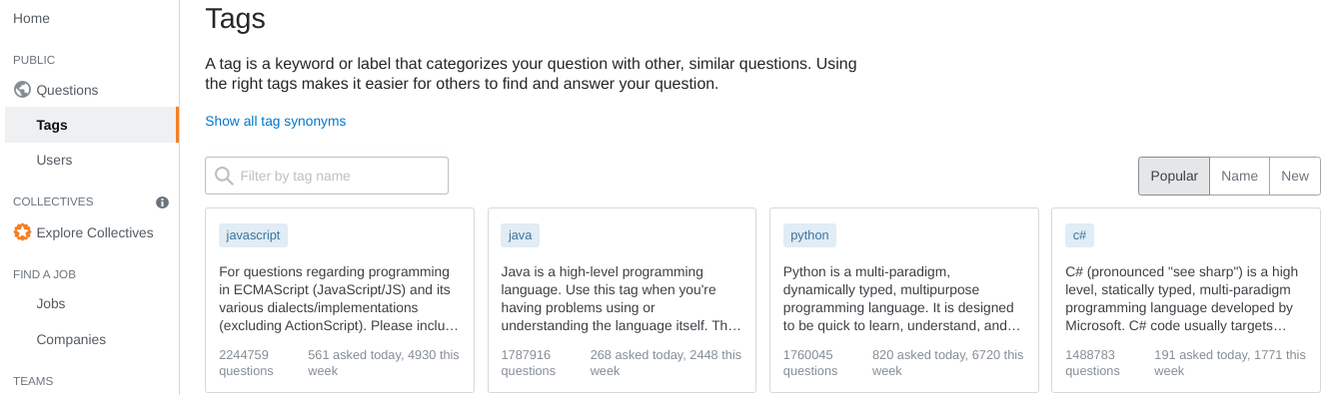

On the Tags page, type in a tag name and then press **Enter** or **Return**. Next, you can click on a tag to view questions that have that particular tag.

Use the **Search** bar at the top of the web page to search for keywords and questions. If you would like to view only questions that have a certain tag, include the tag name in brackets with your search. For example, if you want to only find questions that have the tag “SQL,” then type **[SQL]** in the search field, along with your keywords or question. See the example below.



To learn more about searching, read these [instructions about how to search](https://stackoverflow.com/help/searching). For a quick guide on syntax structures, check out this list of [search types and search syntax](https://stackoverflow.com/search).

Write your own question



When asking a question on Stack Overflow, keep it specific. Don’t use Stack Overflow to ask questions with opinion-based answers.

For example, “Which SQL function can I use to add two numbers together?” is an appropriate question. “Which SQL function is your favorite?” is not.

It is a best practice to search the Stack Overflow website for your question in case someone has already asked it. This reduces redundant questions on the site and saves you the time it would take to wait for an answer.

Write clear and concise questions in complete sentences. Then people are more likely to understand what you ask and give you helpful answers.

To begin asking a question, click the blue **Ask Question** button on [this page](https://stackoverflow.com/questions).

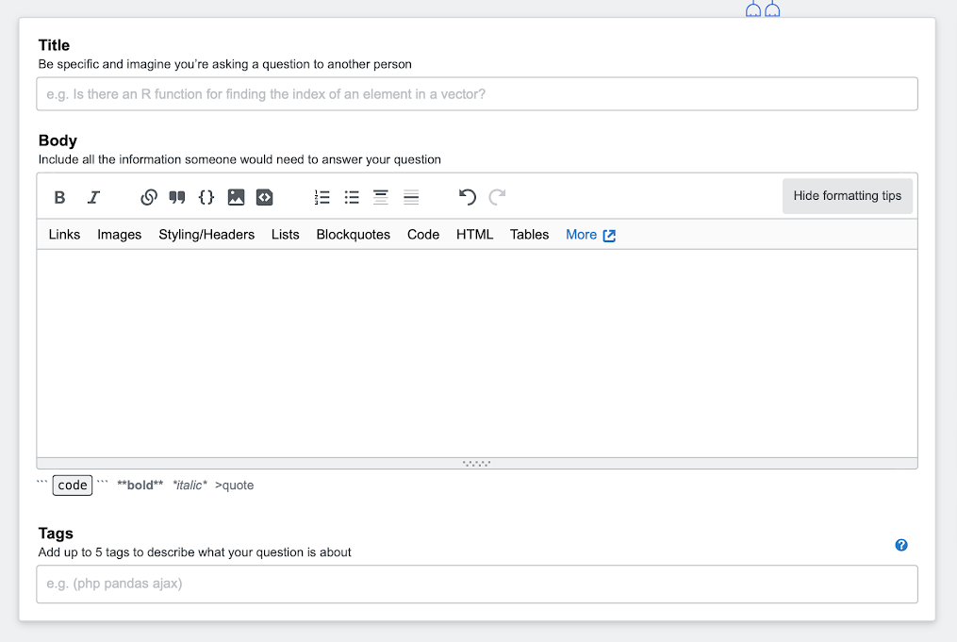

The form for asking a question has three sections: **Title**, **Body**, and **Tags**.

* **Title**: This is where you ask your question.
* **Body**: Summarize your problem and include expected and actual results. Include any error codes. If you think that inserting code into the Body section will help, press **Ctrl**+**K (Windows)** or **Cmd+K (Mac OS)** on your keyboard. Then type your code.
* **Tags**: Tags include specific keywords, like program names. They help other people find your question. You can add up to five tags. Check out this list of [existing tags](https://stackoverflow.com/tags) for examples of what tags to use.

**Note:** Stack Overflow is a public forum. Do not post any confidential company information or code that could impact the company you work for or yourself. When in doubt, first ask your manager whether you may post your question and code excerpt on Stack Overflow.

VLOOKUP core concepts

Functions can be used to quickly find information and perform calculations using specific values. In this reading, you will learn about the importance of one such function, **VLOOKUP**, or Vertical Lookup, which searches for a certain value in a spreadsheet column and returns a corresponding piece of information from the row in which the searched value is found.



**When do you need to use VLOOKUP?**

Two common reasons to use VLOOKUP are:

* Populating data in a spreadsheet
* Merging data from one spreadsheet with data in another

**VLOOKUP syntax**

A VLOOKUP function is available in both Microsoft Excel and Google Sheets. You will be introduced to the general syntax in Google Sheets. (You can refer to the resources at the end of this reading for more information about VLOOKUP in Microsoft Excel.)



Here is the syntax.



**search\_key**

* The value to search for.
* For example, 42, "Cats", or I24.

**range**

* The range to consider for the search.
* The first column in the range is searched to locate data matching the value specified by search\_key.

**index**

* The column index of the value to be returned, where the first column in range is numbered 1.
* If index is not between 1 and the number of columns in range, #VALUE! is returned.

**is\_sorted**

* Indicates whether the column to be searched (the first column of the specified range) is sorted. TRUE by default.
* It’s recommended to set is\_sorted to FALSE. If set to FALSE, an exact match is returned. If there are multiple matching values, the content of the cell corresponding to the first value found is returned, and #N/A is returned if no such value is found.
* If is\_sorted is TRUE or omitted, the nearest match (less than or equal to the search key) is returned. If all values in the search column are greater than the search key, #N/A is returned.

**What if you get #N/A?**

As you have just read, #N/A indicates that a matching value can't be returned as a result of the VLOOKUP. The error doesn’t mean that anything is actually wrong with the data, but people might have questions if they see the error in a report. You can use the **IFNA** function to replace the #N/A error with something more descriptive, like “Does not exist.”



Here is the syntax.



**value**

* This is a required value.
* The function checks if the cell value matches the value; such as #N/A.

**value\_if\_na**

* This is a required value.
* The function returns this value if the cell value matches the value in the first argument; it returns this value when the cell value is #N/A.

**Helpful VLOOKUP reminders**

* TRUE means an approximate match, FALSE means an exact match on the search key. If the data used for the search key is sorted, TRUE can be used.
* You want the column that matches the search key in a VLOOKUP formula to be on the left side of the data. VLOOKUP only looks at data to the right after a match is found. In other words, the index for VLOOKUP indicates columns to the right only. This may require you to move columns around before you use VLOOKUP.
* After you have populated data with the VLOOKUP formula, you may copy and paste the data as values only to remove the formulas so you can manipulate the data again.

**VLOOKUP resources for Microsoft Excel**

VLOOKUP may slightly differ in Microsoft Excel, but the overall concepts can still be generally applied. Refer to the following resources if you are working with Excel.

* [H​ow to use VLOOKUP in Excel](https://support.microsoft.com/en-us/office/vlookup-function-0bbc8083-26fe-4963-8ab8-93a18ad188a1): This tutorial includes a video to help you get a general understanding of how the VLOOKUP function works in Excel, as well as practical examples to look through.
* [VLOOKUP in Excel tutorial](https://www.youtube.com/watch?v=d3BYVQ6xIE4): Follow along in this video lesson and learn how to write a VLOOKUP formula in Excel and master time-saving useful tips and tricks.
* [23 things you should know about VLOOKUP in Excel](https://exceljet.net/things-you-should-know-about-vlookup): Explore this list of 23 VLOOKUP facts as well as challenges you might run into, and start to learn how to master them.
* [How to use Excel's VLOOKUP function](https://edu.gcfglobal.org/en/excel-tips/how-to-use-excels-vlookup-function/1/): This article shares a specific example around how to apply VLOOKUP in your searches.
* [VLOOKUP in Excel vs Google Sheets](https://infoinspired.com/sheets-vs-excel-formula/vlookup-formula-in-excel-and-google-sheets/): This guide offers a VLOOKUP comparison of Excel and Google Sheets.

**Hands-On Activity: Using VLOOKUP**

**Total points**2

**1.**

**Question 1**



Activity overview



Earlier, you learned about VLOOKUP, a function that uses vertical lookup to find specific values in a spreadsheet. In this activity, you will practice using VLOOKUP to consolidate information between two spreadsheets, clean data, and create a summary table from a query.

By the time you complete this activity, you will be able to use VLOOKUP to complete a variety of tasks in spreadsheets. This will enable you to clean and analyze data more efficiently, which is important for working with large datasets in your career as a data analyst.



What you will need

To get started, first access the VLOOKUP Practice Worksheet.

Click the link to the worksheet to create a copy. If you don’t have a Google account, you may download the VLOOKUP Practice Worksheet directly from the attachments below.

Link to the worksheet: [VLOOKUP Practice Worksheet](https://docs.google.com/spreadsheets/d/1Js6kRVYy6Nx6VENibaX9dmNOAP_7CXWuOqUjUz9cBtA/template/preview)

OR

Download VLOOKUP Practice Worksheet:

**VLOOKUP Practice Sheet**XLSX File

[Download file](https://d3c33hcgiwev3.cloudfront.net/cREKC3lpSDaRCgt5aTg2kg_591bae15000040aa99e53a834ced52f1_VLOOKUP-Practice-Sheet.xlsx?Expires=1648080000&Signature=aiD2Rusgg8qDwUshHorxOo1o3Of~K~hcwTXH1jsjQXdcHTwagwBJcNzwVI6b6rxzA-~Gu6sZBBpnd0AokfWNGsio77HWzAxw2aMjTOXSgWss3IZxlooerV-gqzOwCP~Zzlp2ixAkt4h2dMV4m41Wm-ARZ-iibiO31EFAvLZrTpE_&Key-Pair-Id=APKAJLTNE6QMUY6HBC5A" \t "_blank)



Search with VLOOKUP



Although you would usually clean your data prior to using VLOOKUP, this first step will illustrate why it’s important to clean data first.

Imagine your research requires you to know how many hours an employee worked on a specific date. This is easy to do manually on a small spreadsheet and becomes harder as the amount of information grows or is spread across multiple spreadsheets. The VLOOKUP function provides a way to have the spreadsheet gather the information for you.

Assume you needed to figure out how many hours the employee Daniel Chan worked on January 3, 2020. In the spreadsheet you downloaded, it is easy to notice which number contains Daniel’s name. But imagine if you had thousands of employees in your spreadsheet. It might not be easy to find his name without searching each cell. In this step, you are going to use Daniel Chan’s name as the **lookup\_value**, sometimes known as a search key, in VLOOKUP.

The syntax for the VLOOKUP function is **=vlookup(lookup\_value, table\_array, col\_index\_num, [range\_lookup], true/false)**.

Search for the number of hours Daniel Chan worked on January 3, 2020.

1. In **B11** enter **Chan, Daniel.**

2. In **B12** enter **=VLOOKUP(B11, B2:E6, 4, false).**

As a refresher, this syntax means that the lookup value **is contained in cell B11**, the **table array contains cells B2 through E6**, you want to search in **column 4 of this array**, and you want an **exact match**. Remember that **column refers to the array column**, which represents the limits of your query.

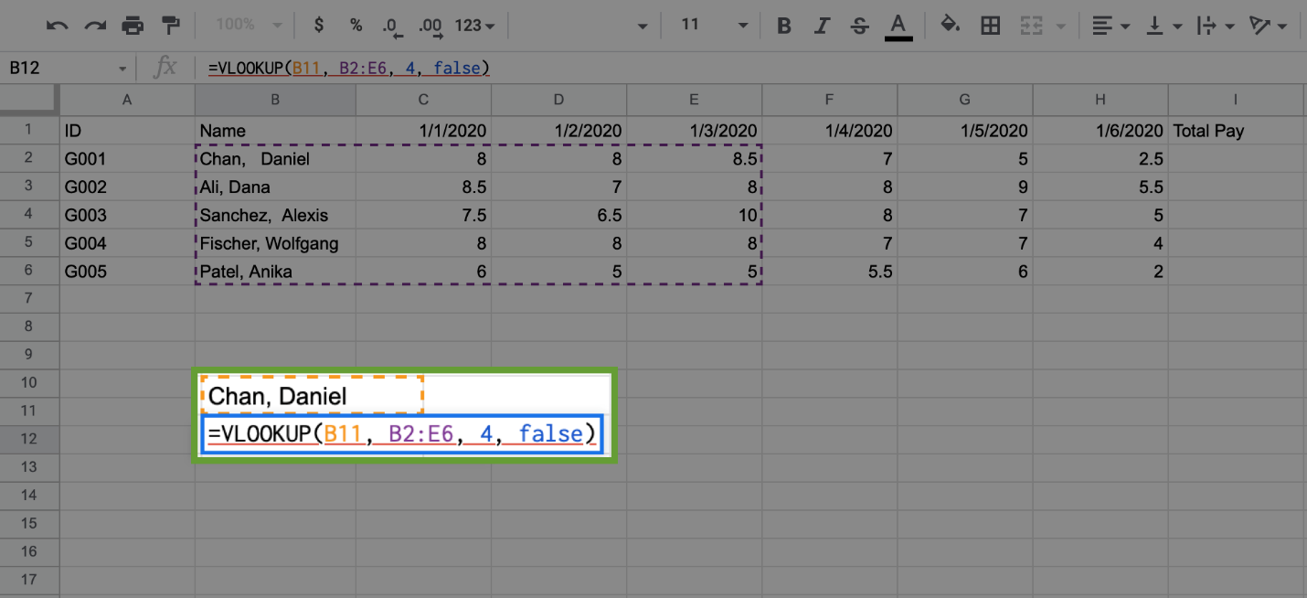

3. Press **Enter** (Windows) or **Return** (Mac). The cell will now contain an error, **#N/A**.

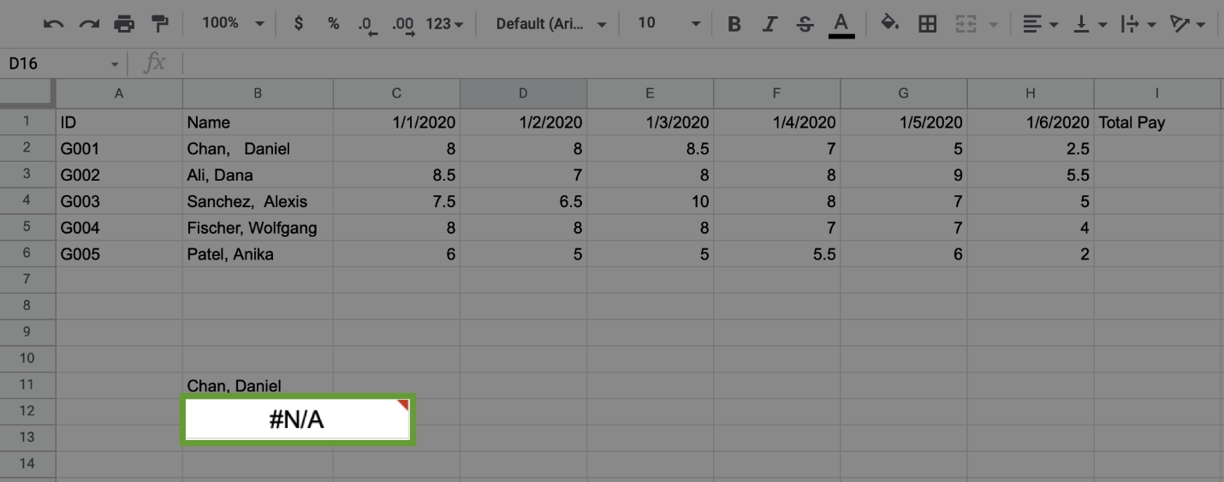

Notice that the entry for Daniel Chan has extra spaces after the comma. Because **B11** does not contain those extra spaces, the search comes back with an error.

One option to fix this is to adjust the number of spaces until you get an exact match. However, this is not very efficient, and if you could identify the name, you would probably just use the cell number for your query.

The best way to handle this is to trim any extra spaces in the data. This is why it’s important to clean your data prior to using VLOOKUP.

Prepare the data



Now you will prepare the data to help you more easily figure out how many hours employees worked. You first need to clean and label the data. Then, you can combine data from two spreadsheets using the trusty VLOOKUP function.

Clean and label the data



To trim the data, follow these steps:

1. In cell **B15** type **=trim(B2).**

2. Click and drag down the bottom-right corner of the cell until you reach **B19**. The rest of the names will populate.

For this exercise, you are not replacing the trimmed data into the original table. There are many cases where you need to clean the data for your use, but you do not want to change data in the set with which you are working.

3. Scroll below the original data. In cell **C15** type **=value(C2).**

4. Click on the bottom-right corner of the cell and drag the cell down to populate the hours for the other employees.

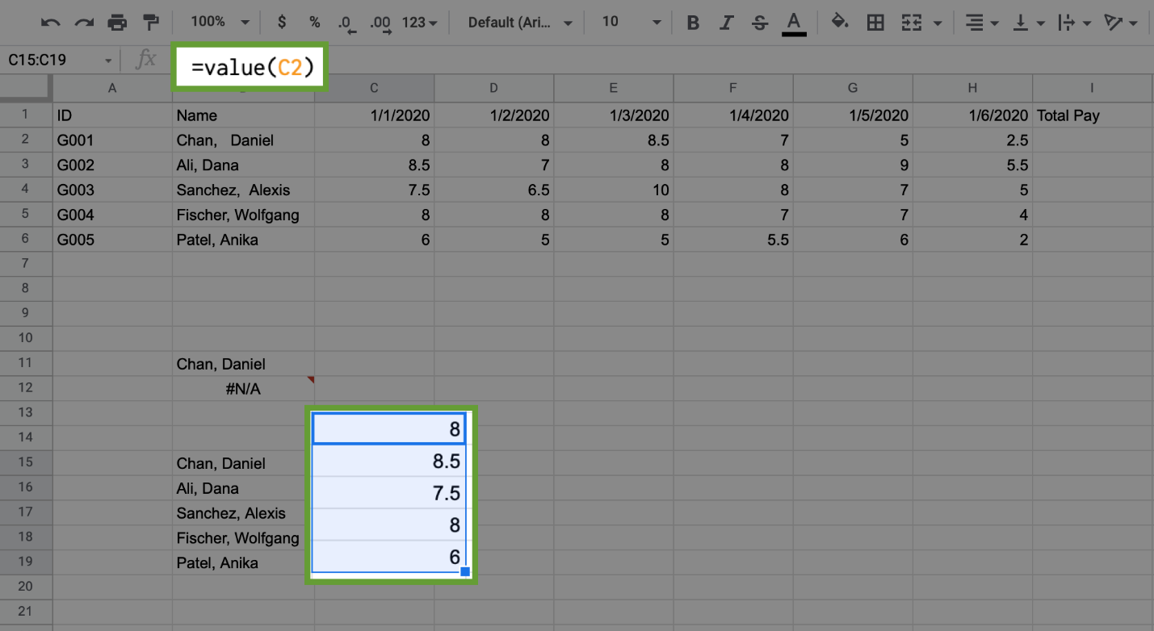

It’s also helpful to label the different columns for the data. Working with data gets messy quickly, and it is important to keep track of your value references.

Enter in the following labels:

* **B14:** Names
* **C14 – H14:** (Enter in the dates 1/1/2020 through 1/6/2020)
* **I14:** Hours
* **J14:** Pay Rate
* **K14:** Total Pay

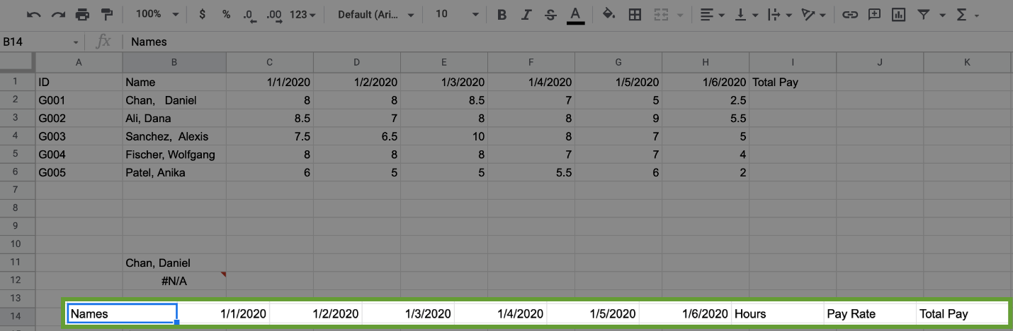

Populate and sum the remaining hours



Use cells already populated in **C15** through **C19** to populate the remaining hours needed for each employee.

1. Click and drag the corner of **C15** to **H15** to populate the remaining hours for Daniel Chan.

2. Repeat this process for the remaining employees.

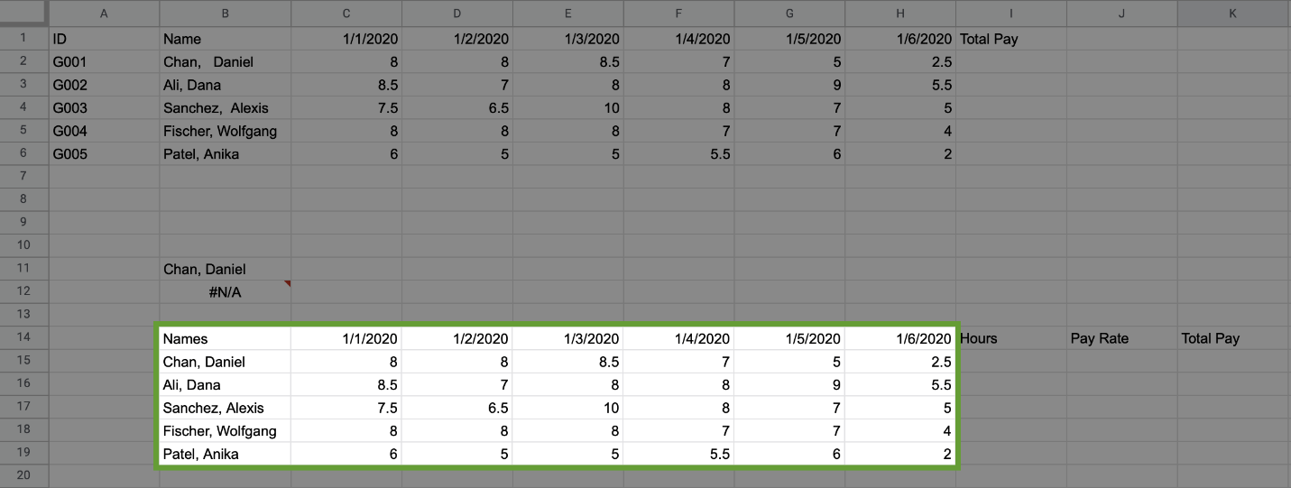

Now, fill in the **Hours** column for the employees.

3. In cell **I15** type **=sum(C15:H15).**

4. Click and drag down the bottom corner of cell **I15** to populate the sums for the remaining employees.

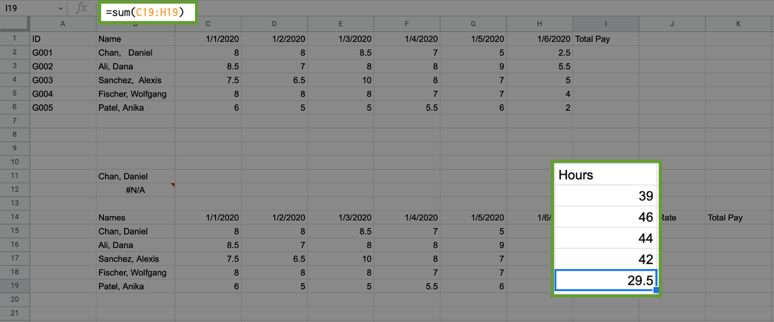

Import pay rate data



You might have noticed that pay information is missing from the spreadsheet. Data analysis often requires importing information from different data sources. In this case, the data required is on **Sheet2**. To import this data:

1. Click on **Sheet2**, which you can find at the bottom of the spreadsheet. **Employee ID, date of hire (DOH), status,** and **pay rate** are the data found on this sheet.

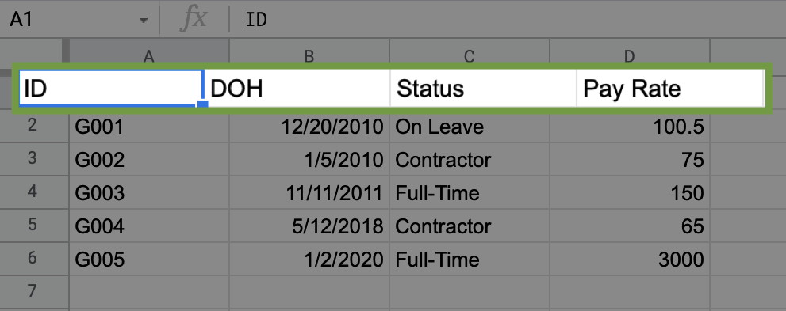

Now, use VLOOKUP to import pay rate data.

2. In **J15 (of sheet 1)** type: **=VLOOKUP(A2, Sheet2!$A$2:$D$6, 4, false).** Consider the syntax for this VLOOKUP function:

* **A2** refers to cell A2 in Sheet1.

**Note:** In Sheet2 the rate of pay, and related fields, are referenced by ID instead of employee name. You need to use employee ID to import the pay rate from Sheet2.

* **Sheet2!** refers to the sheet from which you want to access the data.
* **$A$2:$D$6** refers to the cells that make up the table array. The $ placed in front of the column tabs and cell numbers locks the formula so that it can be copied by dragging down the cell **J15** to import the pay rate for the other employees.
* **4** refers to the column from which the returned value will come. 4 means that the returned value will come from the 4th column in the selected array.
* **false** signifies that you want an exact, character-for-character match to the lookup value. If you put true instead, VLOOKUP would return an approximate match (or the closest match available) for the lookup value. This is not used very often in real-world situations.

3. Populate the pay rate for the remaining employees by dragging down the corner of the cell to copy the formula.

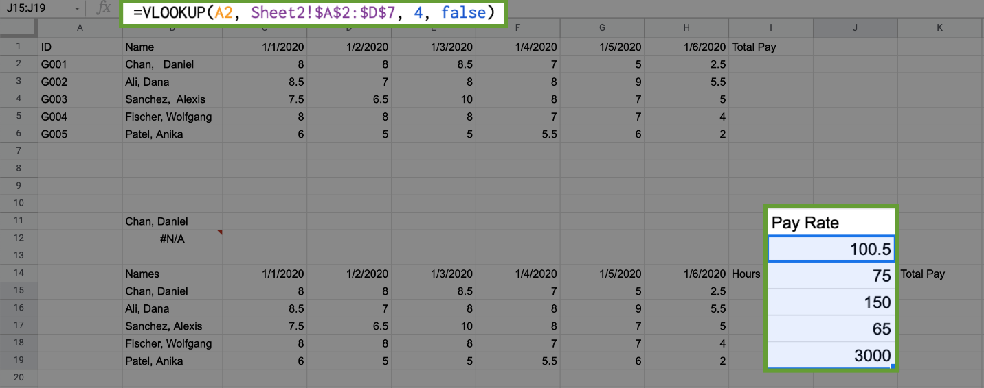

Now, calculate total pay.

4. In **K15** type **=product(I15, J15)**.

5. Drag cell **K15** down to populate the total pay for the remaining employees.

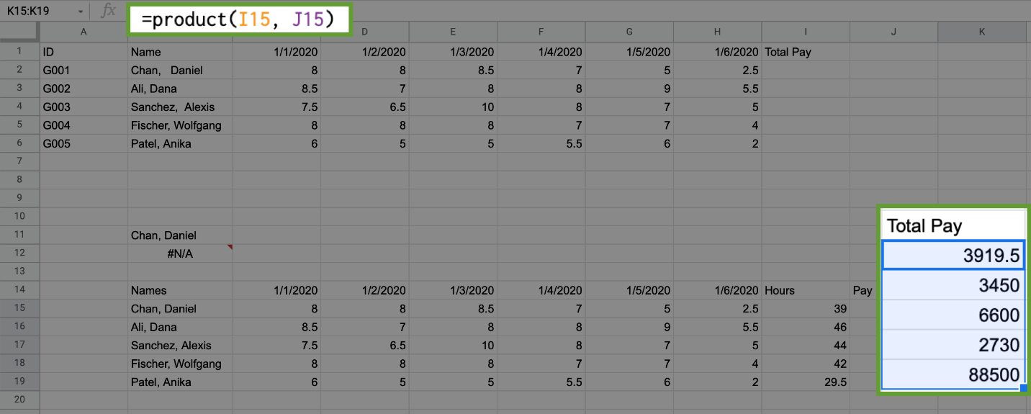

Create a summary table



Now that the data is clean and includes pay rate information, you can create a summary table, or pivot table. The following section demonstrates how to create a pivot table in Google Sheets. If you are using Excel, please follow the [documentation for how to manually create a Pivot Table in Excel](https://support.microsoft.com/en-us/office/create-a-pivottable-to-analyze-worksheet-data-a9a84538-bfe9-40a9-a8e9-f99134456576).

In Google Sheets, create a table for data in cells **(B14:K19)** using the following steps:

1. Select the data in cells **(B14:K19).**

2. Click on the **Data** tab, then select **Pivot Table.**

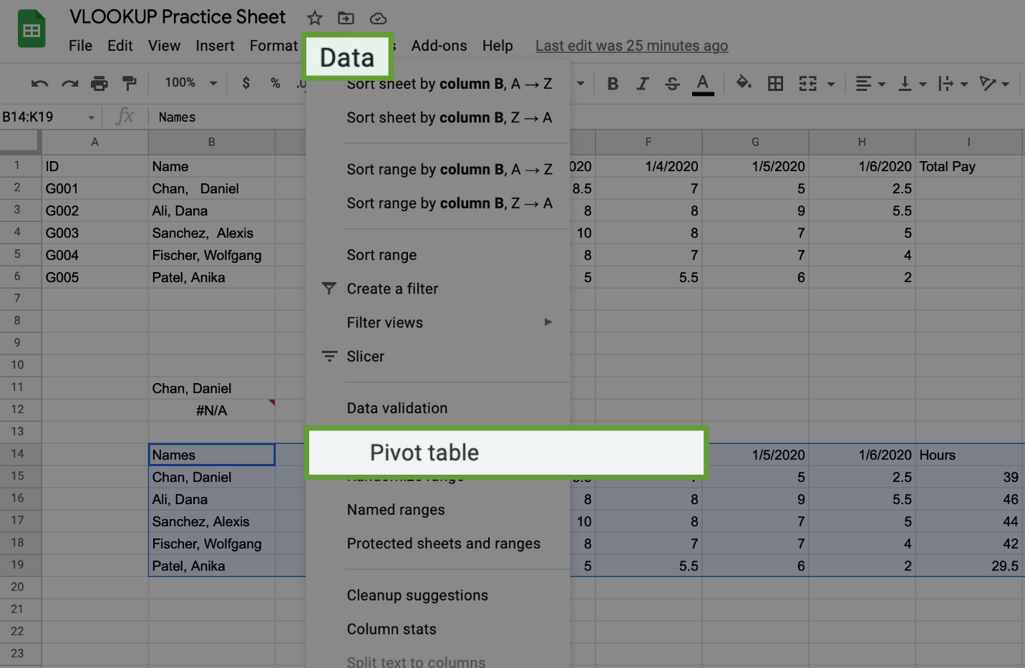

3. A pop-up window will display. Click on **New Sheet,** then click the **Create** button.

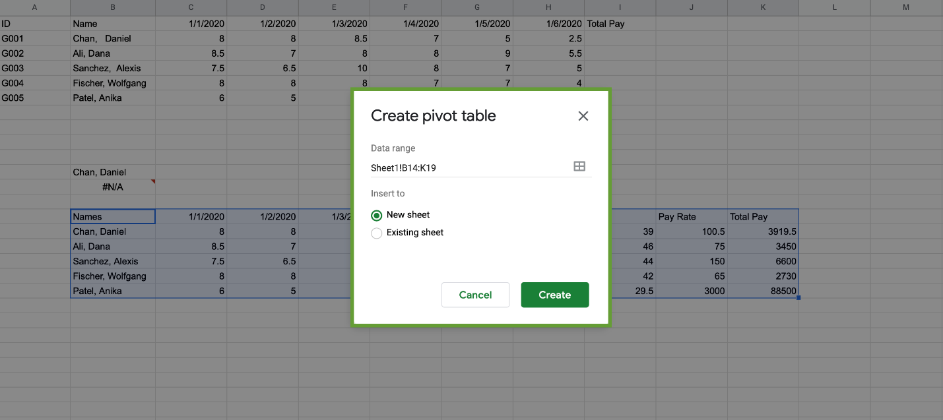

On the side of the new sheet, the **Pivot table editor** will display. The pivot table you are creating will contain each employee’s name, pay rate, and total pay. Follow these steps to create the pivot table:

1. Click the **Add** button for **Rows.** Select **Names.**

2. Click the **Add** button for **Values.** Select **Pay Rate.**

3. Click the **Add** button for **Values** again. Select **Total Pay.**

The result should display like this:

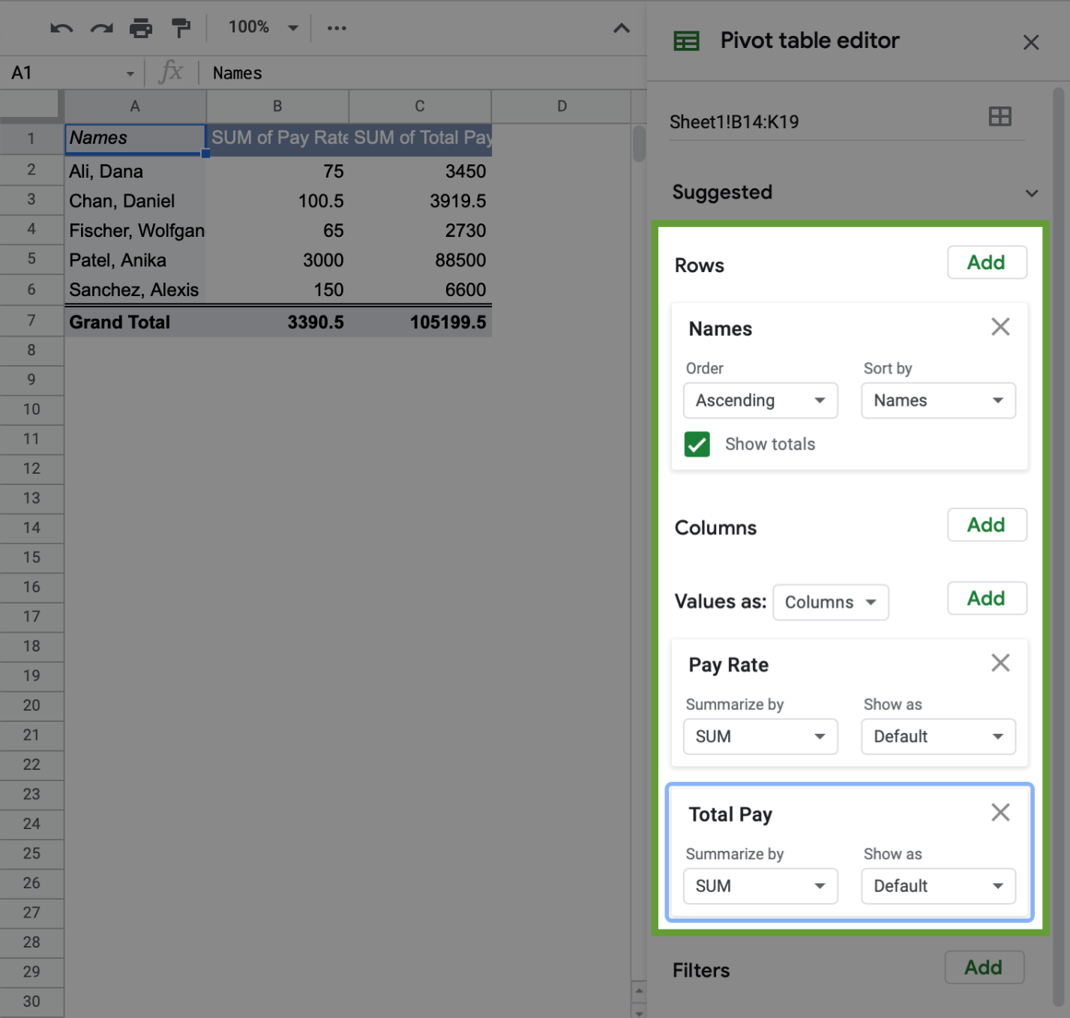

Next, convert the cells in the **Sum of Total Pay** column to currency.

4. Select the cells in the column **Sum of Total Pay.**

5. Click on the **$** symbol on the toolbar.

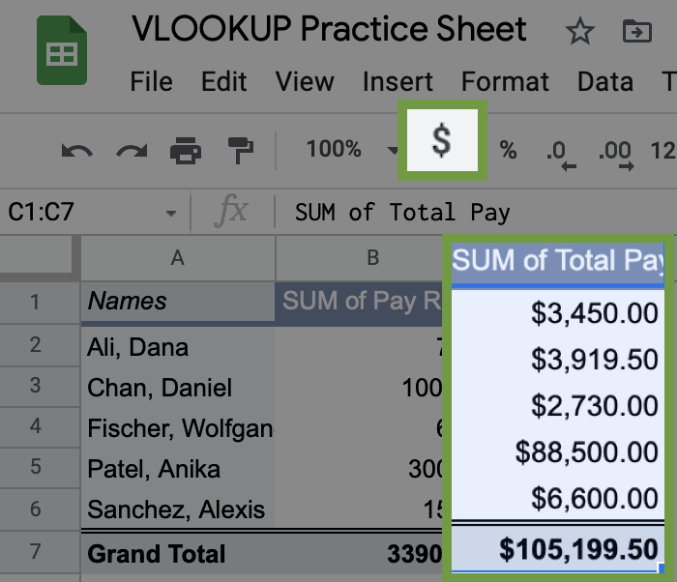

Alternatively, you can also click on the **Format** tab, select **Number**, then select **Currency.**

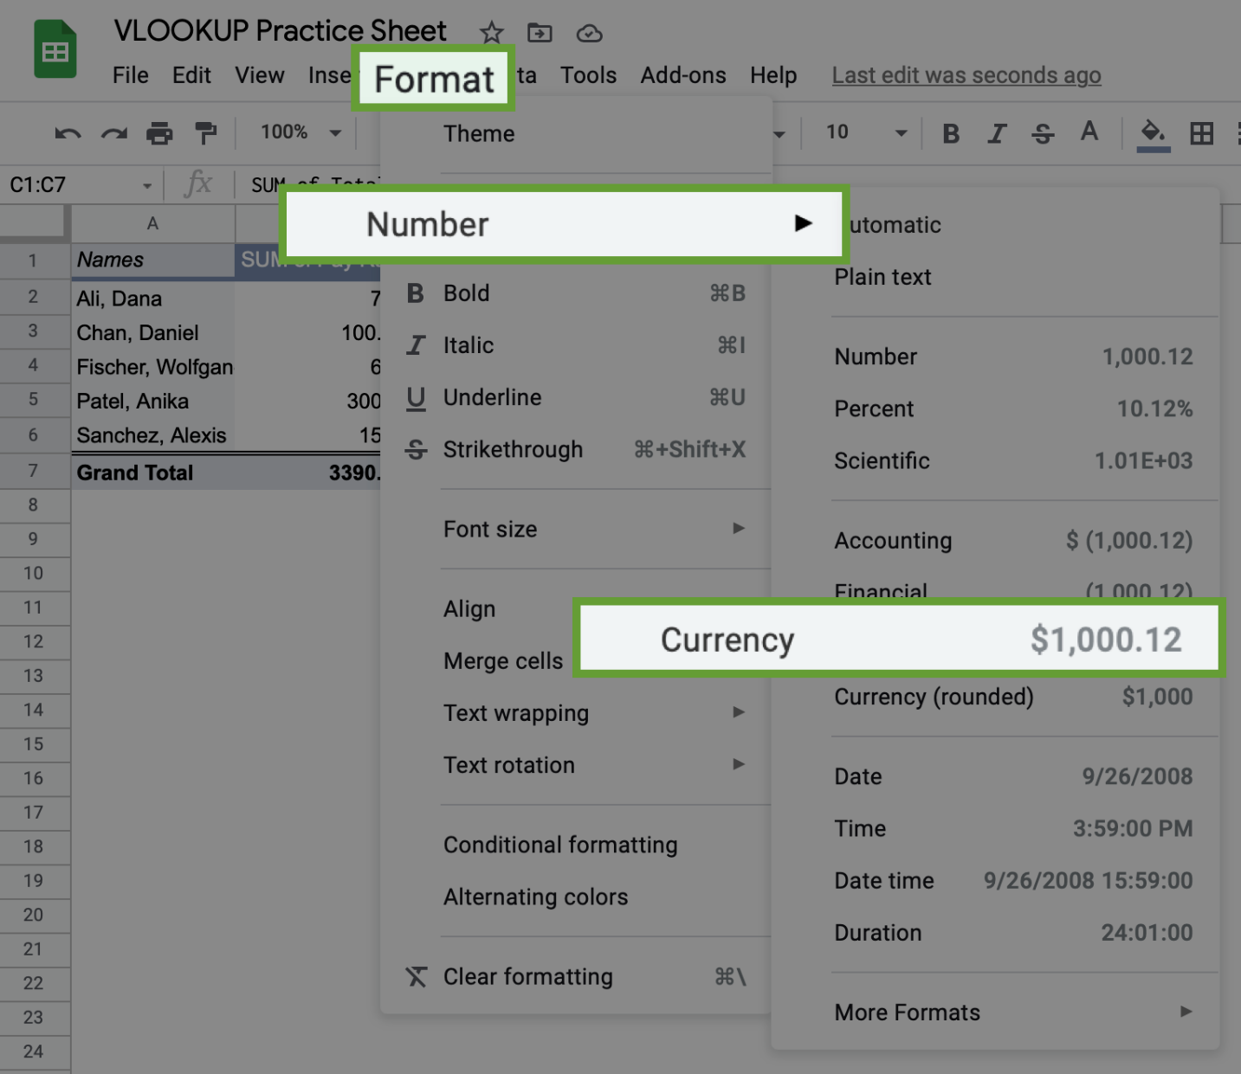

Congratulations! You have now used VLOOKUP and created a pivot table, two essential tools for analyzing data in spreadsheets.

Optional: Upload the employee dataset to BigQuery

The next video demonstrates how to use JOINS to merge and return data from two tables based on a common attribute used in both tables.

If you would like to follow along with the instructor, you will need to log in to your BigQuery account and upload the employee data provided as two CSV files. If you have hopped around courses, [Using BigQuery](https://www.coursera.org/learn/data-preparation/supplement/DYOQK/using-bigquery) in the **Prepare Data for Exploration** course covers how to set up a BigQuery account.

**Prepare for the next video**

* First, download the CSV files from the attachments below:

**Employees Table - Understanding JOINS**CSV File

[Download file](https://d3c33hcgiwev3.cloudfront.net/ac7_JD2BTbyO_yQ9gU28iw_55306ffc65874fedb9efbd01809bfcf1_Employees-Table---Understanding-JOINS.csv?Expires=1648080000&Signature=eSDfkXd3O3Ei5Xaxp6EG78GHdh3HK8wJKFHtwGTdks2vKrbrv8-djW6HYvEskXrNYS3M420ceRUqYJqiF93H9xg86HqywZCaFOM8eY1Q2ZrmUTFPYbz64abCLfsAxam0uh2jEDylllqeVLueEsx9mfHk-isy~tXDk0Nws1OeaMY_&Key-Pair-Id=APKAJLTNE6QMUY6HBC5A" \t "_blank)

**Departments Table - Understanding JOINS**CSV File

[Download file](https://d3c33hcgiwev3.cloudfront.net/EovSmanLQh6L0pmpy4Iedg_fe20c7a8eeed4cdfa40aaa02889759f1_Departments-Table---Understanding-JOINS.csv?Expires=1648080000&Signature=GBUQZ~Av1D~9daDUrCwXQa25e8mb55ZdZv6ctihKqbt87HYcJG9sj1eG6EDA48wgrHoQsNuo~3m71iNw78YS8l8W892oAM0eGxJwiPVhJXdWkXML2lYGAEPSI6Rd9etZ6xzGyCxeL3CbnCrEELE59bwMrm0AdhcN9qUf5zd7n7c_&Key-Pair-Id=APKAJLTNE6QMUY6HBC5A" \t "_blank)

* Next, complete the following steps in your BigQuery console to upload the **employees** and **departments** tables.

**Step 1:** Open your BigQuery console and click on the project you want to upload the data to.

**Step 2:** In the Explorer on the left, click the Actions icon (three vertical dots) next to your project name and select **Create dataset**.



**Step 3:** Enter **employee\_data** for the Dataset ID.

**Step 4:** Click **CREATE DATASET** (blue button) to add the dataset to your project.

**Step 5:** In the Explorer on the left, click to expand your project, and then click the **employee\_data** dataset you just created.

**Step 6:** Click the Actions icon (three vertical dots) next to employee\_data and select **Open**.

**Step 7:** Click the blue **+** icon at the top right to open the Create table window.



**Step 8:** Under Source, for the Create table from selection, choose where the data will be coming from.

* Select **Upload**.
* Click **Browse** to select the Employees Table CSV file you downloaded.
* Choose **CSV** from the file format drop-down.

**Step 9:** For Table name, enter **employees** if you plan to follow along with the video.

**Step 10:** For Schema, click the Auto detect check box.

**Step 11:** Click **Create** **table** (blue button). You will now see the **employees** table under your **employee\_data** dataset in your project.

**Step 12:** Click the **employee\_data** dataset again.

**Step 13:** Click the icon to open the Create table window again.

**Step 14:** Under Source, for the Create table from selection, choose where the data will be coming from.

* Select **Upload**.
* Click **Browse** to select the Departments Table CSV file you downloaded.
* Choose **CSV** from the file format drop-down.

**Step 15:** For Table name, enter **departments** if you plan to follow along with the video.

**Step 16:** For Schema, click the Auto detect check box.

**Step 17:** Click **Create** **table** (blue button). You will now see the **departments** table under your **employee\_data** dataset in your project.

**Step 18:** Click the **employees** table and click the **Preview** tab to verify that you have the data shown below.

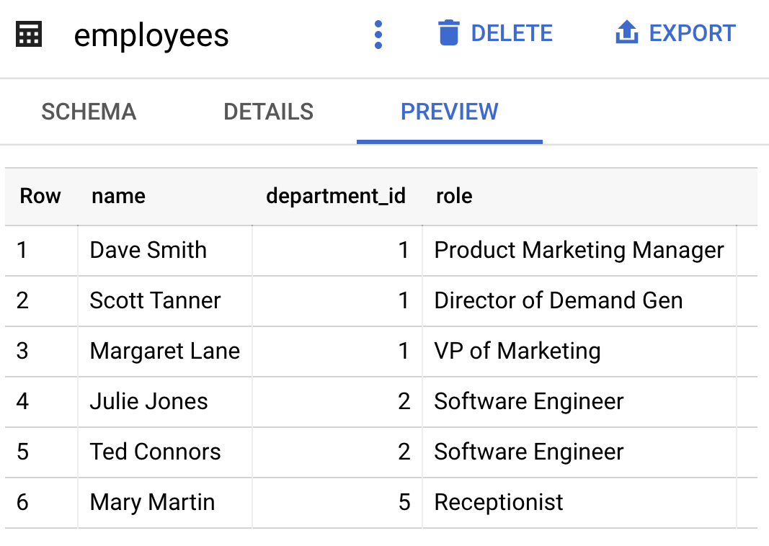

**Step 19:** Click the **departments** table and click the **Preview** tab to verify that you have the data shown below.

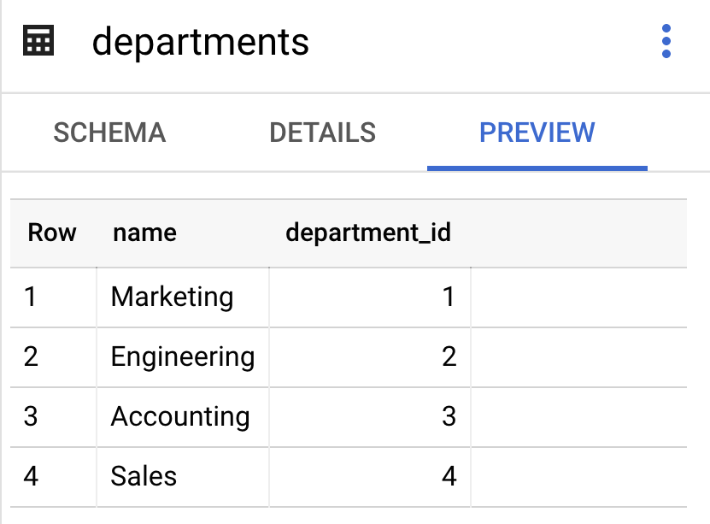

If your data previews match, you are ready to follow along with the next video.

Secret identities: The importance of aliases

In this reading, you will learn about using aliasing to simplify your SQL queries. **Aliases** are used in SQL queries to create temporary names for a column or table. Aliases make referencing tables and columns in your SQL queries much simpler when you have table or column names that are too long or complex to make use of in queries. Imagine a table name like special\_projects\_customer\_negotiation\_mileages. That would be difficult to retype every time you use that table. With an alias, you can create a meaningful nickname that you can use for your analysis. In this case “special\_projects\_customer\_negotiation\_mileages” can be aliased to simply “mileage.” Instead of having to write out the long table name, you can use a meaningful nickname that you decide.

**Basic syntax for aliasing**

**Aliasing** is the process of using aliases. In SQL queries, aliases are implemented by making use of the AS command. The basic syntax for the AS command can be seen in the following query for aliasing a table:



Notice that AS is preceded by the table name and followed by the new nickname. It is a similar approach to aliasing a column:



In both cases, you now have a new name that you can use to refer to the column or table that was aliased.

**Alternate syntax for aliases**

If using AS results in an error when running a query because the SQL database you are working with doesn't support it, you can leave it out. In the previous examples, the alternate syntax for aliasing a table or column would be:

* FROM table\_name alias\_name
* SELECT column\_name alias\_name

The key takeaway is that queries can run with or without using AS for aliasing, but using AS has the benefit of making queries more readable. It helps to make aliases stand out more clearly.

**Aliasing in action**

Let’s check out an example of a SQL query that uses aliasing. Let’s say that you are working with two tables: one of them has employee data and the other one has department data. The FROM statement to alias those tables could be:

FROM work\_day.employees AS employees

These aliases still let you know exactly what is in these tables, but now you don’t have to manually input those long table names. Aliases can be really helpful for long, complicated queries. It is easier to read and write your queries when you have aliases that tell you what is included within your tables.

**For more information**

If you are interested in learning more about aliasing, here are some resources to help you get started:

* [**SQL Aliases**](https://www.w3schools.com/sql/sql_alias.asp)**:** This tutorial on aliasing is a really useful resource to have when you start practicing writing queries and aliasing tables on your own. It also demonstrates how aliasing works with real tables.
* [**SQL Alias**](https://www.sqltutorial.org/sql-alias/)**:** This detailed introduction to aliasing includes multiple examples. This is another great resource to reference if you need more examples.
* [**Using Column Aliasing**](https://documentation.sas.com/?cdcId=pgmsascdc&cdcVersion=9.4_3.5&docsetId=sqlproc&docsetTarget=p0aymxwsvbt5wcn1lncugwjtf758.htm&locale=en)**:** This is a guide that focuses on column aliasing specifically. Generally, you will be aliasing entire tables, but if you find yourself needing to alias just a column, this is a great resource to have bookmarked.

Using JOINs effectively

In this reading, you will review how JOINs are used and will be introduced to some resources that you can use to learn more about them. A JOIN combines tables by using a primary or foreign key to align the information coming from both tables in the combination process. JOINs use these keys to identify relationships and corresponding values across tables.

If you need a refresher on primary and foreign keys, refer to the [glossary](https://www.coursera.org/learn/analyze-data/supplement/0p8b6/glossary-terms-and-definitions) for this course, or go back to [Databases in data analytics](https://www.coursera.org/learn/data-preparation/supplement/uXqEX/databases-in-data-analytics).

**The general JOIN syntax**



As you can see from the syntax, the JOIN statement is part of the FROM clause of the query. **JOIN** in SQL indicates that you are going to combine data from two tables. **ON** in SQL identifies how the tables are to be matched for the correct information to be combined from both.

**Type of JOINs**

There are four general ways in which to conduct JOINs in SQL queries: INNER, LEFT, RIGHT, and FULL OUTER.

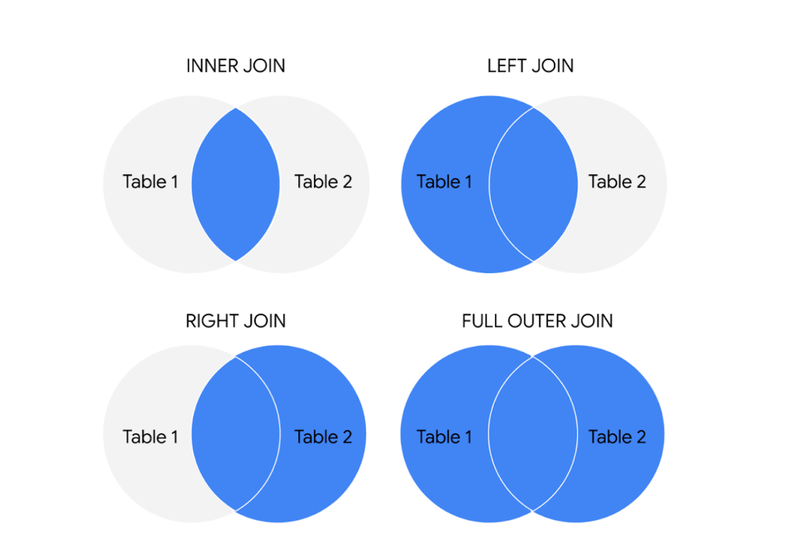The circles represent left and right tables, and where they are joined is highlighted in blue

Here is what these different JOIN queries do.

**INNER JOIN**

INNER is *optional* in this SQL query because it is the default as well as the most commonly used JOIN operation. You may see this as JOIN only. INNER JOIN returns records if the data lives in both tables. For example, if you use INNER JOIN for the 'customers' and 'orders' tables and match the data using the customer\_id key, you would combine the data for each customer\_id that exists in both tables. If a customer\_id exists in the customers table but not the orders table, data for that customer\_id isn’t joined or returned by the query.

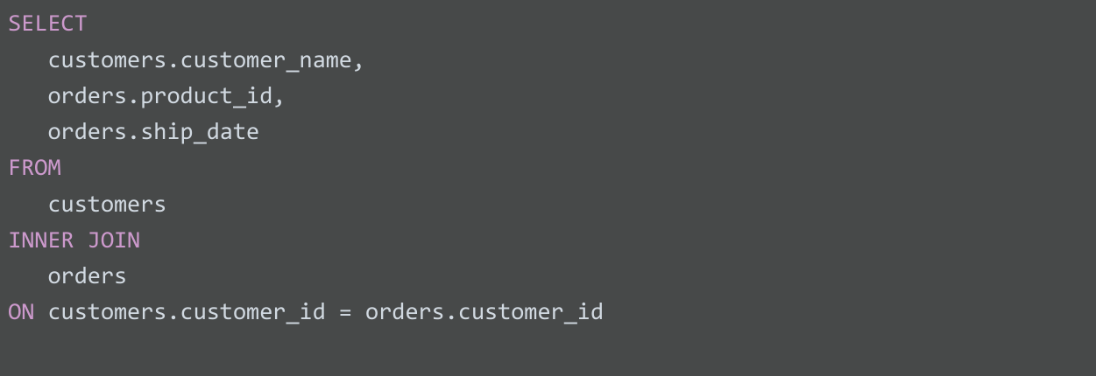

The results from the query might look like the following, where customer\_name is from the customers table and product\_id and ship\_date are from the orders table:

| **customer\_name** | **product\_id** | **ship\_date** |
| --- | --- | --- |
| Martin's Ice Cream | 043998 | 2021-02-23 |
| Beachside Treats | 872012 | 2021-02-25 |
| Mona's Natural Flavors | 724956 | 2021-02-28 |
| ... etc. | ... etc. | ... etc. |

The data from both tables was joined together by matching the customer\_id common to both tables. Notice that customer\_id doesn’t show up in the query results. It is simply used to establish the relationship between the data in the two tables so the data can be joined and returned.

**LEFT JOIN**

You may see this as LEFT OUTER JOIN, but most users prefer LEFT JOIN. Both are correct syntax. LEFT JOIN returns all the records from the left table and only the matching records from the right table. Use LEFT JOIN whenever you need the data from the entire first table and values from the second table, if they exist. For example, in the query below, LEFT JOIN will return customer\_name with the corresponding sales\_rep, if it is available. If there is a customer who did not interact with a sales representative, that customer would still show up in the query results but with a NULL value for sales\_rep.

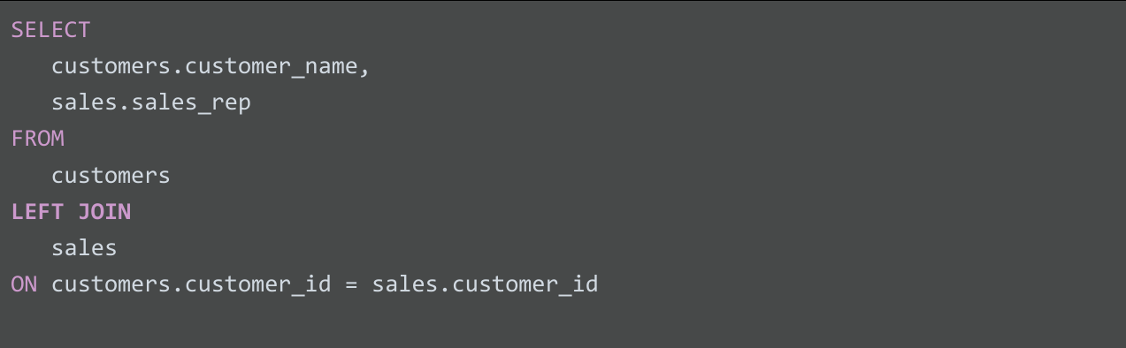

The results from the query might look like the following where customer\_name is from the customers table and sales\_rep is from the sales table. Again, the data from both tables was joined together by matching the customer\_id common to both tables even though customer\_id wasn't returned in the query results.

| **customer\_name** | **sales\_rep** |
| --- | --- |
| Martin's Ice Cream | Luis Reyes |
| Beachside Treats | NULL |
| Mona's Natural Flavors | Geri Hall |
| ...etc. | ...etc. |

**RIGHT JOIN**

You may see this as RIGHT OUTER JOIN or RIGHT JOIN. RIGHT JOIN returns all records from the right table and the corresponding records from the left table. Practically speaking, RIGHT JOIN is rarely used. Most people simply switch the tables and stick with LEFT JOIN. But using the previous example for LEFT JOIN, the query using RIGHT JOIN would look like the following:

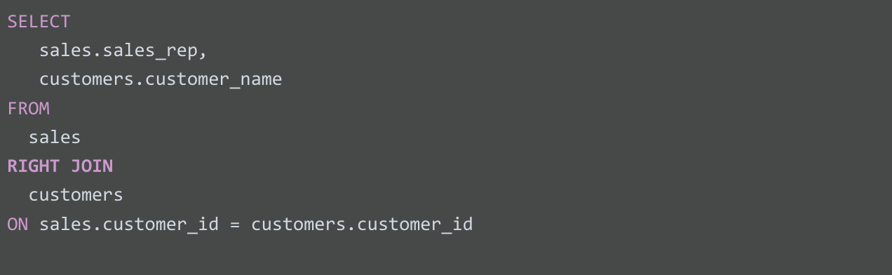

The query results are the same as the previous LEFT JOIN example.

| **customer\_name** | **sales\_rep** |
| --- | --- |
| Martin's Ice Cream | Luis Reyes |
| Beachside Treats | NULL |
| Mona's Natural Flavors | Geri Hall |
| ...etc. | ...etc. |

**FULL OUTER JOIN**

You may sometimes see this as FULL JOIN. FULL OUTER JOIN returns all records from the specified tables. You can combine tables this way, but remember that this can potentially be a large data pull as a result. FULL OUTER JOIN returns all records from *both* tables even if data isn’t populated in one of the tables. For example, in the query below, you will get all customers and their products’ shipping dates. Because you are using a FULL OUTER JOIN, you may get customers returned without corresponding shipping dates or shipping dates without corresponding customers. A NULL value is returned if corresponding data doesn’t exist in either table.

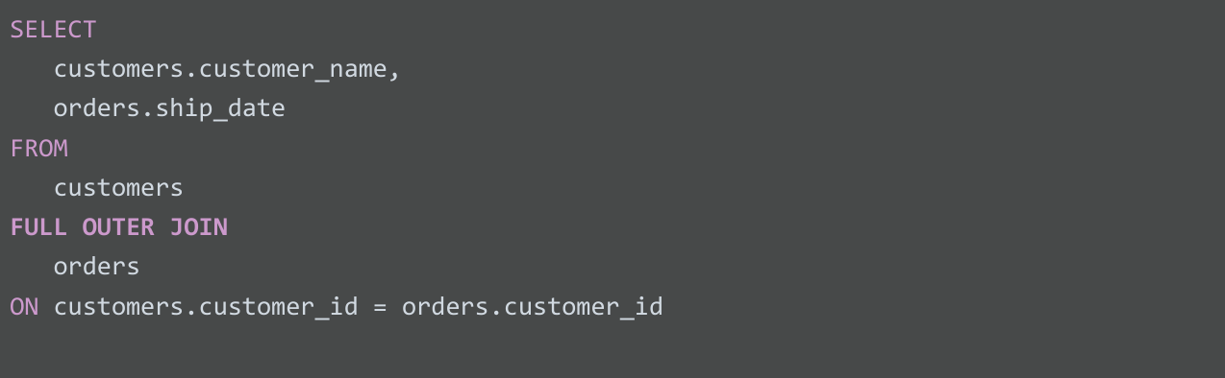

The results from the query might look like the following.

| **customer\_name** | **ship\_date** |
| --- | --- |
| Martin's Ice Cream | 2021-02-23 |
| Beachside Treats | 2021-02-25 |
| NULL | 2021-02-25 |
| The Daily Scoop | NULL |
| Mountain Ice Cream | NULL |
| Mona's Natural Flavors | 2021-02-28 |
| ...etc. | ...etc. |

**For more information**

JOINs are going to be useful for working with relational databases and SQL—and you will have plenty of opportunities to practice them on your own. Here are a few other resources that can give you more information about JOINs and how to use them:

* [**SQL JOINs**](https://www.w3schools.com/sql/sql_join.asp)**:** This is a good basic explanation of JOINs with examples. If you need a quick reminder of what the different JOINs do, this is a great resource to bookmark and come back to later.
* [**Database JOINs - Introduction to JOIN Types and Concepts**](https://www.essentialsql.com/introduction-database-joins/)**:** This is a really thorough introduction to JOINs. Not only does this article explain what JOINs are and how to use them, but it also explains the various scenarios in more detail of when and why you would use the different JOINs. This is a great resource if you are interested in learning more about the logic behind JOINing.
* [**SQL JOIN Types Explained in Visuals**](https://dataschool.com/how-to-teach-people-sql/sql-join-types-explained-visually/)**:** This resource has a visual representation of the different JOINs. This is a really useful way to think about JOINs if you are a visual learner, and it can be a really useful way to remember the different JOINs.
* [**SQL JOINs: Bringing Data Together One Join at a Time**](https://towardsdatascience.com/sql-join-8212e3eb9fde)**:** Not only does this resource have a detailed explanation of JOINs with examples, but it also provides example data that you can use to follow along with their step-by-step guide. This is a useful way to practice JOINs with some real data.
* [**SQL JOIN:**](https://www.dofactory.com/sql/join) This is another resource that provides a clear explanation of JOINs and uses examples to demonstrate how they work. The examples also combine JOINs with aliasing. This is a great opportunity to see how JOINs can be combined with other SQL concepts that you have been learning about in this course.

**Hands-On Activity: Queries for JOINS**

**Total points**2

**1.**

**Question 1**



Activity overview



You’ve come a long way in working with relational databases and SQL. Now, you’ll gain practice writing queries that join multiple tables together.

In this activity, you’ll work with the World Bank’s International Education Dataset. By mastering JOIN statements, you’ll be able to fully harness the power of relational databases by combining data from tables linked by keys.

Load and examine the dataset



1. Log in to [BigQuery Sandbox](https://cloud.google.com/bigquery/docs/sandbox). If you have a free trial version of BigQuery, you can use that instead. On the BigQuery page, click the **Go to BigQuery** button.

* **Note:** BigQuery Sandbox frequently updates its user interface. The latest changes may not be reflected in the screenshots presented in this activity, but the principles remain the same. Adapting to changes in software updates is an essential skill for data analysts, and it’s helpful for you to practice troubleshooting. You can also reach out to your community of learners on the discussion forum for help.

2. If you have never created a BigQuery project before, click **CREATE PROJECT** on the right side of the screen. If you have created a project before, you can use an existing one or create a new one by clicking the project dropdown in the blue header bar and selecting **NEW PROJECT**.

3. Name your project something that will help you identify it later. You can give it a unique project ID or use an auto-generated one. Don’t worry about selecting an organization if you don’t know what to put.

4. Now, you’ll see the **Editor** interface. In the middle of the screen is a window where you can type code, and to the left is the **Explorer** menu where you can search for datasets.

Before you begin joining two tables together, you’ll first need to figure out which tables to join together. Recall that two tables must be connected in order to join them. Two tables can be joined if the **primary key** for one table is included in the other table as a **foreign key***.*

To determine what information the tables contain and identify keys you can join them on, review the schema of the tables. To access the schema:

5. Click **+ ADD DATA** at the top of the Explorer menu**,** then **Explore public datasets** from the resulting dropdown.

6. In the **Search Marketplace** bar, type **international education**.

7. Click the first result, The World Bank's **International Education** dataset.

8. Click **View Dataset**. This will bring you back to the BigQuery Sandbox interface in a new tab.

* **Note:** This may pin the **bigquery-public-data** dropdown to the **Explorer** menu. You can use this to browse datasets and tables.

9. In the Explorer menu, search for **world\_bank\_intl\_education**. Click the dropdown arrow to expand the dataset.

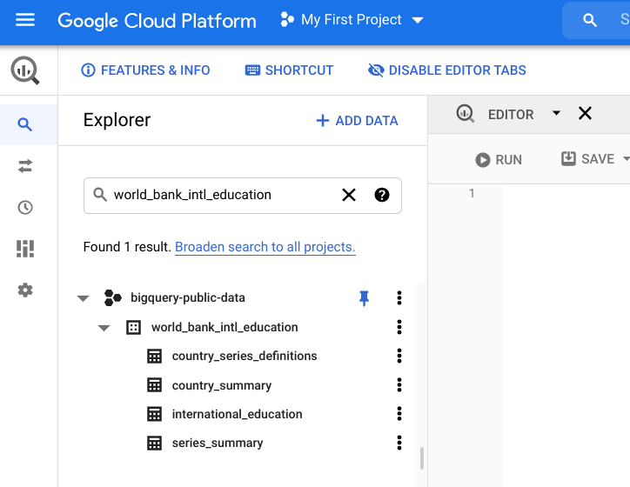

10. Click the **international\_education** table. This will bring up the table’s schema. If the schema doesn’t appear, click on the **Schema** tab in the table viewer.

11. Next, select the **country\_summary** table and examine its schema. You’ll find that the country\_codecolumn appears in both the table schemas.

* **Note:** Foreign keys don’t always have the same names across tables. If you’re ever unsure if the columns are the same, you can always double-check. You can query the column from each table and confirm that they contain the same kinds of information.

Review JOINs



Before you join the two tables with queries, take a moment to review the various kinds of JOIN statements.

Circles represent table 1 and table 2. In inner join, where the tables are joined is highlighted in green. In full join, table 1 and 2 are completely green. 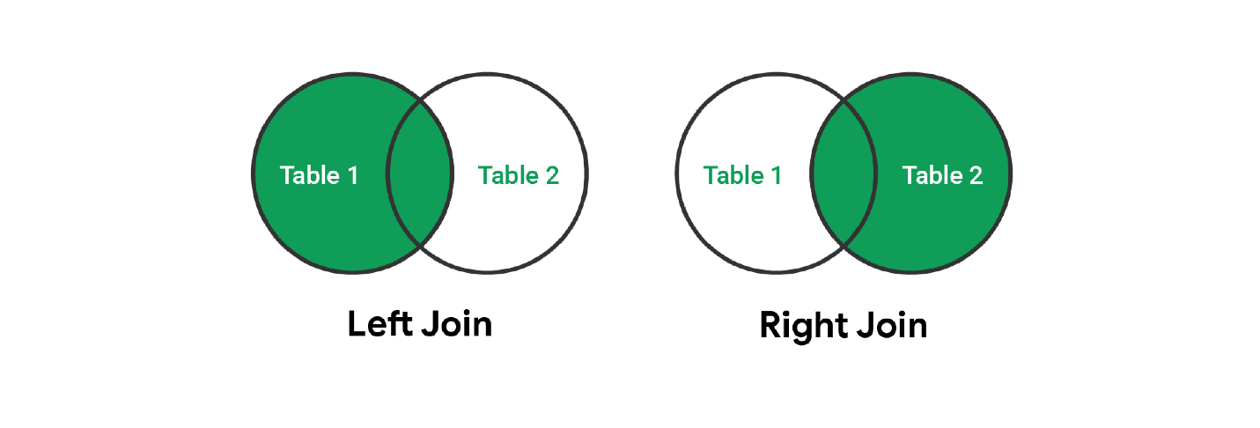Circles represent table 1 and table 2. In left join, table 1 is highlighted in green. In right join, table 2 is highlighted green. Where they are joined is highlighted in green.

The two most common kinds of JOIN statements are INNER JOINs and OUTER LEFT JOINs (also known simply as LEFT JOINs). As a review:

* **INNER JOIN:** Returns only the rows where the target appears in both tables.
* **LEFT JOIN:** Returns every row from the left table, as well as any rows from the right table with matching keys found in the left table.

Note the difference between the INNER JOIN and LEFT JOIN and the implications for when each should be used. Consider the following queries:

1

2

3

4

5

6

7

8

9

10

11

12

13

14

15

16

17

18

19

20

-- Let's say table\_1 has 100 rows and table\_2 has 10 rows.

-- They share 10 keys in common.

-- Using INNER JOIN --> We get 10 rows in our results.

SELECT

    COUNT(\*)

FROM

    table\_1

INNER JOIN

    table\_2

ON table\_1.key = table\_2.key;

-- Using LEFT JOIN --> We get 100 rows in our results.

SELECT

    COUNT(\*)

FROM

    table\_1

LEFT JOIN

    table\_2

ON table\_1.key = table\_2.key;





The takeaway here is that the sort of JOIN you use matters. When writing a query, you can draw out a Venn diagram like the example graphic above to help you decide which sort of JOIN you need.

Queries with JOINS and aliases



Now, it’s time to actually query the dataset. As a starting point, try a query that pulls information from both the international\_education and country\_summary tables. Copy, paste, and run the following query:

1

2

3

4

5

6

7

8

9

SELECT

    `bigquery-public-data.world\_bank\_intl\_education.international\_education`.country\_name,

    `bigquery-public-data.world\_bank\_intl\_education.country\_summary`.country\_code,

    `bigquery-public-data.world\_bank\_intl\_education.international\_education`.value

FROM

    `bigquery-public-data.world\_bank\_intl\_education.international\_education`

INNER JOIN

    `bigquery-public-data.world\_bank\_intl\_education.country\_summary`

ON `bigquery-public-data.world\_bank\_intl\_education.country\_summary`.country\_code = `bigquery-public-data.world\_bank\_intl\_education.international\_education`.country\_code





This basic query joins the tables on the country\_code foreign key, and returns the country name, country code, and value column. This is quite a long, unwieldy query for such a basic result! The length of each table name (which must include the full address for each table for BigQuery to know where to pull the data from) makes this hard to read and work with.

However, you can solve this by setting an **alias** for each table.

Use descriptive aliases



Try using descriptive aliases that tell you what they represent. This next query is the same query as the previous one, but with aliases to improve readability. Copy, paste, and run the following query:

1

2

3

4

5

6

7

8

9

SELECT

    edu.country\_name,

    summary.country\_code,

    edu.value

FROM

    `bigquery-public-data.world\_bank\_intl\_education.international\_education` AS edu

INNER JOIN

    `bigquery-public-data.world\_bank\_intl\_education.country\_summary` AS summary

ON edu.country\_code = summary.country\_code





Your results should appear like this:

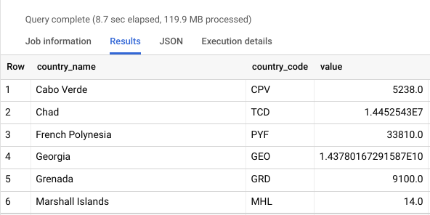

This query is much easier to read and understand. Recall that you can set aliases for tables by specifying the alias for the table after the table’s name in FROM and/or JOIN statements.

For this example, the international\_education table was renamed as **edu**, and the country\_summary table as **summary**. Using descriptive aliases is a best practice and will help you keep your queries clean, readable, and easy to work with.

Use a JOIN to answer a question



Now that you’ve confirmed that the JOIN statement works, try to answer an actual data question using this dataset. What is the average amount of money spent per region on education? Copy, paste, and run the following query:

1

2

3

4

5

6

7

8

9

10

SELECT

    AVG(edu.value) average\_value, summary.region

FROM

    `bigquery-public-data.world\_bank\_intl\_education.international\_education` AS edu

INNER JOIN

    `bigquery-public-data.world\_bank\_intl\_education.country\_summary` AS summary

ON edu.country\_code = summary.country\_code

WHERE summary.region IS NOT null

GROUP BY summary.region

ORDER BY average\_value DESC





Your results should appear like this:

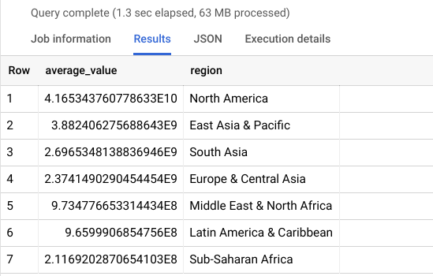

Notice how in this query, an alias is also set to give the **AVG(edu.value)** a more descriptive name for the temporary table the query returns.

Also note that the WHERE statement excludes rows with any null information. This is necessary to present the data succinctly and display only seven rows for the seven regions represented in the data. However, this WHERE statement means that the results will return the same regardless of which JOIN you use. In the next section, you’ll explore a situation where you need to use a specific kind of join in your query...

INNER JOINs versus OUTER JOINs



In the last query, you used an INNER JOIN to find the average amount of money spent per region on education. Because of the WHERE statement in this query, using any kind of JOIN produces the same result.

Now, you will write a LEFT JOIN, a type of OUTER JOIN, for a situation where the type of query you use will change the result you return.

Consider this scenario:

You have been tasked to provide data for a feature sports article on Michael Jordan’s basketball career. The writer wants to include a funny twist and asks you to find out if Michael Jordan played better at schools with animal mascots.

To analyze his early career, you start with the years he played basketball in college. You need to examine National Collegiate Athletic Association (NCAA) college basketball stats from 1984.

You’ll need a list of all NCAA Division I colleges and universities; their mascots, if applicable; and their number of wins and losses. You can find this information in the public dataset **ncaa\_basketball** on BigQuery.

Next, you will write a query. Your query should join the season statistics from one table with the mascot information from another. You need to use a LEFT JOIN instead of an INNER JOIN because not all teams have mascots. If you use an INNER JOIN, you would exclude teams with no mascot.

To demonstrate this, copy, paste, and run the following query:

1

2

3

4

5

6

7

8

9

10

11

12

13

14

15

16

17

18

SELECT

 seasons.market AS university,

 seasons.name AS team\_name,

 seasons.wins,

 seasons.losses,

 seasons.ties,

 mascots.mascot AS team\_mascot

FROM

 `bigquery-public-data.ncaa\_basketball.mbb\_historical\_teams\_seasons` AS seasons

LEFT JOIN

 `bigquery-public-data.ncaa\_basketball.mascots` AS mascots

ON

 seasons.team\_id = mascots.id

WHERE

 seasons.season = 1984

 AND seasons.division = 1

ORDER BY

 seasons.market





This is an example of when a LEFT JOIN is more helpful than an INNER JOIN. With this query, you can look at college basketball statistics to get a better sense of Michael Jordan’s early career, find out more information about which teams had mascots, and answer your business question.

Optional: Upload the warehouse dataset to BigQuery

The next video demonstrates how to use COUNT and COUNT DISTINCT in SQL to count and return the number of certain values in a dataset.

If you would like to follow along with the instructor, you will need to log in to your BigQuery account and upload the warehouse data provided as two CSV files. If you have hopped around courses, [Using BigQuery](https://www.coursera.org/learn/data-preparation/supplement/DYOQK/using-bigquery) in the **Prepare Data for Exploration** course covers how to set up a BigQuery account.

**Prepare for the next video**

* First, download the two CSV files from the attachments below:

**Warehouse Orders - Warehouse**CSV File

[Download file](https://d3c33hcgiwev3.cloudfront.net/imJai0YnRlyiWotGJ4Zc4g_681d60c67a5c443f90940a3e3b548cf1_Warehouse-Orders---Warehouse.csv?Expires=1648080000&Signature=Ff~I~zPf3Z6JlzSzyZIhFqUH2cK87jUaNCupESS8jF-9NJlHz-pIZ9oNx9PE1fPOnkULOn6Wex4Xgyrgq9XHhg6146uFiC7UtDdfT2BhxYvO~TzzmL~w6nrspolVnQUybPvZs~o3yTNt6yPW-Cr1-dwGoF1zhRZEgQ3eJnR8-00_&Key-Pair-Id=APKAJLTNE6QMUY6HBC5A" \t "_blank)

**Warehouse Orders - Orders**CSV File

[Download file](https://d3c33hcgiwev3.cloudfront.net/7wHK8ZKvRoGByvGSr1aBNw_5433b9c9b98d41b09152b3331141def1_Warehouse-Orders---Orders.csv?Expires=1648080000&Signature=S2Zl8wDcEj0jmHPf3S8Zj4hRBk2G5wnQbvo7eu7VZbxyqAwgmtLN1cWPCt1dSulo5EmyMa-DbNlw1tDtyj0vJB6gGFgFdl40iwXhsw1OJVVoVgefPZUXFIUNcWijH21Ekl5Xx8J6N0ODu~wGznXqd4M4Xm3IHuf7hTAIrGGYG4k_&Key-Pair-Id=APKAJLTNE6QMUY6HBC5A" \t "_blank)

* Next, complete the following steps in your BigQuery console to upload the Warehouse Orders dataset with the two Warehouse and Orders tables.

**Step 1:** Open your BigQuery console and click on the project you want to upload the data to.

**Step 2:** In the Explorer on the left, click the Actions icon (three vertical dots) next to your project name and select **Create dataset**.



**Step 3:** In the upcoming video, the name "warehouse\_orders" will be used for the dataset. If you plan to follow along with the video, enter **warehouse\_orders** for the Dataset ID.

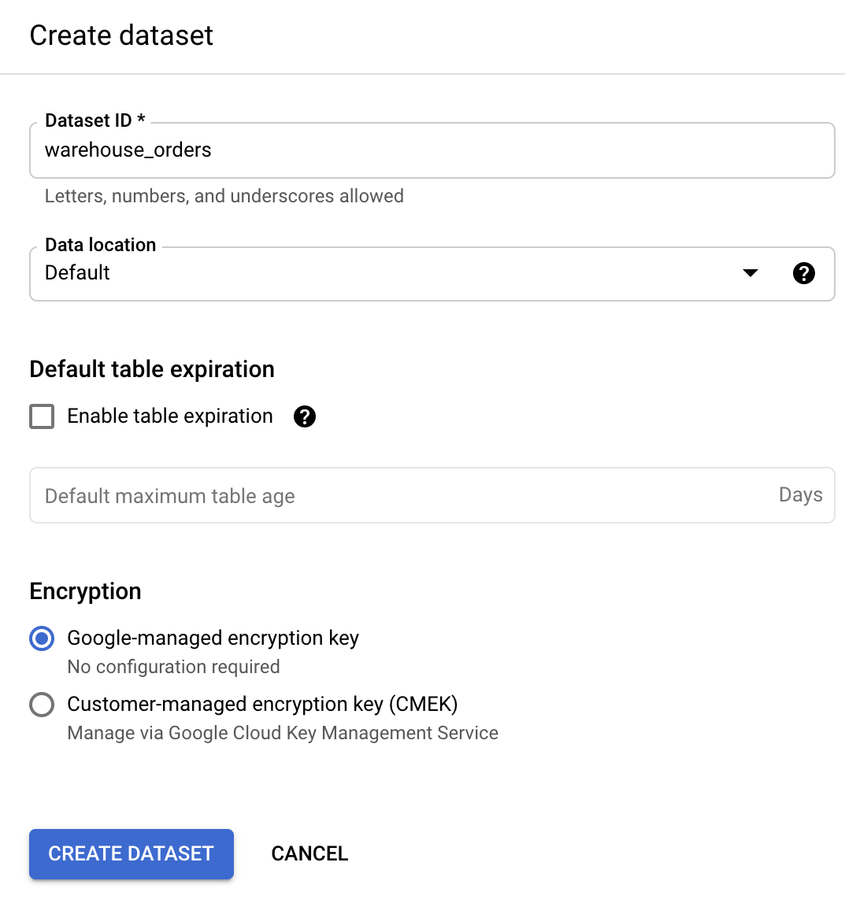

**Step 4:** Click **CREATE DATASET** (blue button) to add the dataset to your project.

**Step 5:** In the Explorer on the left, click to expand your project, and then click the **warehouse\_orders** dataset you just created.

**Step 6:** Click the Actions icon (three vertical dots) next to warehouse\_orders and select **Open**.

**Step 7:** Click the blue **+** icon at the top right to open the Create table window.



**Step 8:** Under Source, for the Create table from selection, choose where the data will be coming from.

* Select **Upload**.
* Click **Browse** to select the Warehouse Orders - Warehouse CSV file you downloaded.
* Choose **CSV** from the file format drop-down.

**Step 9:** For Table name, enter **Warehouse** if you plan to follow along with the video.

**Step 10:** For Schema, click the Auto detect check box.

**Step 11:** Click **Create** **table** (blue button). You will now see the **Warehouse** table under your **warehouse\_orders** dataset in your project.

**Step 12:** Click the **warehouse\_orders** dataset again.

**Step 13:** Click the icon to open the Create table window again.

**Step 14:** Under Source, for the Create table from selection, choose where the data will be coming from.

* Select **Upload**.
* Click **Browse** to select the Warehouse Orders - Orders CSV file you downloaded.
* Choose **CSV** from the file format drop-down.

**Step 15:** For Table name, enter **Orders** if you plan to follow along with the video.

**Step 16:** For Schema, click the Auto detect check box.

**Step 17:** Click **Create** **table** (blue button). You will now see the **Orders** table under your **warehouse\_orders** dataset in your project.

**Step 18:** Click the **Warehouse** table and click the **Preview** tab to verify that you have 10 rows of data.

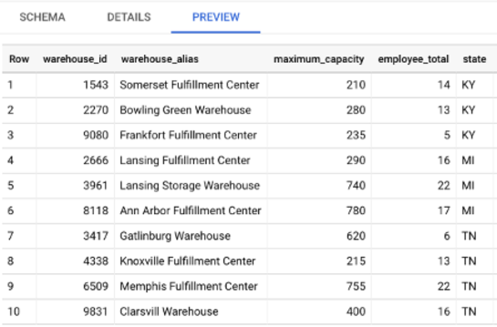

**Step 19:** Click the **Orders** table and click the **Preview** tab to verify that you have the data shown below.

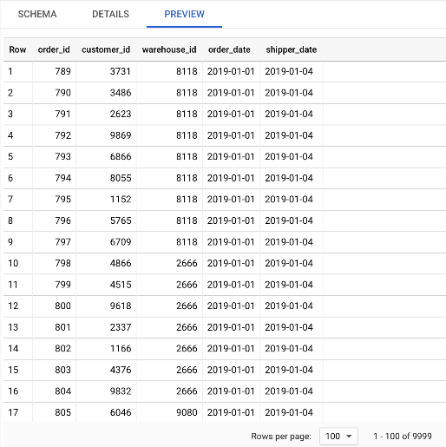

If your data previews match, you are ready to follow along with the next video.

SQL functions and subqueries: A functional friendship

In this reading, you will learn about SQL functions and how they are sometimes used with subqueries. **SQL functions** are tools built into SQL to make it possible to perform calculations. A **subquery** (also called an inner or nested query) is a query within another query.

**How do SQL functions, function?**

SQL functions are what help make data aggregation possible. (As a reminder, data aggregation is the process of gathering data from multiple sources in order to combine it into a single, summarized collection.) So, how do SQL functions work? Going back to W3Schools, let’s review some of these functions to get a better understanding of how to run these queries:

* [**SQL HAVING**](http://www-db.deis.unibo.it/courses/TW/DOCS/w3schools/sql/sql_having.asp.html)**:** This is an overview of the HAVING clause, including what it is and a tutorial on how and when it works.
* [**SQL CASE**](https://www.w3schools.com/sql/sql_case.asp)**:** Explore the usage of the CASE statement and examples of how it works.
* [**SQL IF**](https://www.w3schools.com/sql/func_mysql_if.asp)**:** This is a tutorial of the IF function and offers examples that you can practice with.
* [**SQL COUNT**](http://www-db.deis.unibo.it/courses/TW/DOCS/w3schools/sql/sql_func_count.asp.html)**:** The COUNT function is just as important as all the rest, and this tutorial offers multiple examples to review.

**Subqueries - the cherry on top**

Think of a query as a cake. A cake can have multiple layers contained within it and even layers within those layers. Each of these layers are our subqueries, and when you put all of the layers together, you get a cake (query). Usually, you will find subqueries nested in the SELECT, FROM, and/or WHERE clauses. There is no general syntax for subqueries, but the syntax for a basic subquery is as follows:

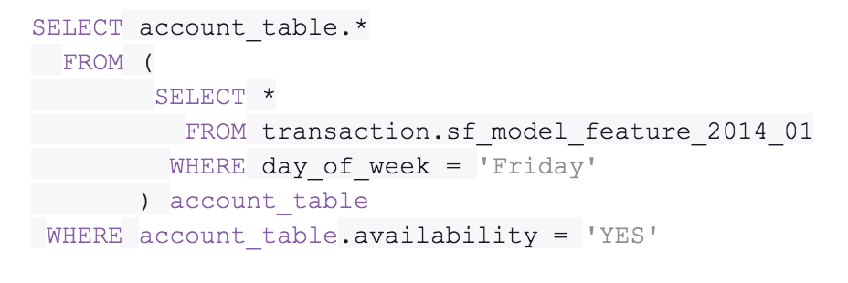SELECT account\_table.\* FROM ( SELECT \* FROM transaction.sf\_model\_feature\_2014\_01 WHERE day\_of\_week = 'Friday' ) account\_table WHERE account\_table.availability = 'YES'

You will find that, within the first SELECT clause is another SELECT clause. The second SELECT clause marks the start of the subquery in this statement. There are many different ways in which you can make use of subqueries, and resources referenced will provide additional guidance as you learn. But first, let’s recap the subquery rules.

There are a few rules that subqueries must follow:

* Subqueries must be enclosed within parentheses
* A subquery can have only one column specified in the SELECT clause. But if you want a subquery to compare multiple columns, those columns must be selected in the main query.
* Subqueries that return more than one row can only be used with multiple value operators, such as the IN operator which allows you to specify multiple values in a WHERE clause.
* A subquery can’t be nested in a SET command. The SET command is used with UPDATE to specify which columns (and values) are to be updated in a table.

**A​dditional resources**

The following resources offer more guidance into subqueries and their usage:

* [**SQL subqueries:**](https://www.w3resource.com/sql/subqueries/understanding-sql-subqueries.php) This detailed introduction includes the definition of a subquery, its purpose in SQL, when and how to use it, and what the results will be
* [**Writing subqueries in SQL**](https://mode.com/sql-tutorial/sql-sub-queries/)**:** Explore the basics of subqueries in this interactive tutorial, including examples and practice problems that you can work through

As you continue to learn more about using SQL, functions, and subqueries, you will realize how much time you can truly save when memorizing these tips and tricks.



Functions with multiple conditions

In this reading, you will learn more about conditional functions and how to construct functions with multiple conditions. Recall that conditional functions and formulas perform calculations according to specific conditions. Previously, you learned how to use functions like **SUMIF** and **COUNTIF** that have one condition. You can use the **SUMIFS** and **COUNTIFS** functions if you have two or more conditions. You will learn their basic syntax in Google Sheets, and check out an example.

Refer to the resources at the end of this reading for information about similar functions in Microsoft Excel.

**SUMIF to SUMIFS**

The basic syntax of a SUMIF function is: **=SUMIF(range, criterion, sum\_range)**

The first range is where the function will search for the condition that you have set. The criterion is the condition you are applying and the sum\_range is the range of cells that will be included in the calculation.

For example, you might have a table with a list of expenses, their cost, and the date they occurred.

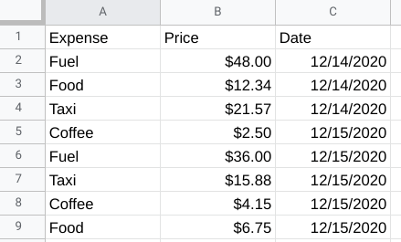Column A: A1 - Expense A2 - Fuel A3 - Food A4 - Taxi A5 - Coffee A6 - Fuel A7 - Taxi A8 - Coffee A9 - Food Column B: B1 - Price B2 - $48.00 B3 - $12.34 B4 - $21.57 A5 - $2.50 A6 - $36.00 A7 - $15.88 A8 - $4.15 A9 - $6.75 Column C: C1 - Date C2 - 12/14/2020 C3 - 12/14/2020 C4 - 12/14/2020 C5 - 12/15/2020 C6 - 12/15/2020 C7 - 12/15/2020 C8 - 12/15/2020 C9 - 12/15/2020

You could use SUMIF to calculate the total price of fuel in this table, like this:



But, you could also build in multiple conditions by using the SUMIFS function. SUMIF and SUMIFS are very similar, but SUMIFS can include multiple conditions.

The basic syntax is: **=SUMIFS(sum\_range, criteria\_range1, criterion1, [criteria\_range2, criterion2, ...])**

The square brackets let you know that this is optional. The ellipsis at the end of the statement lets you know that you can have as many repetition of these parameters as needed. For example, if you wanted to calculate the sum of the fuel costs for one date in this table, you could create a SUMIFS statement with multiple conditions, like this:



This formula gives you the total cost of every fuel expense from the date listed in the conditions. In this example, C1:C9 is our second criterion\_range and the date 12/15/2020 is the second condition. As long as you follow the basic syntax, you can add up to 127 conditions to a SUMIFS statement!

**COUNTIF to COUNTIFS**

Just like the SUMIFS function, COUNTIFS allows you to create a COUNTIF function with multiple conditions.

The basic syntax for COUNTIF is: **=COUNTIF(range, criterion)**

Just like SUMIF, you set the range and then the condition that needs to be met. For example, if you wanted to count the number of times Food came up in the Expenses column, you could use a COUNTIF function like this:



COUNTIFS has the same basic syntax as SUMIFS: **=COUNTIFS(criteria\_range1, criterion1, [criteria\_range2, criterion2, ...])**

The criteria\_range and criterion are in the same order, and you can add more conditions to the end of the function. So, if you wanted to find the number of times Coffee appeared in the Expenses column on 12/15/2020, you could use COUNTIFS to apply those conditions, like this:



This formula follows the basic syntax to create conditions for “Coffee” and the specific date. Now we can find every instance where both of these conditions are true.

**For more information**

SUMIFS and COUNTIFS are just two examples of functions with multiple conditions. They help demonstrate how multiple conditions can be built into the basic syntax of a function. But, there are other functions with multiple conditions that you can use in your data analysis. There are a lot of resources available online to help you get started with these other functions:

* [**How to use the Excel IFS function**](https://exceljet.net/excel-functions/excel-ifs-function): This resource includes an explanation and example of the IFS function in Excel. This is a great reference if you are interested in learning more about IFS. The example is a useful way to understand this function and how it can be used.
* [**VLOOKUP in Excel with multiple criteria**](https://exceljet.net/formula/vlookup-with-multiple-criteria): Similar to the previous resource, this resource goes into more detail about how to use VLOOKUP with multiple criteria. Being able to apply VLOOKUP with multiple criteria will be a useful skill, so check out this resource for more guidance on how you can start using it on your own spreadsheet data.
* [**INDEX and MATCH in Excel with multiple criteria**](https://exceljet.net/formula/index-and-match-with-multiple-criteria)**:** This resource explains how to use the INDEX and MATCH functions with multiple criteria. It also includes an example which helps demonstrate how these functions work with multiple criteria and actual data.
* [**Using IF with AND, OR, and NOT functions in Excel**](https://support.microsoft.com/en-us/office/using-if-with-and-or-and-not-functions-d895f58c-b36c-419e-b1f2-5c193a236d97)**:** This resource combines IF with AND, OR, and NOT functions to create more complex functions. By combining these functions, you can perform your tasks more efficiently and cover more criteria at once.

**Hands-On Activity: Working with conditions**

**Total points**2

**1.**

**Question 1**



Activity overview



In previous activities, you used basic spreadsheet functions such as COUNT, SUM, AVERAGE, and MAX. In this activity, you will work with the conditional versions of these functions: COUNTIF, SUMIF, AVERAGEIF, and MAXIFS.

**Conditional functions** are functions that perform a specific task, but only on cells that satisfy some defined criteria. They are usually identified with an IF suffix adjoined to the desired operation. They are frequently used when constructing more complex queries that cannot be accomplished using more basic functions.

By the time you complete this activity, you will be able to use conditional functions and understand when and why they are appropriate. This will enable you to do more complex analysis with spreadsheets as you continue to develop your data analyst’s skill set.



What you will need

To get started, first access the Working with Conditions spreadsheet.

Click the link to the spreadsheet to create a copy. If you don’t have a Google account, you may download the spreadsheet directly from the attachments below. Make sure to select “Use Template” on the downloadable item.

Link to spreadsheet: [Working with Conditions](https://docs.google.com/spreadsheets/d/1sKNqBzV63Na76jjoKLukjTtDyDMwVW0Vjz4mM-sJDEM/template/preview#gid=895883562)

OR

Download spreadsheet:

**Working with Conditions**XLSX File

[Download file](https://d3c33hcgiwev3.cloudfront.net/TP0HEtBSRZK9BxLQUtWSdw_2d90471b8d4d49d58e6d845ef38b17f1_Working-with-Conditions.xlsx?Expires=1648080000&Signature=fzgef3xs9Rd0V5NZqXIbLOqGLdXc6Lst5EHGxgIOCFT7Cy91IN7KGrxUXAGWwesNRlXSmrkCjyuV3ke~znJHsZh8O6fBE-eMEU2vLfnUyv50plaN8mTr8c-67kTp03Gzd5syvthryyY7BJ4c~1hqrMu5oqFjFhbn~Z4ErnpJisQ_&Key-Pair-Id=APKAJLTNE6QMUY6HBC5A" \t "_blank)



This data set has seven columns and 20 rows (not including the headers). The contents are several metrics pertaining to a fictitious team of salespeople.

Use the COUNTIF function



First, open the Working with Conditions spreadsheet.

Suppose you want to calculate the number of salespeople that the company has in New York state. The COUNTIF function allows you to do this easily. The syntax for COUNTIF is **=COUNTIF(range, criteria).**

The **range** is the array (or collection) of cells that you are checking and the **criteria** is what you are checking for. All cells in the array that match the provided criteria will be counted and this number returned as the value of the function.

To use this function to count the number of salespeople working from “NY,” click on an open cell. In the function bar, type **=COUNTIF(B2:B21, "NY")**.

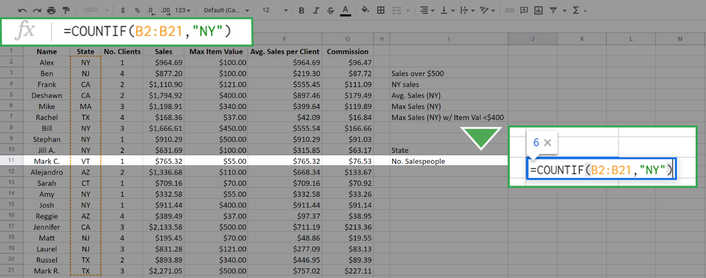

Notice you've entered the range as the array of cells from **B2** to **B21**. This is all from column B with the exception of the column header. The function checks all cells in this array against the value “NY” (entered in quotes) which is the **criteria**. Every cell in this array with a value of “NY” will be counted, and the result is returned in the cell. It is 6 in this case.

Press **Enter** (Windows) or **Return** (Mac). The result should display like this:

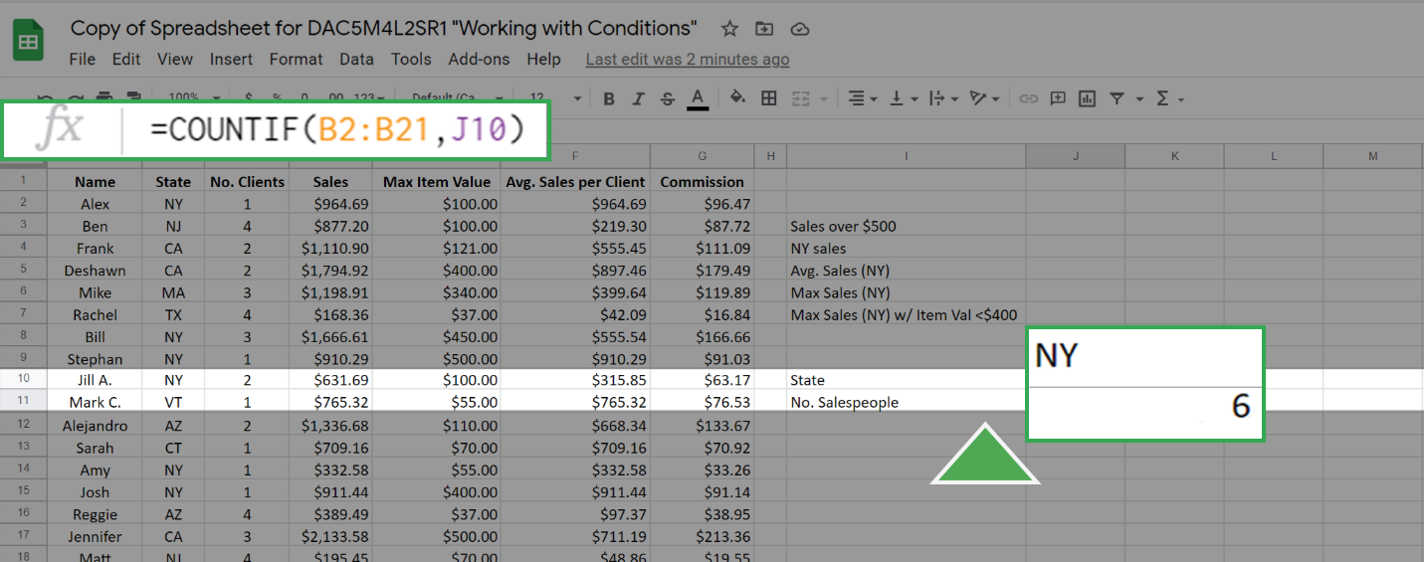

As an alternative to entering the criteria "NY" into the **COUNTIF** function, you can achieve the same result by entering a cell address as the criteria. The function will then use the value of the cited cell as the criteria. For example, the cell **J10** has the value "NY." If you enter this in the function bar the **COUNTIF** function will seek out the value in cell **J10** and use it as the criteria. This gives the same result as before:

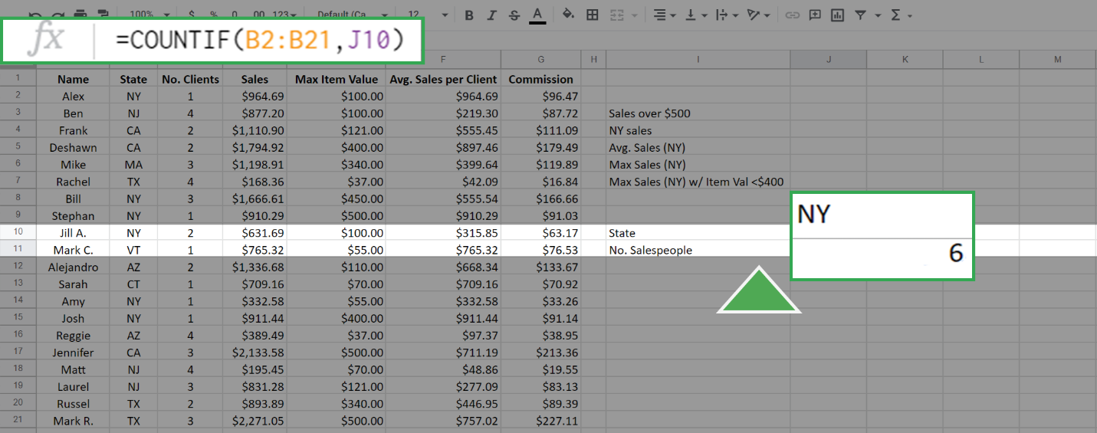

Use the SUMIF function



The **SUMIF** function is used to create a sum of the values of cells that meet a specific criteria. It supports the logical operators (>, <, <>, =). The syntax for this function is **=SUMIF(range, criteria, [sum\_range] )**.

The input**range** is the array of cells that you check against the value of **criteria**. The **sum\_range** is the array of values that you will sum up if the criteria is met. In this syntax above, the square brackets around sum\_range indicate that this input is optional. However, you do not add square brackets when writing the function. If the argument **sum\_range** is absent, then the SUMIF will sum the values in range by default.

As an example of this function, suppose that you want to create a sum of all sales more than $500.00. This can be executed as **=SUMIF(D2:D21, ">500").**

The result is:

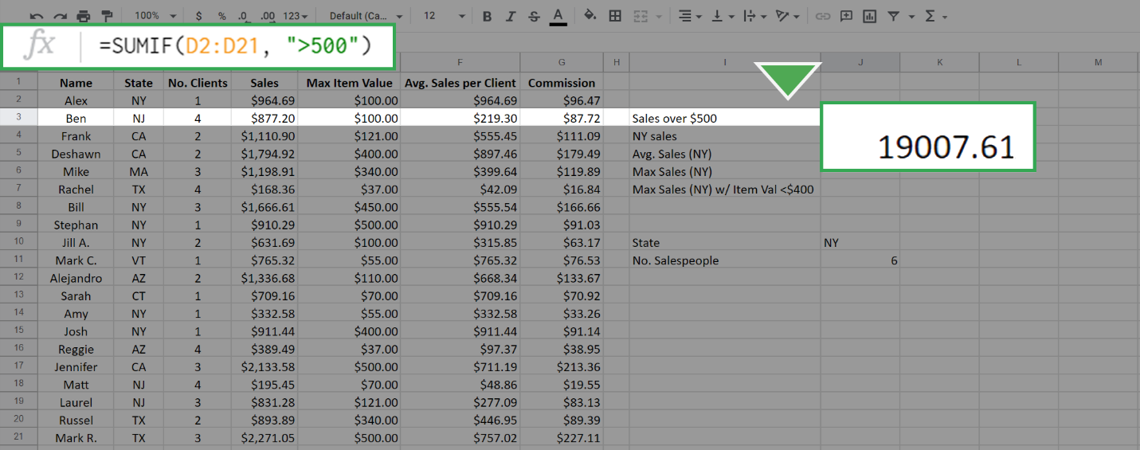

Because you didn't include the sum\_range input, all the values in the cells D2 to D21 that match the criteria were summed by default. To sum only the sales from New York, but not restrict to those greater than $500, type the following function: **=SUMIF(B2:B21, "NY", D2:D21).**

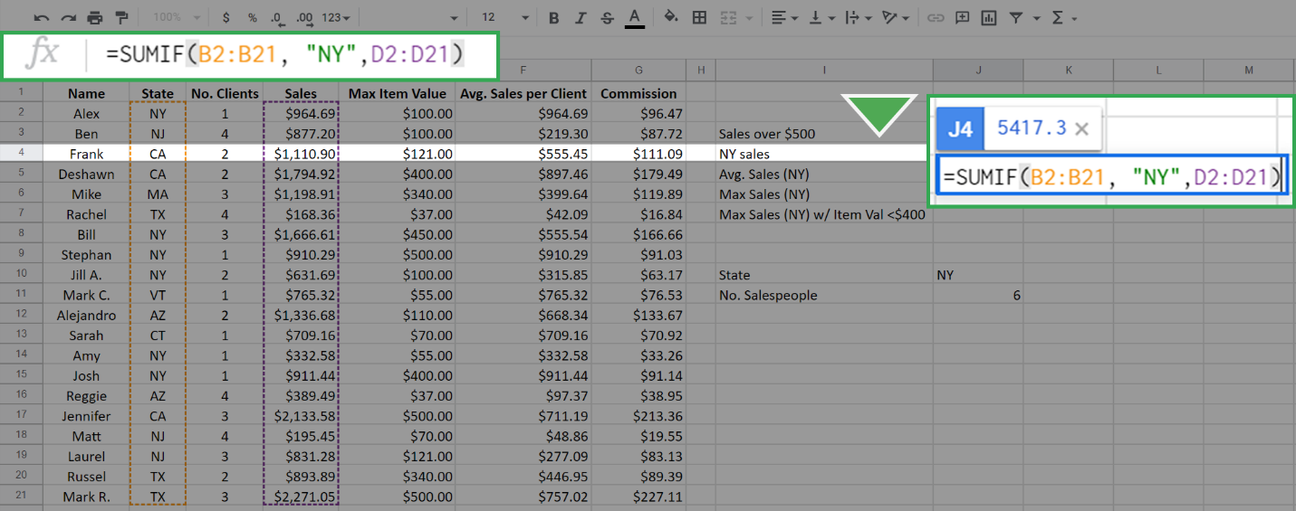

This results in:

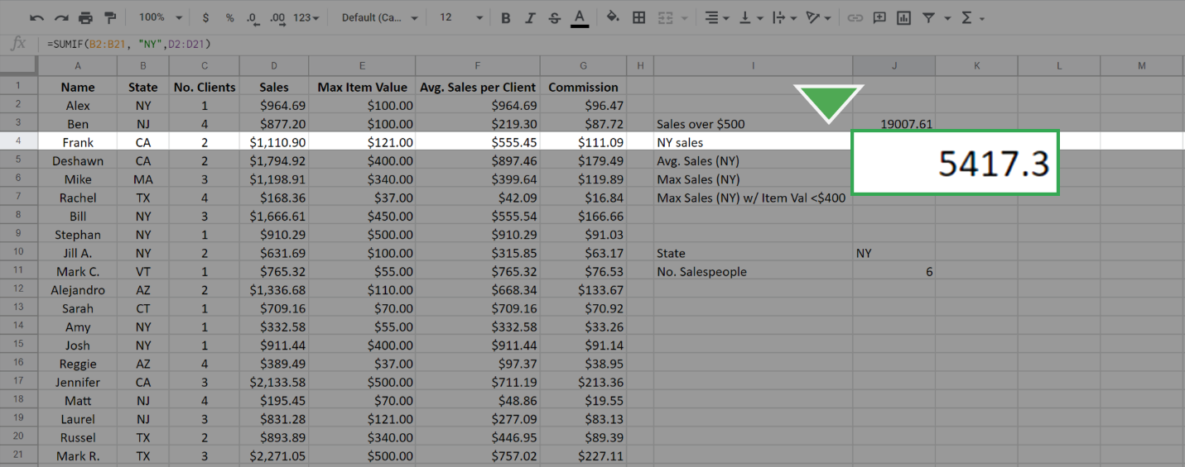

Notice that in the SUMIF, the first input, **B2:B21**, is the range of cells that are checked for the criteria "NY" and the summing is done across the sum\_range of cells **D2:D21** that have the state meeting the criteria "NY." This is different than in the first case. In that case, the array that you check is the same array that you sum across.

Use the AVERAGEIF function



Just like the previous two functions, the **AVERAGEIF** function will average the values in an array based on a given criteria. The syntax is **=AVERAGEIF(range, criteria, [sum\_range]).**

The inputs to this function, **range**, **criteria**, and **sum\_range**, work in exactly the same manner as in the SUMIF function. Again, the sum\_range is optional.

Now, find the average sales per salesperson in New York. Type the following function: **=AVERAGEIF(B2:B21, "NY", D2:D21).**

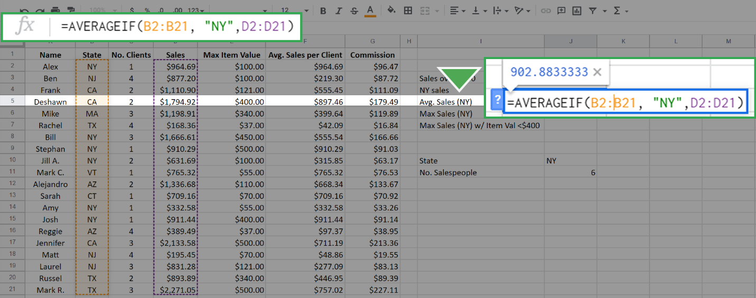

This yields 902.83333 as the result.

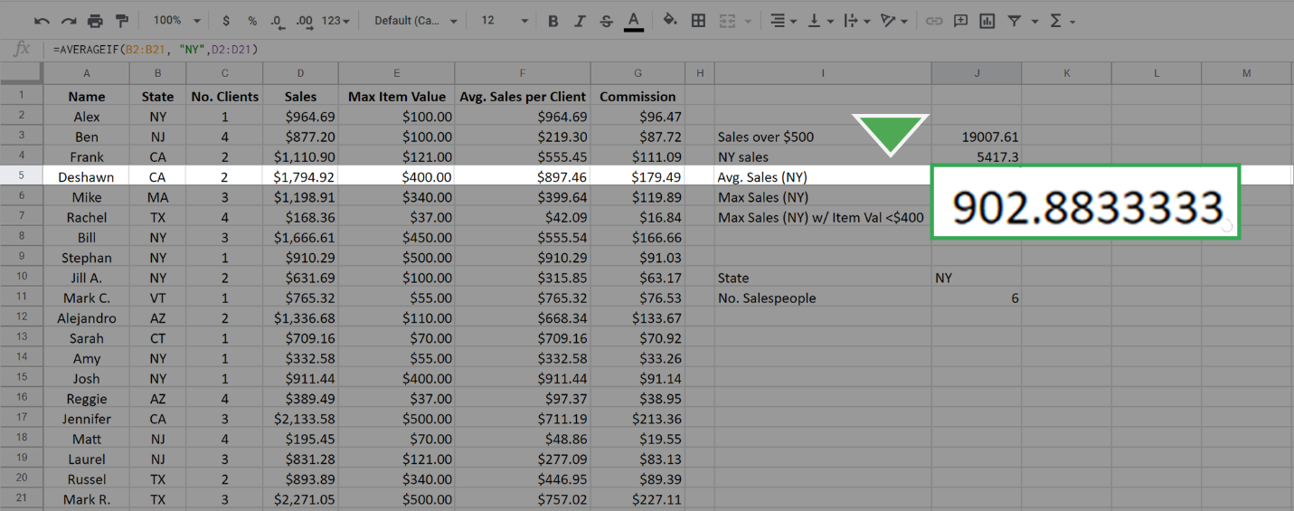

Use the MAXIFS function



The **MAXIFS** function is slightly different from the other three functions. The easiest way to observe the difference is to examine the syntax: **=MAXIFS(max\_range, range1, criteria1, [range2], [criteria2], ...).**

* **Note for Microsoft Excel users:** MAXIFS can only be used with an Office 365 subscription on Excel 2016 or newer. If you cannot use a version of Excel that allows the function MAXIFS, please use Google Sheets for this part of the activity.

The first argument, **max\_range**, is the array over which you are finding the maximum. The second argument (**range1**) is the array you are checking. The third argument (**criteria1**) is the value that you are checking for. The inputs in the square brackets are for optional additional constraints.

Use this function to find the maximum sales from any salesperson in New York. Type the following: **=MAXIFS(D2:D21, B2:B21, "NY").**

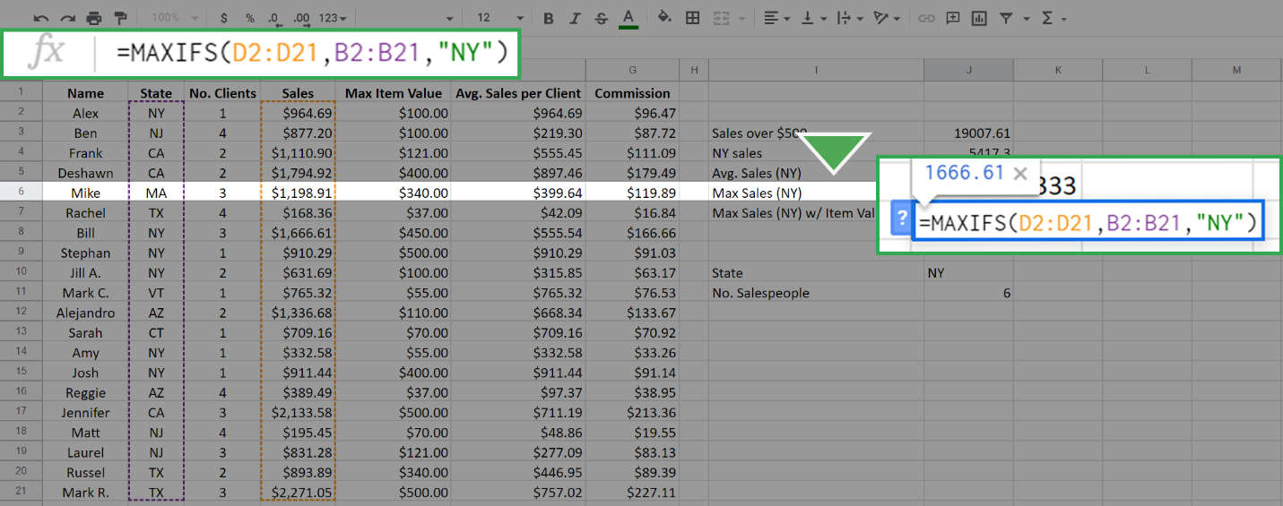

The resulting calculation is **1666.61**.

Remember, the order in which you enter the inputs matters. Try reversing the position of the arrays from the first example and type **=MAXIFS(B2:B21, D2:D21, "NY")**.

The result is **0**.

This is because you are asking the function to find the maximum of the array B2:B21 where the sales equal "NY". This is impossible because the values in the array D2:D21 (the sales array) are numerical. Therefore, none of them equals "NY," which is a string. The function returns 0 when nothing in the range meets the criteria.

The MAXIFS function can input more than one constraint. This is where the optional range2 and constraint2 come into play. Additional constraints follow the logic that every constraint must be satisfied for a cell in the max\_range to be considered.

For example, to find the maximum sales in New York where the Max Item Cost is below $400, type the following into the function bar: **=MAXIFS(D2:D21, B2:B21, "NY", E2:E21, "<400").**

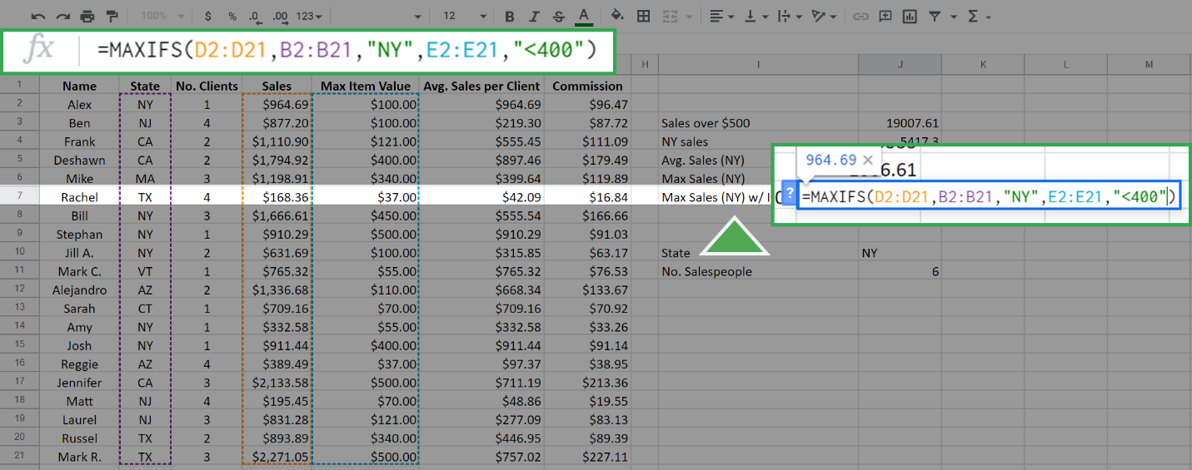

The first three inputs are the same as above, but now you've added the additional constraint that Max Item Value must be less than $400. The array **E2:E21** is the Max Item array and its cells are checked against the criteria <400. The function returns the following, which is the maximum sales of any New York salesperson who did not sell any single item over (or equal to) $400.

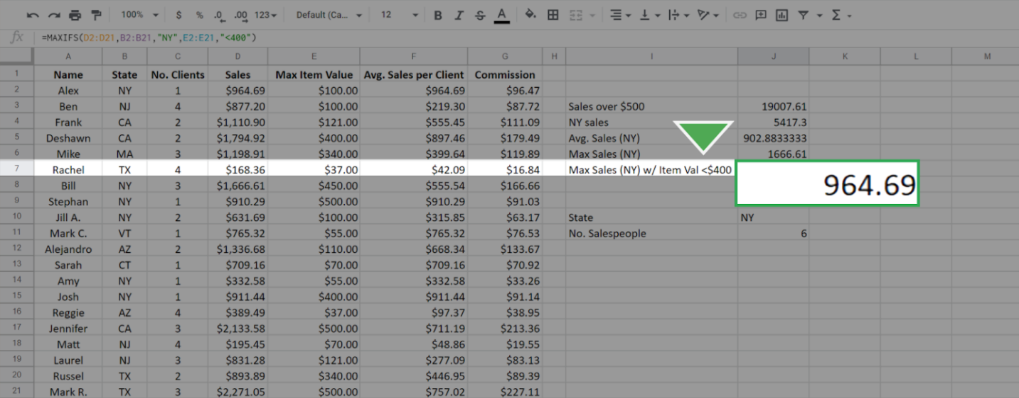

Each of the previous functions—COUNTIF, SUMIF, and AVERAGEIF—have equivalents that work similarly to MAXIFS. These include COUNTIFS, SUMIFS, and AVERAGEIFS. The syntax and functionality of these functions, apart from the specific calculation, are identical to MAXIFS. For example, the SUMIFS function will give the sum for single and multiple constraints just like MAXIFS function does for the maximum. It also has the same syntax as MAXIFS.

# Elements of a pivot table

Previously, you learned that a pivot table is a tool used to sort, reorganize, group, count, total, or average data in spreadsheets. In this reading, you will learn more about the parts of a pivot table and how data analysts use them to summarize data and answer questions about their data.

**Pivot tables** make it possible to view data in multiple ways in order to identify insights and trends. They can help you quickly make sense of larger data sets by comparing metrics, performing calculations, and generating reports. They’re also useful for answering specific questions about your data.

A pivot table has four basic parts: rows, columns, values, and filters.

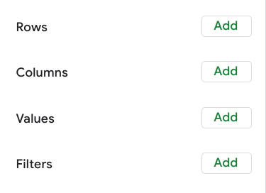

The **rows** of a pivot table organize and group data you select horizontally. For example, in the [Working with pivot tables](https://www.coursera.org/learn/analyze-data/lecture/Jl8cZ/working-with-pivot-tables) video, the Release Date values were used to create rows that grouped the data by year.

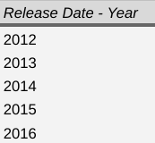

The **columns** organize and display values from your data vertically. Similar to rows, columns can be pulled directly from the data set or created using **values**. **Values** are used to calculate and count data. This is where you input the variables you want to measure. This is also how you create calculated fields in your pivot table. As a refresher, a **calculated field** is a new field within a pivot table that carries out certain calculations based on the values of other fields

In the previous movie data example, the Values editor created columns for the pivot table, including the SUM of Box Office Revenue, the AVERAGE of Box Office Revenue, and the COUNT of Box Office Revenue columns.

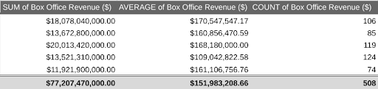

Finally, the **filters** section of a pivot table enables you to apply filters based on specific criteria — just like filters in regular spreadsheets! For example, a filter was added to the movie data pivot table so that it only included movies that generated less than $10 million in revenue.

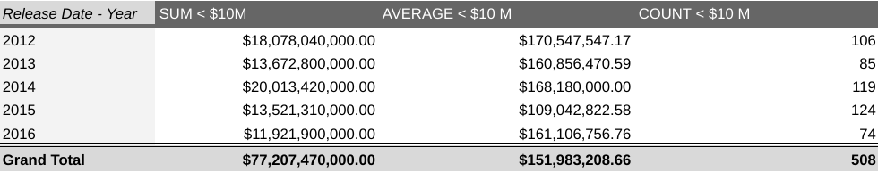

Being able to use all four parts of the pivot table editor will allow you to compare different metrics from your data and execute calculations, which will help you gain valuable insights.

## Using pivot tables for analysis

Pivot tables can be a useful tool for answering specific questions about a dataset so you can quickly share answers with stakeholders. For example, a data analyst working at a department store was asked to determine the total sales for each department and the number of products they each sold. They were also interested in knowing exactly which department generated the most revenue.

Instead of making changes to the original spreadsheet data, they used a pivot table to answer these questions and easily compare the sales revenue and number of products sold by each department.

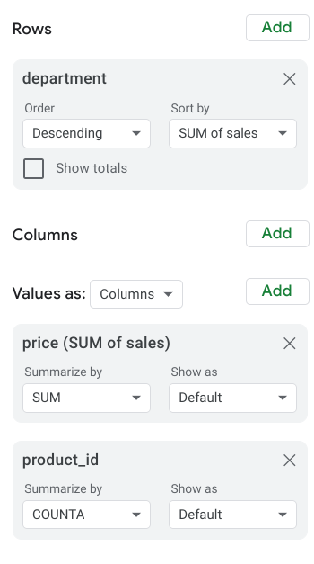

They used the department as the rows for this pivot table to group and organize the rest of the sales data. Then, they input two Values as columns: the SUM of sales and a count of the products sold. They also sorted the data by the SUM of sales column in order to determine which department generated the most revenue.

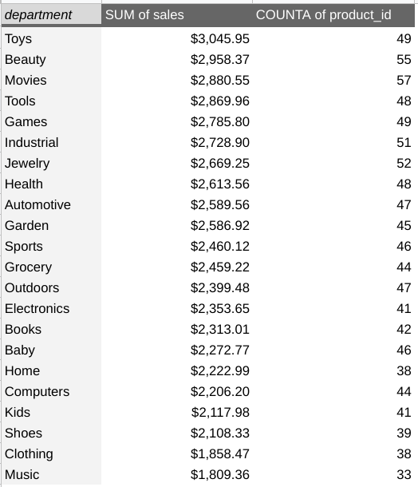

Now they know that the Toys department generated the most revenue!

Pivot tables are an effective tool for data analysts working with spreadsheets because they highlight key insights from the spreadsheet data without having to make changes to the spreadsheet. Coming up, you will create your own pivot table to analyze data and identify trends that will be highly valuable to stakeholders.

# Using pivot tables in analysis

In this reading, you will learn how to create and use pivot tables for data analysis. You will also get some resources about pivot tables that you can save for your own reference when you start creating pivot tables yourself. **Pivot tables** are a spreadsheet tool that let you view data in multiple ways to find insights and trends.

Pivot tables allow you to make sense of large data sets by giving you tools to easily compare metrics, quickly perform calculations, and generate readable reports. You can create a pivot table to help you answer specific questions about your data. For example, if you were analyzing sales data, you could use pivot tables to answer questions like, “Which month had the most sales?” and “What products generated the most revenue this year?” When you need answers to questions about your data, pivot tables can help you cut through the clutter and focus on only the data you need.

## Create your pivot table

Before you can analyze data with pivot tables, you will need to create a pivot table with your data. The following includes the steps for creating a pivot table in Google Sheets, but most spreadsheet programs will have similar tools.

First, you will open the **Data** menu from the toolbar; there will be an option for **Pivot table**.

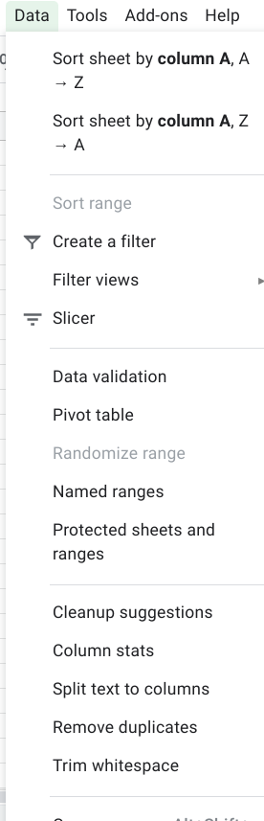

This pop-up menu will appear:

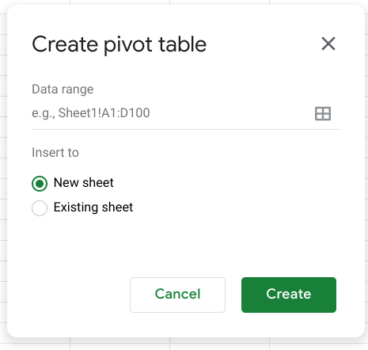There is an option to select New sheet or Existing sheet and a Create button

Generally, you will want to create a new sheet for your pivot table to keep your raw data and your analysis separate. You can also store all of your calculations in one place for easy reference. Once you have created your pivot table, there will be a pivot table editor that you can access to the right of your data.

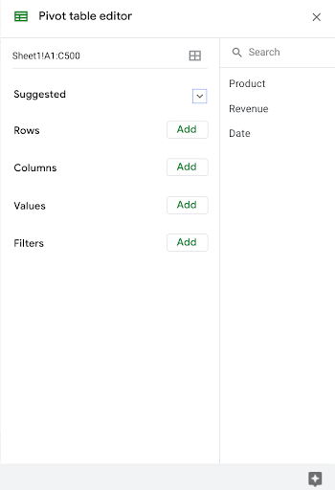

This is where you will be able to customize your pivot table, including what variables you want to include for your analysis.

## Using your pivot table for analysis

You can perform a wide range of analysis tasks with your pivot tables to quickly draw meaningful insights from your data, including performing calculations, sorting, and filtering your data. Below is a list of online resources that will help you learn about performing basic calculations in pivot tables as well as resources for learning about sorting and filtering data in your pivot tables.

### **Perform calculations**

| **Microsoft Excel** | **Google Sheets** |
| --- | --- |
| [**Calculate values in a pivot table**](https://support.microsoft.com/en-us/office/calculate-values-in-a-pivottable-11f41417-da80-435c-a5c6-b0185e59da77)**:** Microsoft Support’s introduction to calculations in Excel pivot tables. This is a useful starting point if you are learning how to perform calculations with pivot tables specifically in Excel. | [**Create and use pivot tables**](https://support.google.com/docs/answer/1272900?co=GENIE.Platform%3DDesktop&hl=en)**:** This guide is focused on using pivot tables in Google Sheets and it provides instructions for creating calculated fields. This is a quick how-to guide you can save and reference as a quick reminder on how to add calculated fields. |
| [**Pivot table calculated field example**](https://exceljet.net/pivot-table/pivot-table-calculated-field-example)**:** This resource includes a detailed example of a pivot table being used for calculations. This step-by-step process demonstrates how calculated fields work, and provides you with some idea of how they can be used for analysis. | [**All about calculated field in pivot tables**](https://infoinspired.com/google-docs/spreadsheet/all-about-calculated-field-in-pivot-table-in-google-sheets/)**:** This is a comprehensive guide to calculated fields for Google Sheets. If you are working with Sheets and are interested in learning more about pivot tables, this is a great resource. |
| [**Pivot table calculated fields: step-by-step tutorial**](https://powerspreadsheets.com/pivottable-calculated-fields/)**:** This tutorial for creating your own calculated fields in pivot tables is a really useful resource to save and bookmark for when you start to apply calculated fields to your own spreadsheets. | [**Pivot tables in Google Sheets**](https://www.benlcollins.com/spreadsheets/pivot-tables-google-sheets/)**:** This beginner’s guide covers the basics of pivot tables and calculated fields in Google Sheets and uses examples and how-to videos to help demonstrate these concepts. |

### **Sort your data**

| **Microsoft Excel** | **Google Sheets** |
| --- | --- |
| [**Sort data in a pivot table or PivotChart**](https://support.microsoft.com/en-us/office/sort-data-in-a-pivottable-or-pivotchart-e41f7107-b92d-44ef-861f-24430830450a)**:** This is a Microsoft Support how-to guide to sorting data in pivot tables. This is a useful reference if you are working with Excel and are interested in checking out how filtering will appear in Excel specifically. | [**Customize a pivot table**](https://support.google.com/docs/answer/7572895?co=GENIE.Platform%3DDesktop&hl=en)**:** This guide from Google Support focuses on sorting pivot tables in Google Sheets. This is a useful, quick reference if you are working on sorting data in Sheets and need a step-by-step guide. |
| [**Pivot tables- Sorting data**](https://www.tutorialspoint.com/excel_pivot_tables/excel_pivot_tables_sorting_data.htm)**:** This tutorial for sorting data in pivot tables includes an example with real data that demonstrates how sorting in Excel pivot tables works. This example is a great way to experience the entire process from start to finish. | [**How to sort pivot table columns**](https://infoinspired.com/google-docs/spreadsheet/pivot-table-columns-in-custom-order-in-google-sheets/)**:** This detailed guide uses real data to demonstrate how the sorting process for Google Sheet pivot tables will work. This is a great resource if you need a slightly more detailed guide with screenshots of the actual Sheets environment. |
| [**How to sort a pivot table by value**](https://exceljet.net/lessons/how-to-sort-a-pivot-table-by-value)**:** This source uses an example to explain sorting by value in pivot tables. It includes a video, which is a useful guide if you need a demonstration of the process. | [**Pivot table ascending and descending order**](https://medium.com/actiondesk/pivot-table-ascending-descending-order-in-google-sheets-and-excel-1-minute-ultimate-beginners-8f9f4c560492)**:** This 1-minute beginner’s guide is a great way to brush up on sorting in pivot tables if you are interested in a quick refresher. |

### **Filter your data**

| **Microsoft Excel** | **Google Sheets** |
| --- | --- |
| [**Filter data in a pivot table**](https://support.microsoft.com/en-us/office/filter-data-in-a-pivottable-cc1ed287-3a97-4e95-b377-ddfafe79fa8f)**:** This resource from the Microsoft Support page provides an explanation of filtering data in pivot tables in Excel. If you are working in Excel spreadsheets, this is a great resource to have bookmarked for quick reference. | [**Customize a pivot table**](https://support.google.com/docs/answer/7572895?co=GENIE.Platform%3DDesktop&hl=en)**:** This is the Google Support page on filtering pivot table data. This is a useful resource if you are working with pivot tables in Google Sheets and need a quick resource to review the process. |
| [**How to filter Excel pivot table data**](https://www.dummies.com/software/microsoft-office/excel/how-to-filter-excel-pivot-table-data/)**:** This how-to guide for filtering data in pivot tables demonstrates the filtering process in an Excel spreadsheet with data and includes tips and reminders for when you start using these tools on your own. | [**Filter multiple values in pivot table**](https://infoinspired.com/google-docs/spreadsheet/filter-multiple-values-in-pivot-table-sheets/)**:** This guide includes details about how to filter for multiple values in Google Sheet pivot tables. This resource expands some of the functionality that you have already learned and sets you up to create more complex filters in Google Sheets. |

### **Format your data**

| **Microsoft Excel** | **Google Sheets** |
| --- | --- |
| [**Design the layout and format of a PivotTable**](https://support.microsoft.com/en-us/office/design-the-layout-and-format-of-a-pivottable-a9600265-95bf-4900-868e-641133c05a80): This Microsoft Support article describes how to change the format of the PivotTable by applying a predefined style, banded rows, and conditional formatting. | [**Create and edit pivot tables**](https://support.google.com/a/users/answer/9308944#group_data_in_a_pivot_table): This Help Center article provides information about how to edit a pivot table to change its style, and group data. |

Pivot tables are a powerful tool that you can use to quickly perform calculations and gain meaningful insights into your data directly from the spreadsheet file you are working in! By using pivot table tools to calculate, sort, and filter your data, you can immediately make high-level observations about your data that you can share with stakeholders in reports.

But, like most tools we have covered in this course, the best way to learn is to practice. This was just a small taste of what you can do with pivot tables, but the more you work with pivot tables, the more you will discover.

**Hands-On Activity: Explore movie data with pivot tables**

**Total points**2

**1.**

**Question 1**



Activity overview



In the previous video,  you were introduced to pivot tables as a tool for quickly comparing metrics, performing calculations, and generating readable reports. In this activity, you will create and work with pivot tables using the movie spreadsheet from the video to draw new insights into this dataset and create visualizations to share with stakeholders.

By the time you complete this activity, you will be able to apply pivot tables in your own analysis projects. This will enable you to draw insights and create reports directly from your spreadsheets, which is important for your career as a data analyst.



What you will need

To get started, first access the movie spreadsheet from the previous video.

Click the link to the movie spreadsheet to create a copy. If you don’t have a Google account, you may download the data directly from the attachments below.

Link to movie data: [movie data starter project](https://docs.google.com/spreadsheets/d/1FLaUmMn62YlHYihV6pK1DJqWcFYCnuoqoxFWmm_o5b0/template/preview)

OR

Download data:

**Movie Data Starter Project**XLSX File

[Download file](https://d3c33hcgiwev3.cloudfront.net/FGjcsftjRDqo3LH7Y4Q61w_2a859fd2a7814494af48d99f80ee8dd0_Movie-Data-Starter-Project.xlsx?Expires=1648080000&Signature=ddQcC-KxQrdigUg4O6G-iZOgHEuWmBGU-D8h8oZ2DNFbrHaxmZdqN2gcmz~LnMVIW3s3z4dgNBcuilClHiyxLwjWfauo1PuE6HV5JIg5O4wBWFZTI3tq9j8fryRwOqLwD5MeA2Jr0tLFVAJVmbF-hbgTvEWz8clEb7VRDilL4n4_&Key-Pair-Id=APKAJLTNE6QMUY6HBC5A" \t "_blank)



Create your pivot table



Once you have the movie data spreadsheet, you can create a pivot table to run calculations and generate reports.

**Open the spreadsheet**. **Use the Data menu** to create a pivot table.

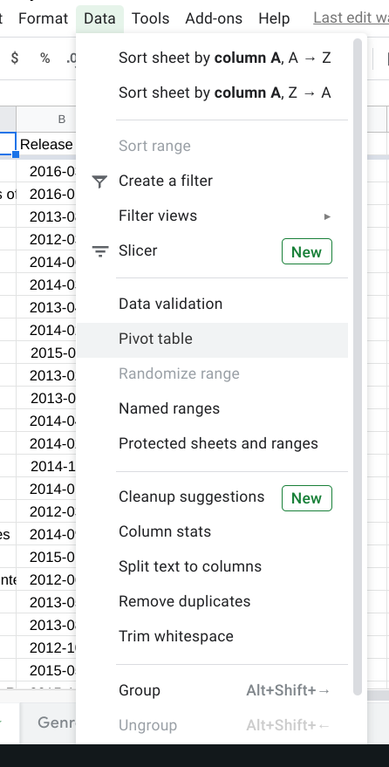

**Insert your pivot table into a new sheet. Click Create.** The data range should already be filled in as ‘Movie Data’!A1:N509.

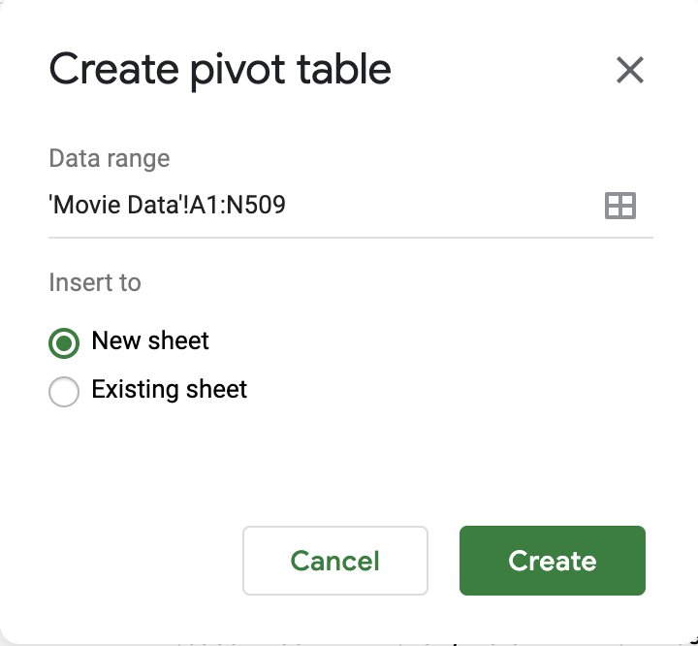

**Rename your new sheet** Summary.

This will open the Pivot table editor, where you will be able to edit your pivot table and add custom calculations.

Using pivot tables to answer questions



Now that you have created your pivot table, you can use it to answer specific questions about your data quickly and easily. For example:

* What is the average budget for each genre?
* What is the average revenue for each genre?
* Which genre is generally the most profitable?

Pivot tables are a useful way to draw these kinds of insights directly from your spreadsheet data.

1. To get the average budget and revenue for each movie genre, first you will **use the Add button next to the Rows section** of the Pivot table editor and **select Genre (1)** from the dropdown list.

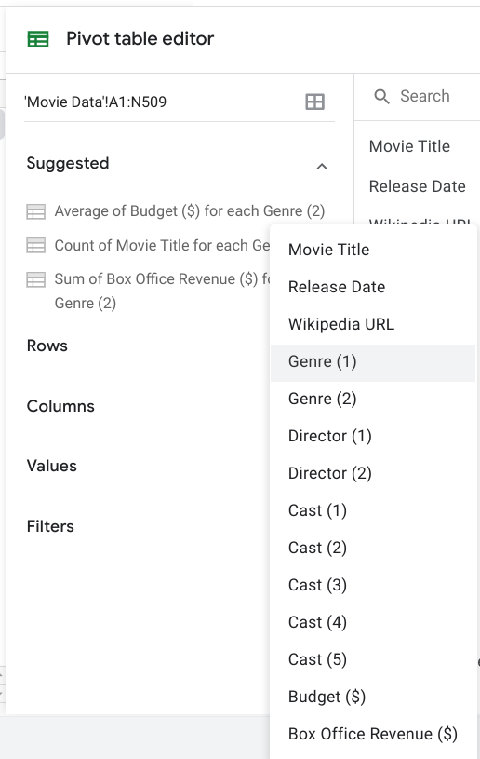

2. Next, you will use the Values section to add the average budget and average box office revenue. **Click the Add button next to Values** and **select Budget.**

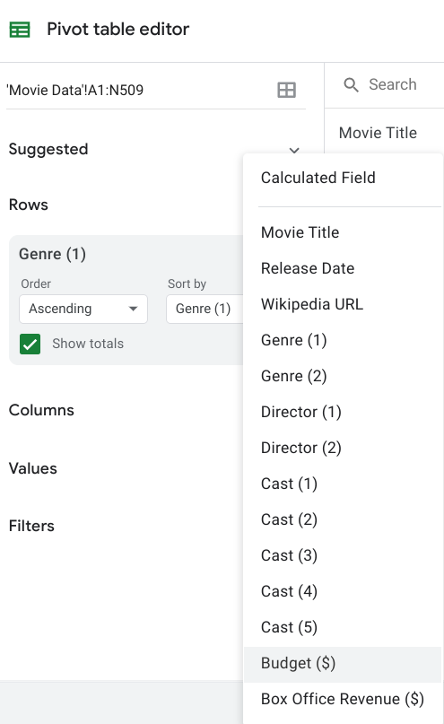

The pivot table will summarize these values from the original data by SUM automatically.  **Change it to AVERAGE** using the dropdown menu.

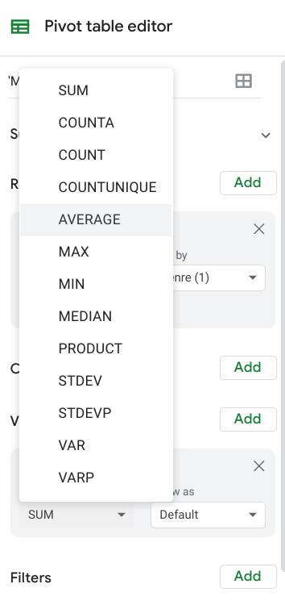

Now you should have a column in your pivot table titled AVERAGE of Budget ($). **Repeat these steps** to create another column **for AVERAGE of Box Office Revenue ($).** Your pivot table should now appear like this:

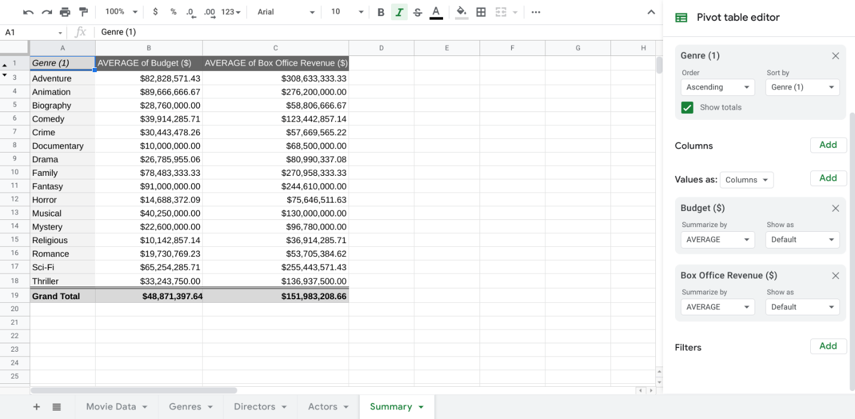

Now you can easily find the average Budget ($) and Box Office Revenue ($) for each genre.

3. In order to find the average net profit for each genre, you will need to create a calculated field. **Use the Add button in the Values section and select Calculated field** from the dropdown list.

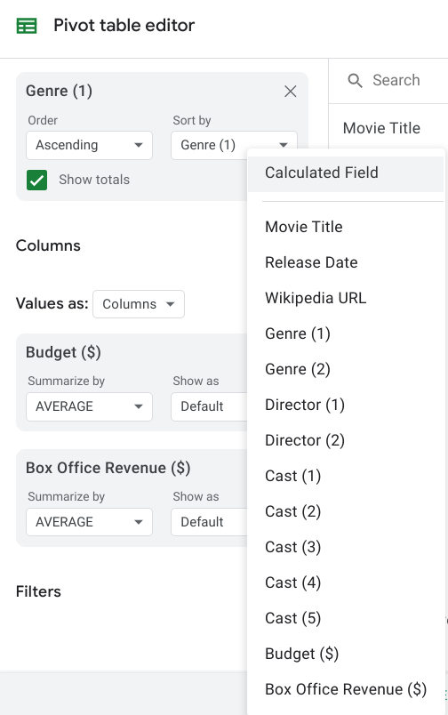

**Input Custom** under the Summarize By option and **paste this formula to get the average profit:**

=AVERAGE('Box Office Revenue ($)')-AVERAGE('Budget ($)')

**Mark Summarize by Custom to avoid creating an error. Title the new column** you created with the calculated field ***AVERAGE Profit*** in cell D1***.*** Your pivot table should now appear like this:

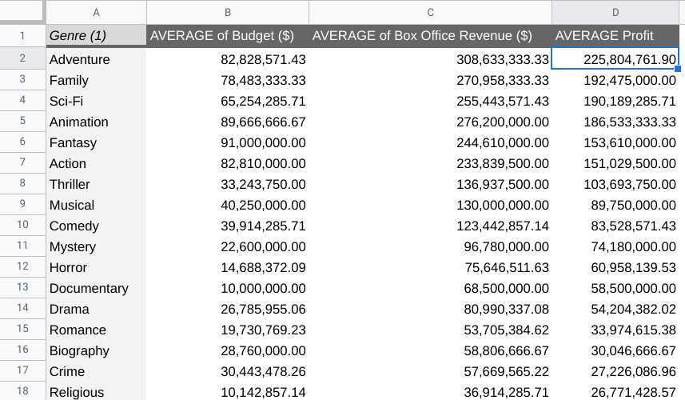

4. Finally, you can use the Sort by option in the Rows section of the pivot table to sort and organize your pivot table. For example, try **sorting by the AVERAGE Profit** values to see which genre generates the most profit on average.

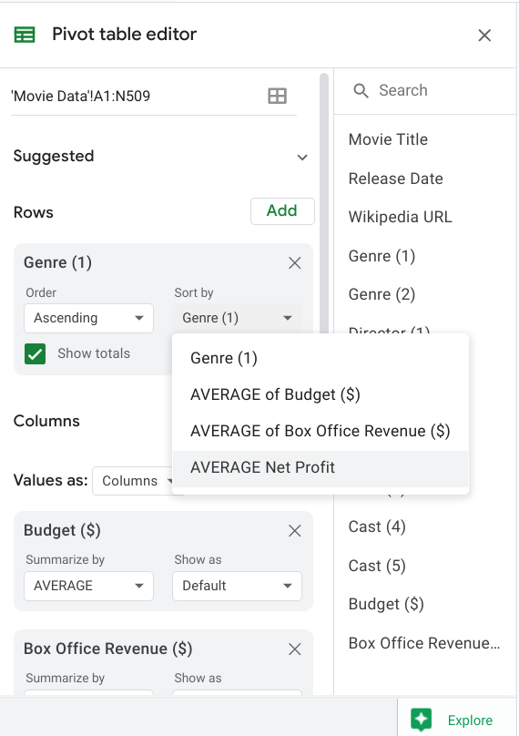

Visualizing your data



You can create some basic visualizations based on your custom tables to share your findings with stakeholders.

**Select any cell** in your pivot table and then **navigate to the Insert menu. Select Insert Chart.**

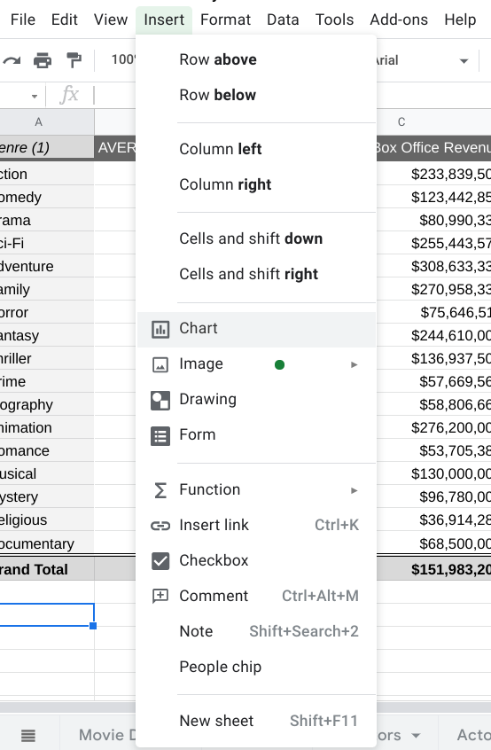

This will create a chart in the same worksheet as your pivot table. Move it next to your pivot table. In the Chart editor, **select Bar chart**. This type of chart makes it easy for your stakeholders to compare the different genres.

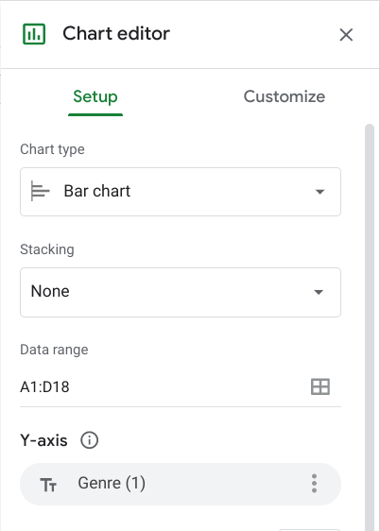

**Input A1:D18 for the Data range** to select the meaningful values from your pivot table. **Set the Y-axis as Genre(1). Add AVERAGE Profit** to the Series list and **check Use row 1 as headers** and **Use column A as labels*.***

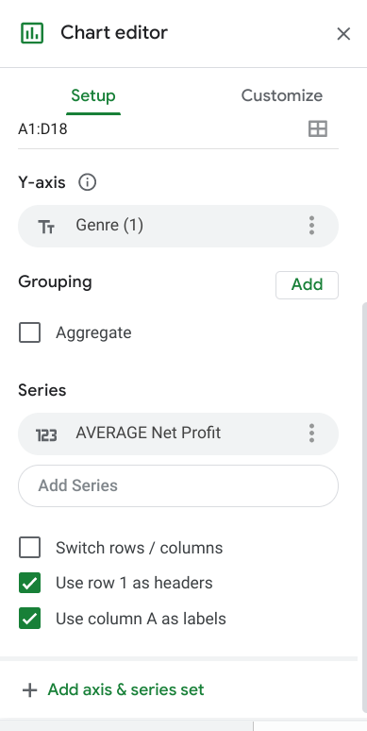

Finally, change the title of your visualization so that your stakeholders know exactly what you’re communicating. You can also customize the color palette using the Customize menu in the Chart editor pane.

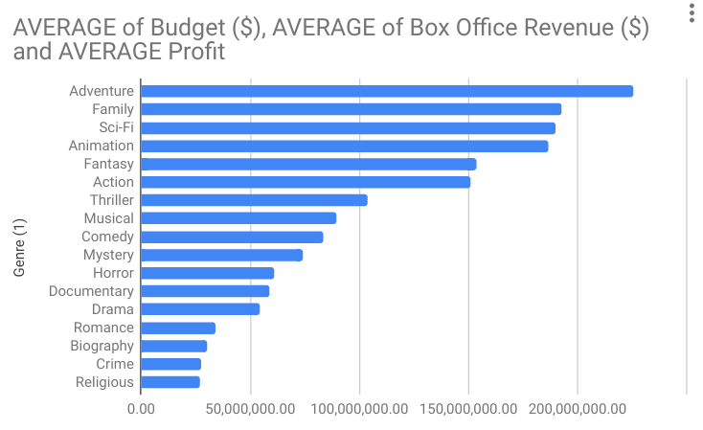

**Hands-On Activity: Calculations in SQL**

**Total points**2

**1.**

**Question 1**



Activity overview



In previous lessons, you were introduced to SQL. In this activity, you will practice it by learning how to write basic calculations in an SQL query.

By the time you complete this activity, you will be able to use operators in SQL queries. This will enable you to make calculations using SQL and combine multiple arithmetic operations in a single query. This will help you to work faster and more efficiently in SQL as you quickly discover significant patterns in your data—a key skill for data analysts.

Operations in SQL



In SQL, the symbols for the four basic arithmetic operations are:

* **+** addition
* **-** subtraction
* **\*** multiplication
* **/** division

For this activity, imagine you’ve been asked to analyze subway ridership data to help improve the quality of the city’s public transportation. You can use basic calculations in SQL to help you make sense of this data.

Access the dataset



Log in to [BigQuery Sandbox](https://cloud.google.com/bigquery/docs/sandbox). If you have a free trial version of BigQuery, you can use that instead. On the BigQuery page, click the **Go to BigQuery** button.

* **Note:** BigQuery Sandbox frequently updates its user interface. The latest changes may not be reflected in the screenshots presented in this activity, but the principles remain the same. Adapting to changes in software updates is an essential skill for data analysts, and it’s helpful for you to practice troubleshooting. You can also reach out to your community of learners on the discussion forum for help.

In this activity, you’ll use data that describes the average weekly subway ridership in New York City from 2013-2018. The columns include: subway stations, subway routes, weekly ridership for each year (2013-2018), the change in ridership from 2017 to 2018 (both in raw numbers and percent), and the ridership rank of each station in 2018. Each row corresponds to a different station in the subway system.

* **Note:** The name of this dataset is **new\_york\_subway** and can be found in bigquery-public-data. However, there seems to be a problem with searching for the dataset. Searching for its name in the Marketplace yields no results, despite the dataset existing in the bigquery-public-data dropdown of the Explorer menu. The Data Analytics Certificate team is investigating this issue. In the meantime, the query you will write in this activity runs correctly and will allow you to examine the data and proceed properly.

To examine the dataset, follow these steps:

1. Make sure that **bigquery-public-data** is pinned to the **Explorer** menu of your SQL Workspace.

2. If it is not pinned, click **+ ADD DATA** and add any BigQuery public dataset (such as noaa\_lightning).

3. Open the bigquery-public-data dropdown in the **Explorer** menu and scroll until you find **new\_york\_subway**.

4. Open the dropdown and click **subway\_ridership\_2013\_present** to open and examine the dataset.

Use a calculation with a single operator



The **change\_2018\_raw** column describes the change in weekly ridership from 2017 to 2018 in raw numbers. Suppose you want to find data on the change in weekly ridership from 2013 to 2014. You can use SQL to subtract the number of riders in 2013 from the number of riders in 2014.

To do that, follow these steps:

1. In the Query editor,type **SELECT**. Add the names of the columns you want to use in your calculations. You’re selecting several columns, so press **Enter** (Windows) or **Return** (Mac) after **SELECT**. Add a **comma** after each column name. Include the following columns: **station\_name**, **ridership\_2013**, and **ridership\_2014**.

2. Add the calculation to the query. Enter the names of the two columns with a minus sign between them: **ridership\_2014 - ridership\_2013**.

3. List the result in a new column. To do this, type **AS** followed by the new column’s name. Name it **change\_2014\_raw** since it represents the change in ridership from 2013 to 2014 in raw numbers.

4. End your query with the **FROM** command and the name of the dataset and subset you’re pulling data from. After FROM, press **Enter** or **Return** and type **bigquery-public-data.new\_york\_subway.subway\_ridership\_2013\_present.**

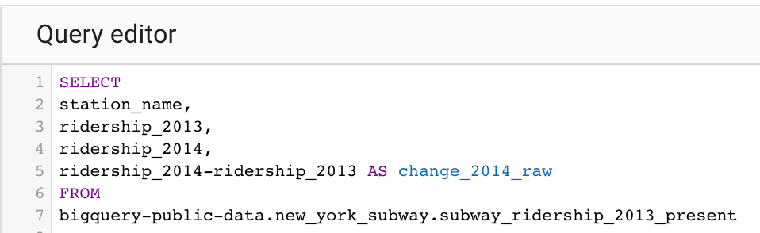1. SELECT 2. station\_name, 3. ridership\_2013, 4. ridership\_2014, 5. ridership\_2014-ridership\_2013 AS change\_2014\_raw 6. FROM 7. bigquery-public-data.new\_york\_subway.subway\_ridership\_2013\_present

5. Now, click **Run** and get the results.

The results show the change in ridership from 2013 to 2014. For example, the *Atlantic Av - Barclays Ctr* station gained an average of 1,774 riders per week. The *4 Av* station lost 321 riders.

By including a basic calculation in your query, you can get an idea of the change in ridership for each subway station in any given year. Basic calculations help you quickly gain important knowledge about your data.

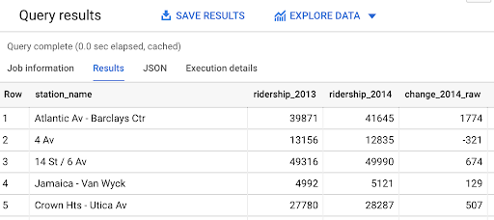

Use a calculation with multiple operators



The original dataset describes average weekly ridership for each individual year.Suppose you want to find average weekly ridership for a longer period of time, such as the multi-year period from 2013-2016.

To do this, you can combine multiple arithmetic operations in a query. The average of a set of numbers is the sum of the numbers divided by the total number of values in the set. There are four values in your new set (ridership data for 2013, 2014, 2015, 2016). You can use SQL to sum the numbers for each year and divide that sum by 4.

1. First, click the **COMPOSE NEW QUERY** button to refresh the query editor.

2. Type **SELECT** to select the columns you want to pull from the table. You’re selecting several columns, so press **Enter** or **Return** after SELECT and add a **comma** after each column name. For this query, enter **station\_name**, **ridership\_2013**, **ridership\_2014**, **ridership\_2015**, and **ridership\_2016**.

3. Add the calculation to the query.If you use more than one arithmetic operator in a calculation, you need to use parentheses to control the order of the operations. In this case, you want to sum the years, and then divide the sum by 4. So, put parentheses around the sum of the four column names. Type **(ridership\_2013** + **ridership\_2014** + **ridership\_2015** + **ridership\_2016)**. Then type a division operator **/** and the number **4**.

4. Next, list the result in a new column by typing **AS** followed by the new column’s name. Call the new column **average** since it represents average weekly ridership for the period 2013-2016.

5. End your query with the **FROM** command and the name of the dataset and subset that you’re pulling data from. After FROM, press **Enter** and type **bigquery-public-data.new\_york\_subway.subway\_ridership\_2013\_present.**

At this point, your screen should display like this:

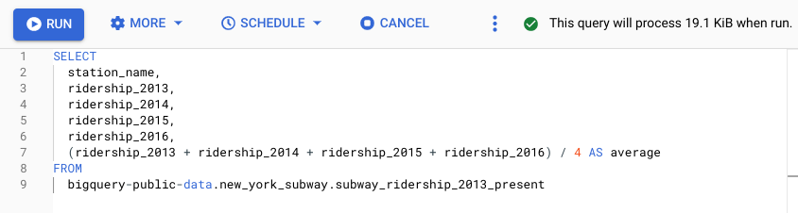

6. Click the **Run** button to get the results. The results clearly show the trend in ridership at each station from 2013 to 2016. For example, weekly ridership at the *Atlantic Av - Barclays Ctr* station increased every year since 2013. Further, for the years 2014, 2015, and 2016, weekly ridership at *Atlantic Av - Barclays Ctr* exceeded the overall average for the period 2013-2016 (listed in the **average** column).

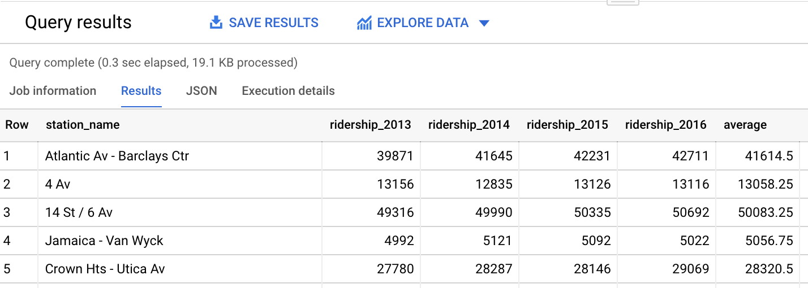

This kind of data is useful for managing public transportation. It can help you determine which stations or routes to expand due to increased ridership. Using basic calculations in your query allows you to quickly discover significant patterns in your data.

Types of data validation

This reading describes the purpose, examples, and limitations of six types of data validation. The first five are validation types associated with the data (type, range, constraint, consistency, and structure) and the sixth type focuses on the validation of application code used to accept data from user input.

As a junior data analyst, you might not perform all of these validations. But you could ask if and how the data was validated before you begin working with a dataset. Data validation helps to ensure the integrity of data. It also gives you confidence that the data you are using is clean. The following list outlines six types of data validation and the purpose of each, and includes examples and limitations.



* **Purpose**: Check that the data matches the data type defined for a field.
* **Example**: Data values for school grades 1-12 must be a numeric data type.
* **Limitations**: The data value 13 would pass the data type validation but would be an unacceptable value. For this case, data range validation is also needed.



* **Purpose**: Check that the data falls within an acceptable range of values defined for the field.
* **Example**: Data values for school grades should be values between 1 and 12.
* **Limitations**: The data value 11.5 would be in the data range and would also pass as a numeric data type. But, it would be unacceptable because there aren't half grades. For this case, data constraint validation is also needed.



* **Purpose**: Check that the data meets certain conditions or criteria for a field. This includes the type of data entered as well as other attributes of the field, such as number of characters.
* **Example**: Content constraint: Data values for school grades 1-12 must be whole numbers.
* **Limitations**: The data value 13 is a whole number and would pass the content constraint validation. But, it would be unacceptable since 13 isn’t a recognized school grade. For this case, data range validation is also needed.



* **Purpose**: Check that the data makes sense in the context of other related data.
* **Example**: Data values for product shipping dates can’t be earlier than product production dates.
* **Limitations**: Data might be consistent but still incorrect or inaccurate. A shipping date could be later than a production date and still be wrong.



* **Purpose**: Check that the data follows or conforms to a set structure.
* **Example**: Web pages must follow a prescribed structure to be displayed properly.
* **Limitations**: A data structure might be correct with the data still incorrect or inaccurate. Content on a web page could be displayed properly and still contain the wrong information.



* **Purpose:** Check that the application code systematically performs any of the previously mentioned validations during user data input.
* **Example:** Common problems discovered during code validation include: more than one data type allowed, data range checking not done, or ending of text strings not well defined.
* **Limitations:** Code validation might not validate all possible variations with data input.

Learning Log: Finish your data analysis checklist



**Overview**



In a previous learning log, you started creating a high-level data analysis checklist. Now, you’ll complete that checklist with more detailed steps. By the time you complete this activity, you will have an in-depth data analysis checklist to help keep you organized during analysis projects. As a data analyst, staying organized will ensure that you don’t make any mistakes or miss any steps-- saving you time and effort!

**Complete Your Checklist**



The high-level outline of your checklist was based on the phases of the data analysis process: **Ask, Prepare, Process, Analyze, Share,** and **Act**.

Now, you can fill in each step of your high-level checklist with detailed substeps. For example, for the Process phase, you probably have a step for cleaning data. You might break this step down to include detailed substeps such as checking that each variable is one column and that each observation is one row.

You could create a step in your checklist like this:

**Process Phase**

Step X: Cleaning data

* Is each variable one column?
* Is each observation one row?

This example takes a high-level data analysis task like cleaning data and breaks it down into more specific steps. Ultimately, you get to decide how detailed you want your checklist to be and which specific steps to include. This is meant to be a useful tool for you, so you can customize it however you want!

You might not know how to break down every phase of the data analysis process. Here are a few questions that you can consider as you think about it:

* What are the high-level steps you need to take? How can the phases of analysis help you organize the whole process?
* What specific details are necessary to complete these high-level steps?
* How can you simplify each step as you go? Are there any shortcuts that can help you?
* Are there any steps you might be most at risk of forgetting? If so, how can your checklist remind you to complete these steps?

You can always adapt and add to your checklist as you have new ideas or as your project needs change.

In the learning log template linked below, copy and paste your original checklist and complete it with the specific steps and tasks you want to add.



**Access your learning log**

To use the template for this course item, click the link below and select “Use Template.”

Link to learning log template: [Finish your data analysis checklist](https://docs.google.com/document/d/1D8bAGx7uY2gMb18g54ecOrTIqrrlU3SEkK--I3LqXd8/template/preview)

OR

If you don’t have a Google account, you can download the template directly from the attachment below.

**Learning Log Template\_ Finish your data analysis checklist**DOCX File

[Download file](https://d3c33hcgiwev3.cloudfront.net/8ifaszLbRiSn2rMy2xYksg_711e4de9a69c485c81af0bf6e3de1141_Learning-Log-Template_-Finish-your-data-analysis-checklist.docx?Expires=1648080000&Signature=focvBLzdUir4XJDpX9p8zBcsn-nRxUBY8Zlu49pWcZShqIsHXDfN8ZvvUMY4HTmjqdt0kS0A2pA-zEmz9Kah~3-k8abTGo61X-ugmxSRhtCVqHJsP~TU8V1S8blMkwg8WKG5V1KZbQ7p7agKLAymxdF6awURCQ5YjiPeV~LGIzE_&Key-Pair-Id=APKAJLTNE6QMUY6HBC5A" \t "_blank)



**Reflection**



When you’re finished, reflect on the process of creating your checklist and its possible uses. Please write 3-5 sentences (60-100 words) in response to each question.

* Review your checklist and compare it to the tasks and activities related to this course. How is your checklist similar to or different from the organization of the course?
* How does creating a checklist help you develop your data analysis skills?
* How will your checklist help you analyze your own data?
* What else could you use your checklist for?

When you’ve finished your entry in the learning log template, make sure to save the document so your response is somewhere accessible. This will help you continue applying data analysis to your everyday life. You will also be able to track your progress and growth as a data analyst.

**Hands-On Activity: Create temporary tables**

**Total points**2

**1.**

**Question 1**



Activity overview



In previous lessons, you learned about temporary tables. In this activity, you will practice making one and using it to run a query.

By the time you complete this activity, you will be able to use temporary tables to work with data without changing the original data. This will help you complete more complicated analytical tasks in your career as a data analyst.

What are temp tables?



As data calculations become more complicated, there are many components to keep track of. This is similar to keeping track of tasks in daily life. Some people use sticky notes while others use checklists. In data science, a temporary table is just like a sticky note.

**Temporary tables,** or temp tables, store subsets of data from standard data tables for a certain period of time. When you end your SQL database session, they are automatically deleted. Temp tables allow you to run calculations in temporary data tables without needing to make modifications to the primary tables in your database.

Now, you will practice creating a temp table.

Importing data



To begin, import your data. You will use a dataset on bikesharing in Austin, Texas. Specifically, you will work with a table that gives details about each public bike ride’s duration, starting station, and ending station.

To load your data, follow these steps:

1. Log in to and open the [BigQuery Console](https://console.cloud.google.com/bigquery). If you have a free trial version of BigQuery, you can use that instead. On the BigQuery page, click the **Go to BigQuery** button.

* **Note:** BigQuery frequently updates its user interface. The latest changes may not be reflected in the screenshots presented in this activity, but the principles remain the same. Adapting to changes in software updates is an essential skill for data analysts, and it’s helpful for you to practice troubleshooting. You can also reach out to your community of learners on the discussion forum for help.

2. If you have never created a BigQuery project before, click **CREATE PROJECT** on the right side of the screen. If you have created a project before, you can use an existing one or create a new one by clicking the project dropdown in the blue header bar and selecting **NEW PROJECT**.

3. Name your project something that will help you identify it later. You can give it a unique project ID or use an auto-generated one. Don’t worry about selecting an organization if you don’t know what to put.

4. Now, you’ll see the **Editor** interface. In the middle of the screen is a window where you can type code, and to the left is the **Explorer** menu where you can search for datasets.

* **Note:** The name of the dataset you'll use in this activity is **austin\_bikeshare** and can be found in bigquery-public-data. However, there seems to be a problem with searching for the dataset. Searching for its name in the Marketplace yields no results, despite the dataset existing in the bigquery-public-data dropdown of the Explorer menu. The Data Analytics Certificate team is investigating this issue. In the meantime, the query you will write in this activity runs correctly and will allow you to examine the data and proceed properly.

To examine the dataset, follow these steps:

1. Make sure that **bigquery-public-data** is pinned to the **Explorer** menu of your SQL Workspace.

2. If it is not pinned, click **+ ADD DATA** and add any BigQuery public dataset (such as noaa\_lightning).

3. Open the bigquery-public-data dropdown in the **Explorer** menu and scroll until you find **austin\_bikeshare**.

4. Open the dropdown and click **bikeshare\_trips** to open and examine the dataset.

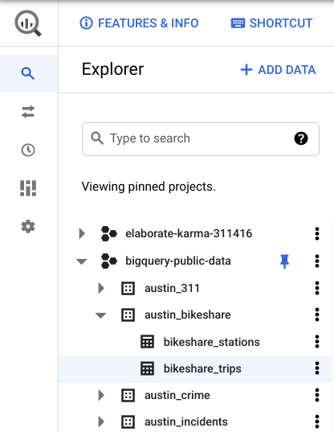

5. Click on the **Preview** tab in the viewer on the right, then examine the dataset.

You’ll need to use the WITH clause to create a temporary table so you can find at which station the longest (duration) bike ride started.

Create a temporary table



Consider the following scenario: A bikeshare company has reached a recent milestone, and their marketing team wants to write a blog post that “congratulates” their most-used bike on being so popular. They want to include the name of the station that the bike is most likely to be found.

They task you with figuring out the station from which the bike begins a trip most frequently.

In order to do this, you will need to create a temp table to find the ID number of the bike that has taken the longest total trips (in minutes). You will take a sum of the minutes of each trip for each bike, then sort by descending order to find the bike that has spent the most minutes being used.

To do that, complete the following steps:

1. Return to your Editor tab or click **Compose new query.**

2. Begin your query with **WITH** to set up a temp table. Then on a new indented line, create the name of your temp table. Make sure your table name is in the proper snake case (with underscores between each word). Name it **longest\_used\_bike**. Then add a **space**.

3. Type **AS** and an open parenthesis **(,** then press **Enter** (Windows) or **Return** (Mac) to create a new indented line.

4. Type **SELECT**, then press **Enter** or **Return** and **Tab** to create a new indented line.

5. Type **bikeid** and a **comma**. Then press **Enter** or **Return** to create a new line and type **SUM(duration\_minutes) AS trip\_duration**. This creates a column in the temp table that contains the sum of the total minutes a bike has been used. Press **Enter** or **Return** again, then press **Backspace** to align the cursor with SELECT.

6. Type **FROM**, then press **Enter** or **Return** and **Tab** to create a new indented line.

7. Specify the dataset you’ll be using. To do this, type **bigquery-public-data.austin\_bikeshare.bikeshare\_trips.** Press **Enter** or **Return**, then press **Backspace** to align the cursor with SELECT.

Your text should appear like this:

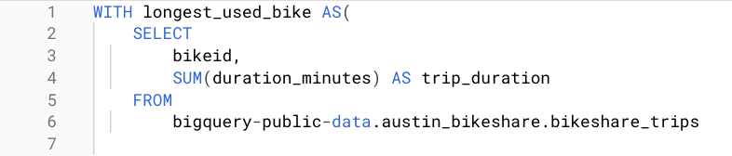

8.Type **GROUP BY**, then press **Enter** or **Return** and **Tab** to create a new indented line.

9. Type **bikeid** to group the data by the column bikeid. Press **Enter** or **Return** again, then press **Backspace** to align the cursor with SELECT.

10.Type **ORDER BY**, then press **Enter** or **Return** and **Tab** to create a new indented line.

11. Type **trip\_duration DESC** to sort the data in descending order by the column trip\_duration. Press **Enter** or **Return** again, then press **Backspace** to align the cursor with SELECT.

12. Type **LIMIT 1**.

13. Make sure there is a closed parenthesis **)** on the next line. If it is not there, add it.

This sets up your temporary table. This section identifies the specific bike (bikeid) with the longest trip duration.

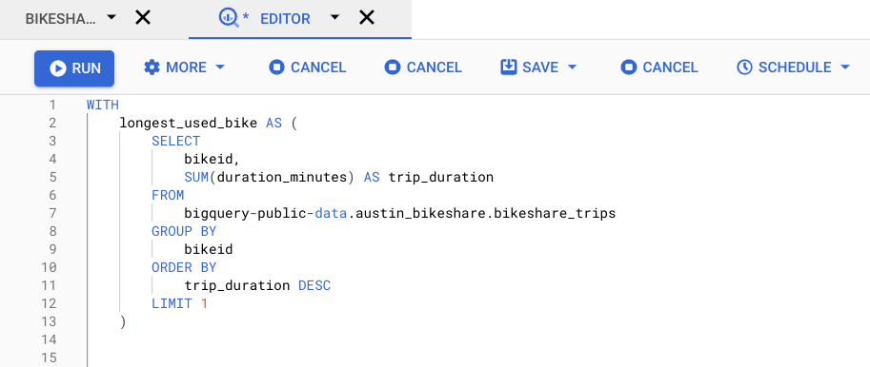

If you run it now, it’ll return an error because you haven’t written any queries yet. Now, it’s time to write a query that identifies the start station that this bike came out of.

Write your query



Now that you have found the ID of the bike that has been used the longest, you will write a query to find the station from which this bike leaves most frequently. To do this, you will join your temp table (containing just the bike’s ID) with the original table and return the station ID with the highest number of trips started.

To find this station ID, follow these steps:

1.On a new line, type two **#** signs to begin a comment.

2.Describe the purpose of your query. This will help you remember the purpose of your query as you’re writing it. It can also help you share your work with others. In this case, type **find station at which the longest-used bike leaves most often** or something similar. Then press **Enter** or **Return** to make a new line.

3.Begin the query with **SELECT**, then press **Enter** or **Return** and **Tab** to create a new indented line.

4. Type **trips.start\_station\_id**, and a **comma**. This line contains the start\_station\_id column from the trips table, which you will define with an alias later in this query. Then press **Enter** or **Return** to create a new line.

5. Type **COUNT(\*) AS trip\_ct**. This line will help you count how many times the bike has left each station. Press **Enter** or **Return** again, then press **Backspace** to align the cursor with SELECT.

6. Type **FROM**, then press **Enter** or **Return** and **Tab** to create a new indented line.

7. Type **longest\_used\_bike AS longest** to rename your temp table with an alias. Then press **Backspace** to align the cursor with SELECT.

Your text should appear like this:

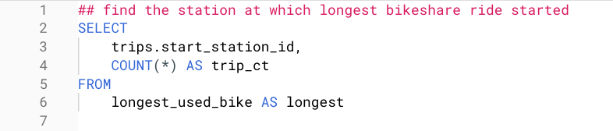

Now, it's time to write an INNER JOIN, which you will use to pick out the station ID that corresponds to the bike you identified in the temporary table.

8. Type **INNER JOIN.** Press **Enter** or **Return** and **Tab** to create a new indented line.

9. Type **`bigquery-public-data.austin\_bikeshare.bikeshare\_trips` AS trips**. Press **Enter** or **Return** again, then press **Backspace** to align the cursor with SELECT.

10. Type **ON longest.bikeid = trips.bikeid**. This specifies that the JOIN is on the bikeid column in the temp table you created and the original dataset. Then press **Enter** or **Return** to create a new line.

11. Type GROUP BY, then press **Enter** or **Return** and **Tab** to create a new indented line.

12. Type **trips.start\_station\_id** to group by the start\_station\_id column in the original dataset. Press **Enter** or **Return** again, then press **Backspace** to align the cursor with SELECT.

13. Type **ORDER BY**, then press **Enter** or **Return** and **Tab** to create a new indented line.

14, Type **trip\_ct DESC** to sort by the trip\_ct column in descending order. Press **Enter** or **Return** again, then press **Backspace** to align the cursor with SELECT.

15. Type **LIMIT 1**.

16.Finally, click **Run**. The query might take a few seconds before showing you the count. If your query returns **2575** in the **start\_station\_id** column and **90** in the **trip\_ct** column, you’ve written it correctly. Your text should appear like this:

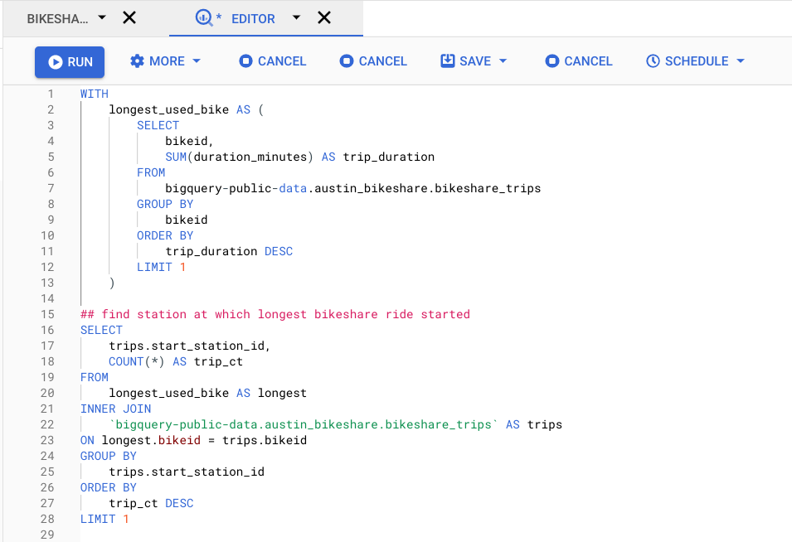

You’ve now created a temporary table and executed a query with it. This will be helpful when you are performing several calculations at once.

Other types of temp tables



There are also other ways to create a temp table. Instead of using the **WITH** clause, you can use the **SELECT INTO** or the **CREATE TABLE** clauses.

The **SELECT INTO** clause copies data from one table into a new table, but doesn’t add the new table to the database. It’s useful if you want to make a copy of a table with a specific condition.

The **CREATE TABLE** clause is a good option when several people need to access the same temp table. This statement adds the table into the database.

Which clause you use depends on your preference and the project’s demands. Different clauses have their own strengths, so understanding how each of them work is helpful for using them effectively.

Working with temporary tables

**Temporary tables** are exactly what they sound like—temporary tables in a SQL database that aren’t stored permanently. In this reading, you will learn the methods to create temporary tables using SQL commands. You will also learn a few best practices to follow when working with temporary tables.

**A quick refresher on what you have already learned about temporary tables**

* They are automatically deleted from the database when you end your SQL session.
* They can be used as a holding area for storing values if you are making a series of calculations. This is sometimes referred to as **pre-processing** of the data.
* They can collect the results of multiple, separate queries. This is sometimes referred to as data **staging**. Staging is useful if you need to perform a query on the collected data or merge the collected data.
* They can store a filtered subset of the database. You don’t need to select and filter the data each time you work with it. In addition, using fewer SQL commands helps to keep your data clean.

It is important to point out that each database has its own unique set of commands to create and manage temporary tables. We have been working with BigQuery, so we will focus on the commands that work well in that environment. The rest of this reading will go over the ways to create temporary tables, primarily in BigQuery.

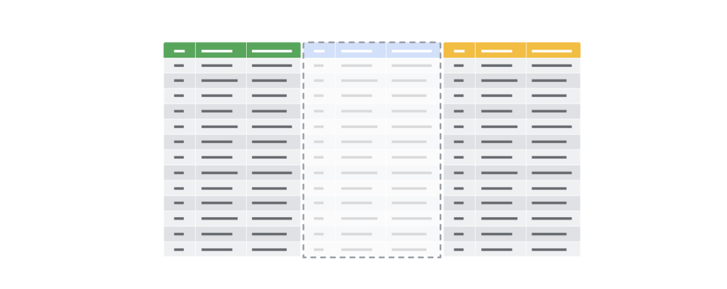

**Temporary table creation in BigQuery**

Temporary tables can be created using different clauses. In BigQuery, the **WITH** clause can be used to create a temporary table. The general syntax for this method is as follows:

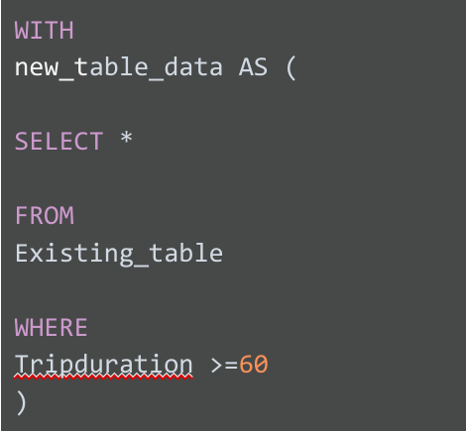

Breaking down this query a bit, notice the following:

* The statement begins with the **WITH** clause followed by the name of the new temporary table you want to create
* The **AS** clause appears after the name of the new table. This clause instructs the database to put all of the data identified in the next part of the statement into the new table.
* The opening parenthesis after the **AS** clause creates the subquery that filters the data from an existing table. The subquery is a regular **SELECT** statement along with a **WHERE** clause to specify the data to be filtered.
* The closing parenthesis ends the subquery created by the **AS** clause.

When the database executes this query, it will first complete the subquery and assign the values that result from that subquery to “new\_table\_data,” which is the temporary table. You can then run multiple queries on this filtered data without having to filter the data every time.

**Temporary table creation in other databases (not supported in BigQuery)**

The following method isn’t supported in BigQuery, but most other versions of SQL databases support it, including SQL Server and mySQL. Using **SELECT** and **INTO**, you can create a temporary table based on conditions defined by a **WHERE** clause to locate the information you need for the temporary table. The general syntax for this method is as follows:

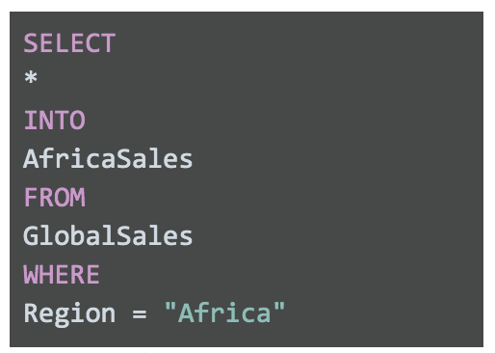SELECT \* INTO AfricaSales FROM GlobalSales WHERE Region = "Africa"

This **SELECT** statement uses the standard clauses like **FROM** and **WHERE**, but the **INTO** clause tells the database to store the data that is being requested in a new temporary table named, in this case, “AfricaSales.”

**User-managed temporary table creation**

So far, we have explored ways of creating temporary tables that the database is responsible for managing. But, you can also create temporary tables that you can manage as a user. As an analyst, you might decide to create a temporary table for your analysis that you can manage yourself. You would use the **CREATE TABLE** statement to create this kind of temporary table. After you have finished working with the table, you would then delete or drop it from the database at the end of your session.

**Note:** BigQuery uses **CREATE TEMP TABLE** instead of **CREATE TABLE**, but the general syntax is the same.

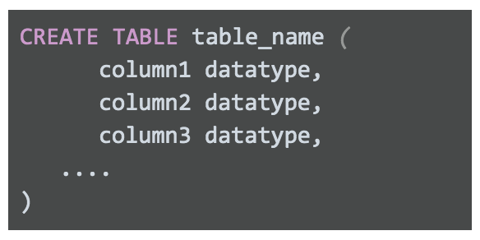CREATE TABLE table\_name ( column1 datatype, column2 datatype, column3 datatype, .... )

After you have completed working with your temporary table, you can remove the table from the database using the **DROP TABLE** clause. The general syntax is as follows:



**Best practices when working with temporary tables**

* **Global vs. local temporary tables:** Global temporary tables are made available to all database users and are deleted when all connections that use them have closed. Local temporary tables are made available only to the user whose query or connection established the temporary table. You will most likely be working with local temporary tables. If you have created a local temporary table and are the only person using it, you can drop the temporary table after you are done using it.
* **Dropping temporary tables after use:** Dropping a temporary table is a little different from deleting a temporary table. Dropping a temporary table not only removes the information contained in the rows of the table, but removes the table variable definitions (columns) themselves. Deleting a temporary table removes the rows of the table but leaves the table definition and columns ready to be used again. Although local temporary tables are dropped after you end your SQL session, it may not happen immediately. If a lot of processing is happening in the database, dropping your temporary tables after using them is a good practice to keep the database running smoothly.

**For more information**

* [BigQuery Documentation for Temporary Tables](https://cloud.google.com/bigquery/docs/reference/standard-sql/data-definition-language#temporary_tables)**:** Documentation has the syntax to create temporary tables in BigQuery
* [How to use temporary tables via WITH in Google BigQuery](https://www.pascallandau.com/bigquery-snippets/use-temporary-tables-with-named-subquery/?utm_source=blog&utm_medium=rss&utm_campaign=development-feed)**:** Article describes how to use **WITH**
* [Introduction to Temporary Tables in SQL Server](https://codingsight.com/introduction-to-temporary-tables-in-sql-server/)**:** Article describes how to use **SELECT INTO** and **CREATE TABLE**
* [SQL Server Temporary Tables](https://www.sqlservertutorial.net/sql-server-basics/sql-server-temporary-tables/)**:** Article describes temporary table creation and removal
* [Choosing Between Table Variables and Temporary Tables](https://www.red-gate.com/hub/product-learning/sql-prompt/choosing-table-variables-temporary-tables)**:** Article describes the differences between passing variables in SQL statements vs. using temporary tables